






Manage financial performance within a budget
D1.HFI.CL8.03
D1.HFA.CL7.02
D2.TRM.CL9.09
Trainer Guide

Manage financial performance within a budget
D1.HFI.CL8.03
D1.HFA.CL7.02
D2.TRM.CL9.09
Trainer Guide





Project Base
William Angliss Institute of TAFE
555 La Trobe Street
Melbourne 3000 Victoria
Telephone: | (03) 9606 2111
Facsimile: | (03) 9670 1330
Acknowledgements
Project Director: | Wayne Crosbie
Project Manager | Jim Irwin
Chief Writer: | Alan Hickman
Subject Writer: | Alan Hickman
Editor: | Insert Name
DTP/Production: | Daniel Chee, Mai Vu, Cindy Curran

The Association of Southeast Asian Nations (ASEAN) was established on 8 August 1967. The Member States of the Association are Brunei Darussalam, Cambodia, Indonesia, Lao PDR, Malaysia, Myanmar, Philippines, Singapore, Thailand and Viet Nam.
The ASEAN Secretariat is based in Jakarta, Indonesia.
General Information on ASEAN appears online at the ASEAN Website: www.asean.org.
All text is produced by William Angliss Institute of TAFE for the ASEAN Project on “Toolbox Development for Tourism Labour Divisions for Travel Agencies and Tour Operations”.
This publication is supported by the Australian Government’s aid program through the ASEAN-Australia Development Cooperation Program Phase II (AADCP II).
Copyright: Association of Southeast Asian Nations (ASEAN) 2015.
All rights reserved.
Disclaimer
Every effort has been made to ensure that this publication is free from errors or omissions. However, you should conduct your own enquiries and seek professional advice before relying on any fact, statement or matter contained in this book. The ASEAN Secretariat and William Angliss Institute of TAFE are not responsible for any injury, loss or damage as a result of material included or omitted from this course. Information in this module is current at the time of publication. Time of publication is indicated in the date stamp at the bottom of each page.
Some images appearing in this resource have been purchased from stock photography suppliers Shutterstock and iStockphoto and other third party copyright owners and as such are non-transferable and non-exclusive. Clip arts, font images and illustrations used are from the Microsoft Office Clip Art and Media Library. Some images have been provided by and are the property of William Angliss Institute.
Additional images have been sourced from Flickr and SXC and are used under Creative Commons licence: http://creativecommons.org/licenses/by/2.0/deed.en
File name: TG_Manage_fin_perf_within_budget_280415





Table of contents
Competency Based Training (CBT) and assessment – An introduction for trainers 1
Competency standard 11
Notes and PowerPoint slides 19
Recommended training equipment 215
Instructions for Trainers for using PowerPoint – Presenter View 217
Appendix – ASEAN acronyms 219

Competency Based Training (CBT) and assessment – An introduction for trainers

Competency
Competency refers to the ability to perform particular tasks and duties to the standard of performance expected in the workplace.
Competency requires the application of specified knowledge, skills and attitudes relevant to effective participation, consistently over time and in the workplace environment.
The essential skills and knowledge are either identified separately or combined.
Knowledge identifies what a person needs to know to perform the work in an informed and effective manner.
Skills describe the application of knowledge to situations where understanding is converted into a workplace outcome.
Attitude describes the founding reasons behind the need for certain knowledge or why skills are performed in a specified manner.
Competency covers all aspects of workplace performance and involves:
- Performing individual tasks
- Managing a range of different tasks
- Responding to contingencies or breakdowns
- Dealing with the responsibilities of the workplace
- Working with others.

Unit of competency
Like with any training qualification or program, a range of subject topics are identified that focus on the ability in a certain work area, responsibility or function.
Each manual focuses on a specific unit of competency that applies in the hospitality workplace.
In this manual a unit of competency is identified as a ‘unit’.
Each unit of competency identifies a discrete workplace requirement and includes:
- Knowledge and skills that underpin competency
- Language, literacy and numeracy
- Occupational safety and health requirements.
Each unit of competency must be adhered to in training and assessment to ensure consistency of outcomes.

Element of competency
An element of competency describes the essential outcomes within a unit of competency.
The elements of competency are the basic building blocks of the unit of competency. They describe in terms of outcomes the significant functions and tasks that make up the competency.
In this manual elements of competency are identified as an ‘element’.

Performance criteria
Performance criteria indicate the standard of performance that is required to demonstrate achievement within an element of competency. The standards reflect identified industry skill needs.
Performance criteria will be made up of certain specified skills, knowledge and attitudes.

Learning
For the purpose of this manual learning incorporates two key activities:
- Training
- Assessment.
Both of these activities will be discussed in detail in this introduction.
Today training and assessment can be delivered in a variety of ways. It may be provided to participants:
- On-the-job – in the workplace
- Off-the-job – at an educational institution or dedicated training environment
- As a combination of these two options.
No longer is it necessary for learners to be absent from the workplace for long periods of time in order to obtain recognised and accredited qualifications.

Learning approaches
This manual will identify two avenues to facilitate learning:
Competency Based Training (CBT)
This is the strategy of developing a participant’s competency.
Educational institutions utilise a range of training strategies to ensure that participants are able to gain the knowledge and skills required for successful:
- Completion of the training program or qualification
- Implementation in the workplace.
The strategies selected should be chosen based on suitability and the learning styles of participants.

Competency Based Assessment (CBA)
This is the strategy of assessing competency of a participant.
Educational institutions utilise a range of assessment strategies to ensure that participants are assessed in a manner that demonstrates validity, fairness, reliability, flexibility and fairness of assessment processes.

Flexibility in learning
It is important to note that flexibility in training and assessment strategies is required to meet the needs of participants who may have learning difficulties. The strategies used will vary, taking into account the needs of individual participants with learning difficulties. However they will be applied in a manner which does not discriminate against the participant or the participant body as a whole.
Catering for participant diversity
Participants have diverse backgrounds, needs and interests. When planning training and assessment activities to cater for individual differences, trainers and assessors should:
- Consider individuals’ experiences, learning styles and interests
- Develop questions and activities that are aimed at different levels of ability
- Modify the expectations for some participants
- Provide opportunities for a variety of forms of participation, such as individual, pair and small group activities
- Assess participants based on individual progress and outcomes.
The diversity among participants also provides a good reason for building up a learning community in which participants support each other’s learning.
Participant centred learning
This involves taking into account structuring training and assessment that:
- Builds on strengths – Training environments need to demonstrate the many positive features of local participants (such as the attribution of academic success to effort, and the social nature of achievement motivation) and of their trainers (such as a strong emphasis on subject disciplines and moral responsibility). These strengths and uniqueness of local participants and trainers should be acknowledged and treasured
- Acknowledges prior knowledge and experience – The learning activities should be planned with participants’ prior knowledge and experience in mind
- Understands learning objectives – Each learning activity should have clear learning objectives and participants should be informed of them at the outset. Trainers should also be clear about the purpose of assignments and explain their significance to participants
- Teaches for understanding – The pedagogies chosen should aim at enabling participants to act and think flexibly with what they know
- Teaches for independent learning – Generic skills and reflection should be nurtured through learning activities in appropriate contexts of the curriculum. Participants should be encouraged to take responsibility for their own learning
- Enhances motivation – Learning is most effective when participants are motivated. Various strategies should be used to arouse the interest of participants
- Makes effective use of resources – A variety of teaching resources can be employed as tools for learning
- Maximises engagement – In conducting learning activities, it is important for the minds of participants to be actively engaged
- Aligns assessment with learning and teaching – Feedback and assessment should be an integral part of learning and teaching
- Caters for learner diversity – Trainers should be aware that participants have different characteristics and strengths and try to nurture these rather than impose a standard set of expectations.
Active learning
The goal of nurturing independent learning in participants does not imply that they always have to work in isolation or solely in a classroom. On the contrary, the construction of knowledge in tourism and hospitality studies can often best be carried out in collaboration with others in the field. Sharing experiences, insights and views on issues of common concern, and working together to collect information through conducting investigative studies in the field (active learning) can contribute a lot to their eventual success.
Active learning has an important part to play in fostering a sense of community in the class. First, to operate successfully, a learning community requires an ethos of acceptance and a sense of trust among participants, and between them and their trainers. Trainers can help to foster acceptance and trust through encouragement and personal example, and by allowing participants to take risks as they explore and articulate their views, however immature these may appear to be. Participants also come to realise that their classmates (and their trainers) are partners in learning and solving.
Trainers can also encourage cooperative learning by designing appropriate group learning tasks, which include, for example, collecting background information, conducting small-scale surveys, or producing media presentations on certain issues and themes. Participants need to be reminded that, while they should work towards successful completion of the field tasks, developing positive peer relationships in the process is an important objective of all group work.

Competency Based Training (CBT)
Principle of Competency Based Training
Competency based training is aimed at developing the knowledge, skills and attitudes of participants, through a variety of training tools.
Training strategies
The aims of this curriculum are to enable participants to:
- Undertake a variety of subject courses that are relevant to industry in the current environment
- Learn current industry skills, information and trends relevant to industry
- Learn through a range of practical and theoretical approaches
- Be able to identify, explore and solve issues in a productive manner
- Be able to become confident, equipped and flexible managers of the future
- Be ‘job ready’ and a valuable employee in the industry upon graduation of any qualification level.
To ensure participants are able to gain the knowledge and skills required to meet competency in each unit of competency in the qualification, a range of training delivery modes are used.
Types of training
In choosing learning and teaching strategies, trainers should take into account the practical, complex and multi-disciplinary nature of the subject area, as well as their participant’s prior knowledge, learning styles and abilities.
Training outcomes can be attained by utilising one or more delivery methods:
Lecture/tutorial
This is a common method of training involving transfer of information from the trainer to the participants. It is an effective approach to introduce new concepts or information to the learners and also to build upon the existing knowledge. The listener is expected to reflect on the subject and seek clarifications on the doubts.
Demonstration
Demonstration is a very effective training method that involves a trainer showing a participant how to perform a task or activity. Through a visual demonstration, trainers may also explain reasoning behind certain actions or provide supplementary information to help facilitate understanding.
Group discussions
Brainstorming in which all the members in a group express their ideas, views and opinions on a given topic. It is a free flow and exchange of knowledge among the participants and the trainer. The discussion is carried out by the group on the basis of their own experience, perceptions and values. This will facilitate acquiring new knowledge. When everybody is expected to participate in the group discussion, even the introverted persons will also get stimulated and try to articulate their feelings.
The ideas that emerge in the discussions should be noted down and presentations are to be made by the groups. Sometimes consensus needs to be arrived at on a given topic. Group discussions are to be held under the moderation of a leader guided by the trainer. Group discussion technique triggers thinking process, encourages interactions and enhances communication skills.
Role play
This is a common and very effective method of bringing into the classroom real life situations, which may not otherwise be possible. Participants are made to enact a particular role so as to give a real feel of the roles they may be called upon to play. This enables participants to understand the behaviour of others as well as their own emotions and feelings. The instructor must brief the role players on what is expected of them. The role player may either be given a ready-made script, which they can memorize and enact, or they may be required to develop their own scripts around a given situation. This technique is extremely useful in understanding creative selling techniques and human relations. It can be entertaining and energizing and it helps the reserved and less literate to express their feelings.

Simulation games
When trainees need to become aware of something that they have not been conscious of, simulations can be a useful mechanism. Simulation games are a method based on "here and now" experience shared by all the participants. The games focus on the participation of the trainees and their willingness to share their ideas with others. A "near real life" situation is created providing an opportunity to which they apply themselves by adopting certain behaviour. They then experience the impact of their behaviour on the situation. It is carried out to generate responses and reactions based on the real feelings of the participants, which are subsequently analysed by the trainer.
While use of simulation games can result in very effective learning, it needs considerable trainer competence to analyse the situations.
Individual /group exercises
Exercises are often introduced to find out how much the participant has assimilated. This method involves imparting instructions to participants on a particular subject through use of written exercises. In the group exercises, the entire class is divided into small groups, and members are asked to collaborate to arrive at a consensus or solution to a problem.
Case study
This is a training method that enables the trainer and the participant to experience a real life situation. It may be on account of events in the past or situations in the present, in which there may be one or more problems to be solved and decisions to be taken. The basic objective of a case study is to help participants diagnose, analyse and/or solve a particular problem and to make them internalize the critical inputs delivered in the training. Questions are generally given at the end of the case study to direct the participants and to stimulate their thinking towards possible solutions. Studies may be presented in written or verbal form.
Field visit
This involves a carefully planned visit or tour to a place of learning or interest. The idea is to give first-hand knowledge by personal observation of field situations, and to relate theory with practice. The emphasis is on observing, exploring, asking questions and understanding. The trainer should remember to brief the participants about what they should observe and about the customs and norms that need to be respected.
Group presentation
The participants are asked to work in groups and produce the results and findings of their group work to the members of another sub-group. By this method participants get a good picture of each other's views and perceptions on the topic and they are able to compare them with their own point of view. The pooling and sharing of findings enriches the discussion and learning process.
Practice sessions
This method is of paramount importance for skills training. Participants are provided with an opportunity to practice in a controlled situation what they have learnt. It could be real life or through a make-believe situation.

Games
This is a group process and includes those methods that involve usually fun-based activity, aimed at conveying feelings and experiences, which are everyday in nature, and applying them within the game being played. A game has set rules and regulations, and may or may not include a competitive element. After the game is played, it is essential that the participants be debriefed and their lessons and experiences consolidated by the trainer.
Research
Trainers may require learners to undertake research activities, including online research, to gather information or further understanding about a specific subject area.

Competency Based Assessment (CBA)
Principle of Competency Based Assessment
Competency based assessment is aimed at compiling a list of evidence that shows that a person is competent in a particular unit of competency.
Competencies are gained through a multitude of ways including:
- Training and development programs
- Formal education
- Life experience
- Apprenticeships
- On-the-job experience
- Self-help programs.
All of these together contribute to job competence in a person. Ultimately, assessors and participants work together, through the ‘collection of evidence’ in determining overall competence.
This evidence can be collected:
- Using different formats
- Using different people
- Collected over a period of time.
The assessor who is ideally someone with considerable experience in the area being assessed, reviews the evidence and verifies the person as being competent or not.
Flexibility in assessment
Whilst allocated assessment tools have been identified for this subject, all attempts are made to determine competency and suitable alternate assessment tools may be used, according to the requirements of the participant.
The assessment needs to be equitable for all participants, taking into account their cultural and linguistic needs.
Competency must be proven regardless of:
- Language
- Delivery Method
- Assessment Method.
Assessment objectives
The assessment tools used for subjects are designed to determine competency against the ‘elements of competency’ and their associated ‘performance criteria’.
The assessment tools are used to identify sufficient:
- Knowledge, including underpinning knowledge
- Skills
- Attitudes
Assessment tools are activities that trainees are required to undertake to prove participant competency in this subject.
All assessments must be completed satisfactorily for participants to obtain competence in this subject. There are no exceptions to this requirement, however, it is possible that in some cases several assessment items may be combined and assessed together.
Types of assessment
Allocated Assessment Tools
There are a number of assessment tools that are used to determine competency in this subject:
- Work projects
- Written questions
- Oral questions
- Third Party Report
- Observation Checklist.
Instructions on how assessors should conduct these assessment methods are explained in the Assessment Manuals.
Alternative assessment tools
Whilst this subject has identified assessment tools, as indicated above, this does not restrict the assessor from using different assessment methods to measure the competency of a participant.
Evidence is simply proof that the assessor gathers to show participants can actually do what they are required to do.
Whilst there is a distinct requirement for participants to demonstrate competency, there are many and diverse sources of evidence available to the assessor.
Ongoing performance at work, as verified by a supervisor or physical evidence, can count towards assessment. Additionally, the assessor can talk to customers or work colleagues to gather evidence about performance.
A range of assessment methods to assess competency include:
- Practical demonstrations
- Practical demonstrations in simulated work conditions
- Problem solving
- Portfolios of evidence
- Critical incident reports
- Journals
- Oral presentations
- Interviews
- Videos
- Visuals: slides, audio tapes
- Case studies
- Log books
- Projects
- Role plays
- Group projects
- Group discussions
- Examinations.
Recognition of Prior Learning
Recognition of Prior Learning is the process that gives current industry professionals who do not have a formal qualification, the opportunity to benchmark their extensive skills and experience against the standards set out in each unit of competency/subject.
Also known as a Skills Recognition Audit (SRA), this process is a learning and assessment pathway which encompasses:
- Recognition of Current Competencies (RCC)
- Skills auditing
- Gap analysis and training
- Credit transfer.
Assessing competency
As mentioned, assessment is the process of identifying a participant’s current knowledge, skills and attitudes sets against all elements of competency within a unit of competency. Traditionally in education, grades or marks were given to participants, dependent on how many questions the participant successfully answered in an assessment tool.
Competency based assessment does not award grades, but simply identifies if the participant has the knowledge, skills and attitudes to undertake the required task to the specified standard.
Therefore, when assessing competency, an assessor has two possible results that can be awarded:
- Pass Competent (PC)
- Not Yet Competent (NYC).
Pass Competent (PC)
If the participant is able to successfully answer or demonstrate what is required, to the expected standards of the performance criteria, they will be deemed as ‘Pass Competent’ (PC).
The assessor will award a ‘Pass Competent’ (PC) if they feel the participant has the necessary knowledge, skills and attitudes in all assessment tasks for a unit.
Not Yet Competent’ (NYC)
If the participant is unable to answer or demonstrate competency to the desired standard, they will be deemed to be ‘Not Yet Competent’ (NYC).
This does not mean the participant will need to complete all the assessment tasks again. The focus will be on the specific assessment tasks that were not performed to the expected standards.
The participant may be required to:
a) Undertake further training or instruction
b) Undertake the assessment task again until they are deemed to be ‘Pass Competent’.

Competency standard
UNIT TITLE: MANAGE FINANCIAL PERFORMANCE WITHIN A BUDGET |  | NOMINAL HOURS: 45
UNIT NUMBER: D1.HFI.CL8.03 D1.HFA.CL7.02 D2.TRM.CL9.09
UNIT DESCRIPTOR: This unit deals with the skills and knowledge required to manage financial performance within a budget in a range of settings within the hotel and travel industries.
ELEMENTS AND PERFORMANCE CRITERIA | UNIT VARIABLE AND ASSESSMENT GUIDE
Element 1. Allocate budget resources  1.1 Allocate funds according to agreed priorities and adopt sound financial management strategies  1.2 Discuss with appropriate colleagues prior to implementation  1.3 Consult and inform all relevant stakeholders in relation to resource decisions  1.4 Promote awareness of the importance of budget control  1.5 Maintain detailed records of resource allocation in accordance with enterprise financial procedures and systems | Unit Variables  The Unit Variables provide advice to interpret the scope and context of this unit of competence, allowing for differences between enterprises and workplaces. It relates to the unit as a whole and facilitates holistic assessment.  This unit applies to managing financial performance within a budget within the labour divisions of the hotel and travel industries and may include:  - Front Office  - Housekeeping  - Food and Beverage Service  - Food Production  - Travel Agencies  - Tour Operation  Budget may include:  - Cash budgets  - Departmental budgets
Element 2. Monitor financial activities against budget  2.1 Check actual income and expenditure against budgets accurately and at regular intervals and prepare financial and/or statistical reports  2.2 Identify and report discrepancies according to enterprise policy and significance of deviation  2.3 Advise appropriate colleagues of budget status in relation to targets within agreed timeframes  Element 3. Identify and evaluate options for improved budget performance  3.1 Assess existing costs and resources and identify areas for improvement  3.2 Discuss desired outcomes with relevant colleagues  - Research new approaches to manage discrepancies  - Undertake appropriate research to investigate new approaches  3.5 Define and communicate clearly the benefits and disadvantages of new approaches  3.6 Take account of impacts on customer service levels and colleagues in developing new approaches | - Wages budgets  - Project budgets  - Purchasing budgets  - Sales budgets  - Cash flow budgets  - Budgets for a small business.  Financial management strategies will vary between enterprises and may relate to differing requirements for:  - Budgeting and forecasting  - Reporting, depth, regularity, nature of reports  - Control mechanisms  - Specialist financial skills.  Colleagues may include:  - Co-workers  - Supervisors  - Finance department staff  - Accountants.  Relevant stakeholders may include:  - Management  - Owners  - Board of directors  - Strategic alliance partners.
3.7 Present recommendations clearly and logically to the appropriate relevant stakeholders  Element 4. Complete financial/statistical reports  4.1 Complete all required financial and statistical reports accurately and within designated timelines  4.2 Produce clear and concise information to enable informed decision making  4.3 Forward reports promptly to the appropriate person/department | Budget control should relate to:  - Comparison of actual performance with budgetary performance  - Revision of budgets in the light of changed circumstances  - Changes in income and expenditure priorities.  Financial procedures and systems must address the following:  - Transaction recording  - Checking and reconciliation processes  - Banking procedures  - Invoicing  - Accounts payable  - Cash management and security measures  - Cash flow management  - Budget management  - Reporting requirements  - Taxation requirements  - Statutory requirements that apply to the specific business structure  - Sector specific requirements such as the travel compensation fund in retail travel.
Financial and statistical reports may relate to
- Daily, weekly, monthly transactions and reports
- Break up by department
- Occupancy
- Sales performance

- Commission earnings
- Sales returns
- Yield management
- Commercial account activity
- Cash flow statements
- Profit and loss statements
- Balance sheets
- Reconciliations.
Discrepancies may relate to:
- Data entry errors
- Sales that should have had an invoice raised but by error did not
- Goods not delivered but charged for
- Posting errors including
- Posting of the wrong amount
- Omitting a posting
- Posting in the wrong column or
- Posting more than once.
Research new approaches may include:
- Discussions with existing suppliers
- Sourcing of new suppliers
- Evaluation of staffing/roster requirements
- Review of operating procedures
- Potential roster changes.

Assessment Guide
The following skills and knowledge must be assessed as part of this unit:
- Knowledge and understanding of budgets specifically how a budget is structured and how to interpret a budget
- Knowledge of any legislative requirements specifically related to disbursement of funds and record keeping
- Ability to apply techniques related to maximising budget performance relevant to the enterprise or industry sector
- Ability to use budgeting terminology relevant to the hotel and travel industries context
- Ability to comply with financial reporting procedures and cycles relevant to the hotel and travel industries context.
Linkages To Other Units
- Develop and implement business plans
- Develop and implement operational plans
- Plan and establish systems and procedures
- Prepare business documents
- Maintain financial standards and records
- Manage legal requirements for business compliance
- Manage physical assets and infrastructure
- Lead and manage people.
Critical Aspects of Assessment
Evidence of the following is essential:
- Demonstrated ability to undertake detailed, thorough and appropriate analysis of both internal and external business environments to provide a sound basis for managing financial performance within a budget
- Demonstrated ability to manage financial performance within a given budget
- Demonstrated ability to read a given budget, identify discrepancies and suggest approaches to rectify
- Demonstrated ability to collect and analyse financial performance information and to manage finances within a budget
- Demonstrated ability to evaluate reports and apply the principles of budget management to different situations.
Context of Assessment
This unit may be assessed on or off the job:
- Assessment should include practical demonstration of the ability to manage financial performance within budget in the workplace or through a simulation activity, supported by a range of methods to assess underpinning knowledge
- Assessment must relate to the individual’s work area, job role and area of responsibility
- Assessment must include project or work activities that allow the candidate to respond to multiple and varying workplace issues relevant to work area, job role and area of responsibility that allow the candidate to demonstrate knowledge and awareness of managing financial performance within a budget.
Resource Implications
Training and assessment to include access to a real or simulated commercial workplace environment in which an operational budget can be managed; and access to workplace standards, procedures, policies, guidelines, tools and equipment.

Assessment Methods
The following methods may be used to assess competency for this unit:
- Case studies
- Observation of practical candidate performance
- Oral and written questions
- Portfolio evidence
- Problem solving
- Role plays
- Third party reports completed by a supervisor
- Project and assignment work.
Key Competencies in this Unit
Level 1 = competence to undertake tasks effectively
Level 2 = competence to manage tasks
Level 3 = competence to use concepts for evaluating
 | Key Competencies | Level | Examples
 | Collecting, organising and analysing information | 3 | Analyse financial reports
 | Communicating ideas and information | 3 | Express complex strategies in a clear and concise format
 | Planning and organising activities | 2 | Co-ordinate stakeholder involvement in the process
 | Working with others and in teams | 2 | Devise strategies to ensure team commitment to budget control
 | Using mathematical ideas and techniques | 2 | Calculate deviations and effect of such deviations on financial performance
 | Solving problems | 3 | Adjust strategies to respond to severe and sudden budgetary constraints
 | Using technology | 2 | Identify and analyse the optimum use of technology to achieve business objectives; use accounting software

Notes and PowerPoint slides
Slide

Slide No | Trainer Notes
 | Trainer welcomes students to class.

Slide
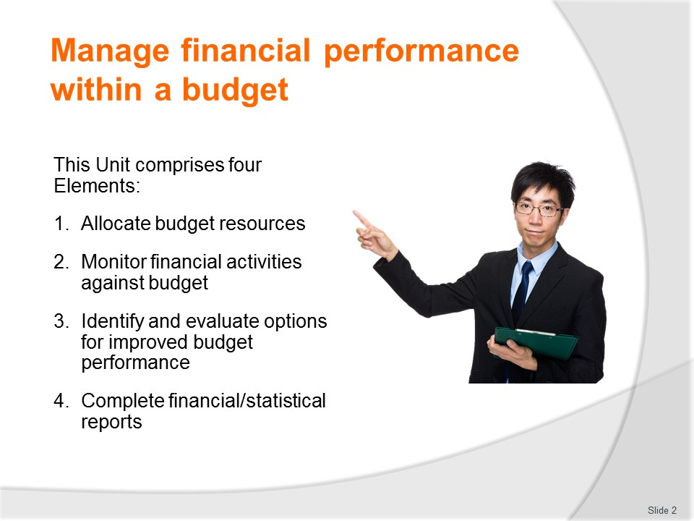
Slide No | Trainer Notes
Trainer advises trainees this Unit comprises four Elements, as listed on the slide explaining:
- Each Element comprises a number of Performance Criteria which will be identified throughout the class and explained in detail
- Trainees can obtain more detail from their Trainee Manual
- At times the course presents advice and information about various protocols but where their workplace requirements differ to what is presented, the workplace practices and standards, as well as policies and procedures must be observed.

Slide

Slide No | Trainer Notes
Trainer advises trainees that assessment for this Unit may take several forms, all of which are aimed at verifying they have achieved competency for the Unit as required.
Trainer indicates to trainees the methods of assessment that will be applied to them for this Unit.

Slide
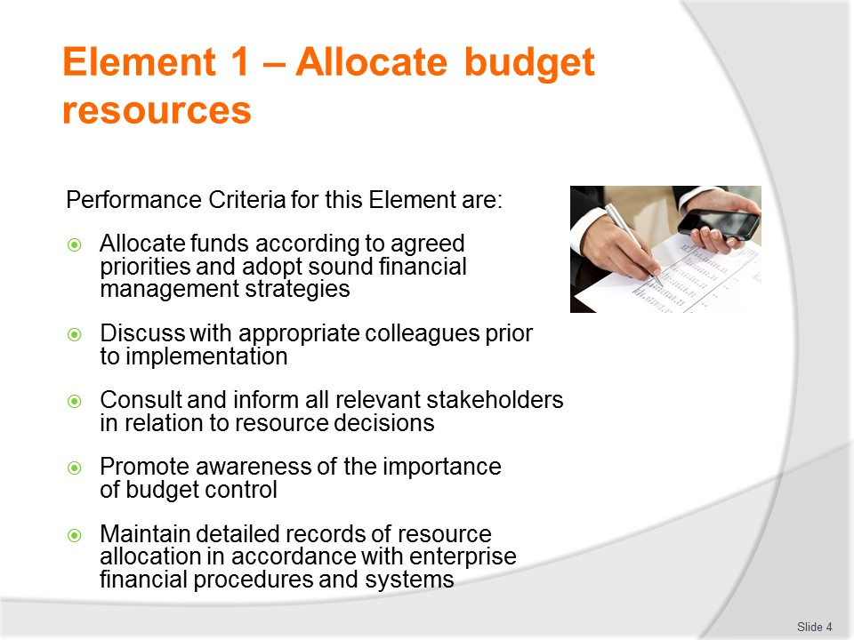
Slide No | Trainer Notes
Trainer identifies for trainees the Performance Criteria for this Element, as listed on the slide.
Class Activity – General Discussion
Trainer leads a general class discussion by asking questions such as:
- What is a budget?
- What are budgets used for?
- What types of budgets are there?
- What experience have you had of working with budgets?

Slide
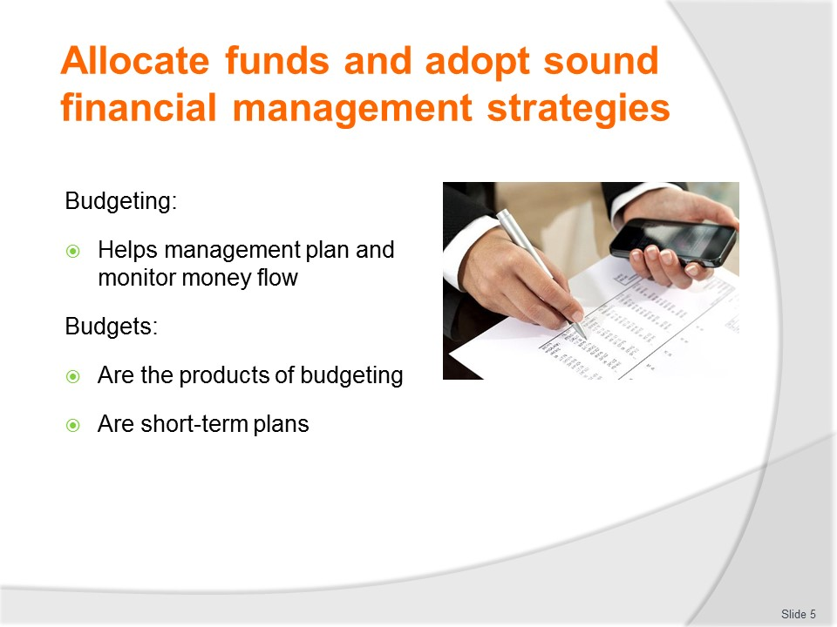
Slide No | Trainer Notes
Trainer introduces budgets and budgeting stating:
- One of the tools that assists owners and managers of a business to plan and monitor the flow of money through their business is a good budgeting system.
- The product of this system is a document called a budget. They are expressed in:
- Monetary terms
- In terms of quantities such as number of customers to be served per day, number of tickets sold or the number of clients on a tour.
- The plan or budget should help managers monitor the performance of the business.
- Budgets are short-term plans of up to one year.
- Plans for the longer term are not usually made into budgets because there are so many unknown factors as the term grows longer that putting precise quantity or monetary values on plans becomes difficult.
- Long-term plans are usually more about decisions to take on new kinds of business and other such major changes in business direction.

Slide
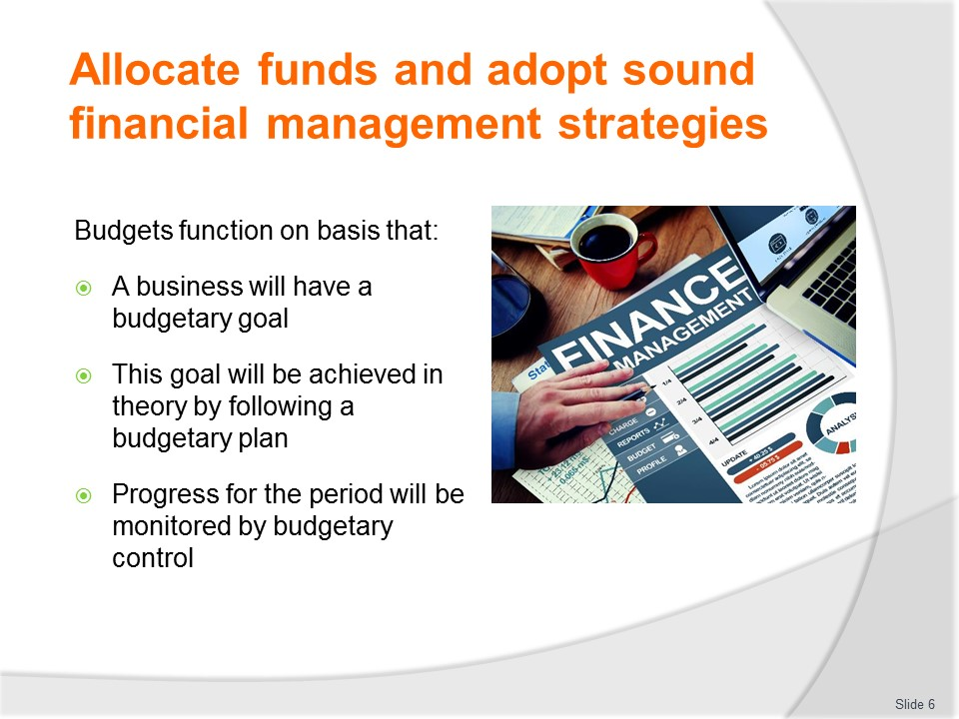
Slide No | Trainer Notes
Trainer explains the basis for budgets stating they function on the basis that:
- A business will have a budgetary goal – that is, what it wants to achieve in terms of a financial outcome for the period in question
- This goal will be achieved in theory by following a budgetary plan – that is, a forecast of what income and expenditures are expected for the period
- Progress for the period will be monitored by budgetary control – that is, on–going comparisons between predicted and actual figures, combined with action to rectify variances.
- In essence, a budget can be seen as a guide, a map of the upcoming period in a financial sense.

Slide
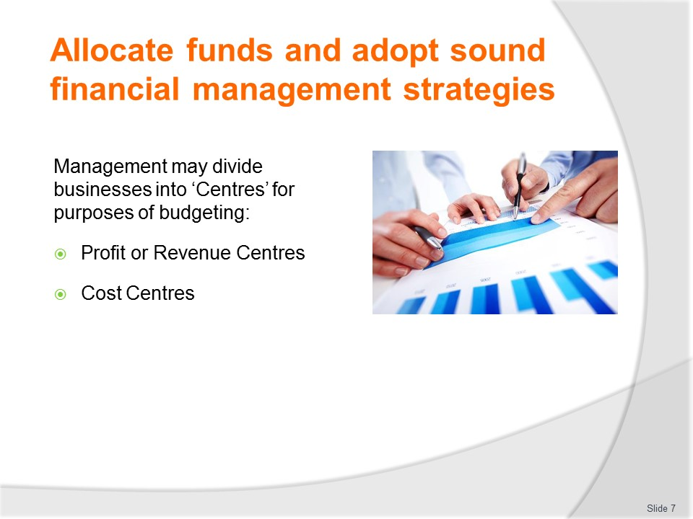
Slide No | Trainer Notes
Trainer introduces concept of Centres, stating:
- For a small business, there is usually one budget showing the planned revenue and expenses for the whole operation
- For a larger business, budgets can be compiled a number of different ways
- Managers can find it useful to divide the business into segments or activity centres of two types.
Profit Centre
One approach is the use of Profit Centres.
These are parts of a business selling goods or services to customers and also incurring expenses.
Part of the planning and managing the financial performance is about how to make each profit centre earn a profit/maximise its profit.
The rooms area of a hotel, the dining room, conference centre, bars and gymnasium could all be Profit Centres.
Cost Centres
The other type of segment/the other approach is the Cost Centre approach.
These are parts of a business which do not sell anything but nonetheless incur expenses.
Planning and managing the financial performance in this context is about managing expenses.
Examples of cost centres are Finance and Marketing departments.

Slide
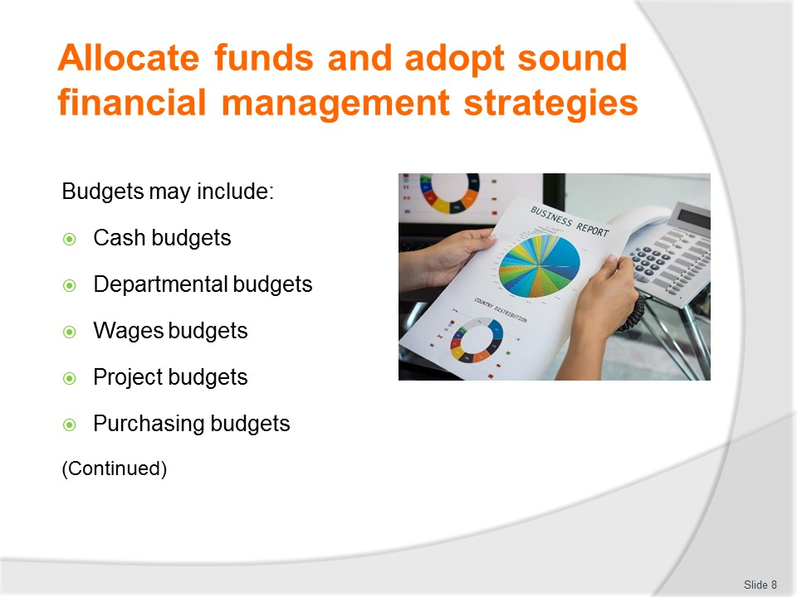
Slide No | Trainer Notes
Trainer identifies and describes various budgets which may be used:
- Cash budgets – concerns the estimated cash inflow, cash outflow and cash position of a business
- Departmental budgets – budgets established for specific departments as named by the budget title
- Wages budgets – to forecast labour expenses
- Project budget – developed to accommodate the needs of specific event/project
- Purchasing/purchases (or ‘Materials’) budget – to address inventory required for a period in order to attain a nominated outcome or sales figure/outcome (such as buying the raw materials or products required to prepare a finished product/saleable item)
Class Activity – Handouts
Trainer distributes and discusses sample budgets as identified on slide.

Slide
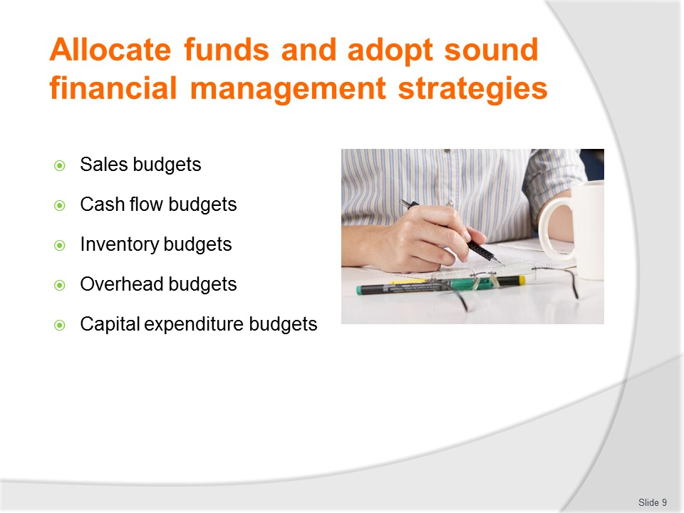
Slide No | Trainer Notes
Trainer continues identifying and describing various budgets which may be used:
- Sales budgets – to forecast sales revenue
- Cash flow budgets – showing actual cash coming in to the business and flowing out from the business for the budget period
- Inventory budget – planning quantities to be held in stock, and the amount of money invested in stock
- Overhead budgets – concerns other estimated operating expenses (such as rent, rates and other direct costs except goods/materials and labour
- Capital Expenditure budgets – plans for long-term assets to be purchased, replaced, upgraded
Class Activity – Handouts
Trainer distributes and discusses sample budgets as identified on slide.

Slide
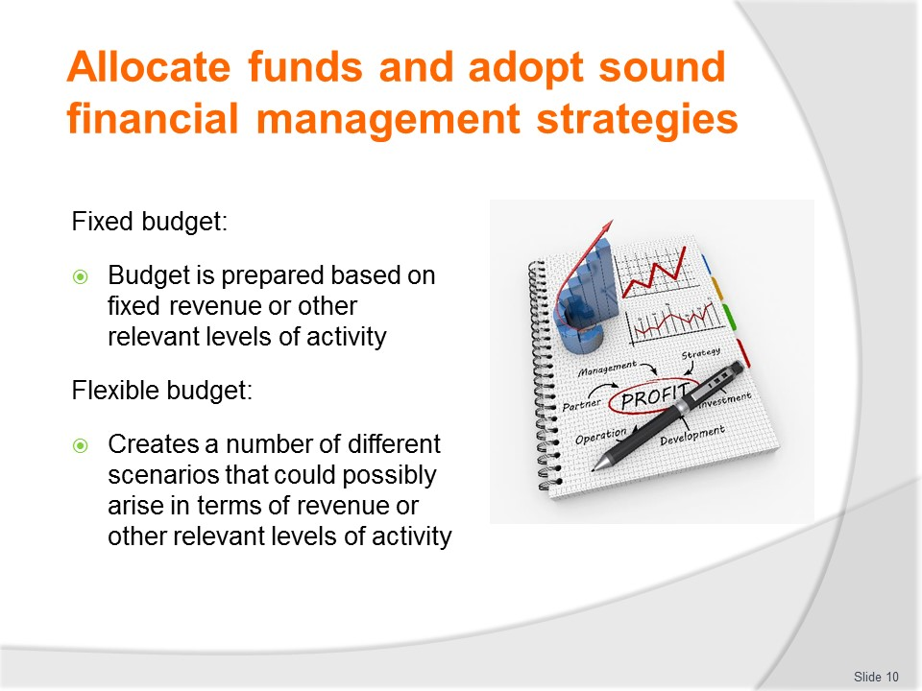
Slide No | Trainer Notes
Trainer introduces concept of Fixed and Flexible budgets stating:
Fixed budget
- A fixed budget is one where the budget is prepared based on fixed revenue or other relevant levels of activity
- The budget does not look at any variations that might occur in trade (that is, increases or decreases in revenue or levels of activity) – the budget is prepared based only on one set of possibilities
- This type of budget is an alternative to the ‘Flexible budget’ below.
Flexible budget
- The advent of computer programmes to assist in budgeting processes has seen an increase in the incidence of these budgets
- A flexible budget creates a number of different scenarios that could possibly arise in terms of revenue or other relevant levels of activity
- For example, the dining room may create a flexible budget based on different projections for patronage at, say, 50% of seats sold (given that we know the average sale per patron), 60%, 70%.
Class Activity – Handouts
Trainer distributes and discusses sample budgets as identified on slide.

Slide
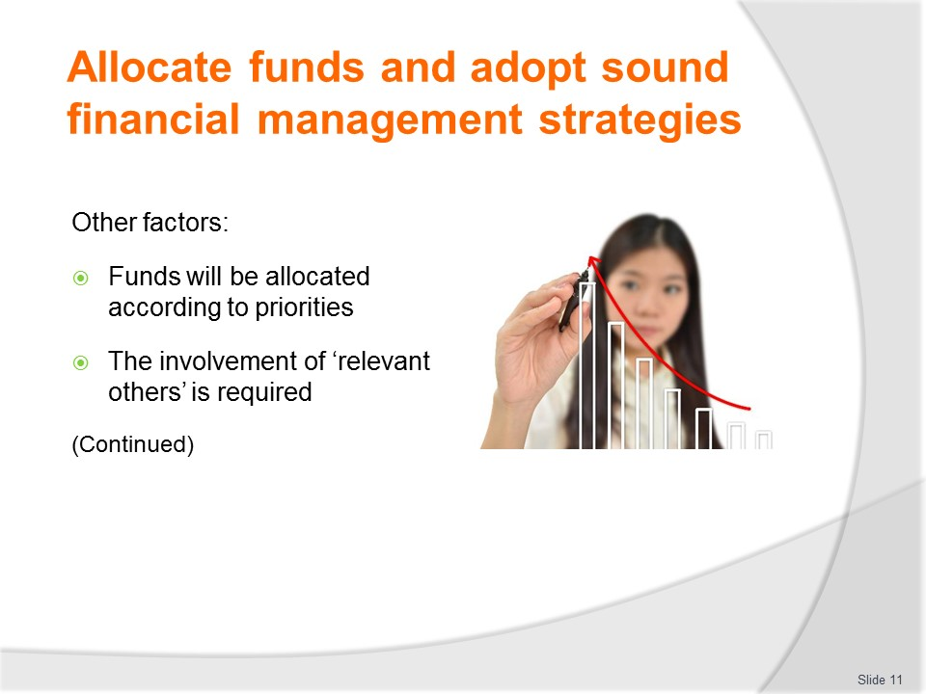
Slide No | Trainer Notes
Trainer discusses other factors implicit in allocating funds to budgets highlighting:
Priorities
- Every organisation will have different priorities for its allocation of funds – and these allocations/priorities will even change within the organisation over time
- It is traditional for the objectives and plans businesses have set for themselves to guide this resource allocation: the objectives and plans deemed to be most important will attract a higher level of funding than lesser ones
- Nonetheless, areas where the premises are required to adhere to various legal requirements (such as safety and other compliance issues/demands from government authorities) will also be allocated sufficient funding to achieve compliance
- These requirements are absolutely necessary for the operation of the business and may well take a large part of available funding: the point being these necessities reduce the amount of discretionary funding available for distribution elsewhere/to other budgets
Involvement of relevant others
May include input from:
- Departments
- A budget committee
- Head office
- Owner
- Senior management
More on this on following slides.

Slide
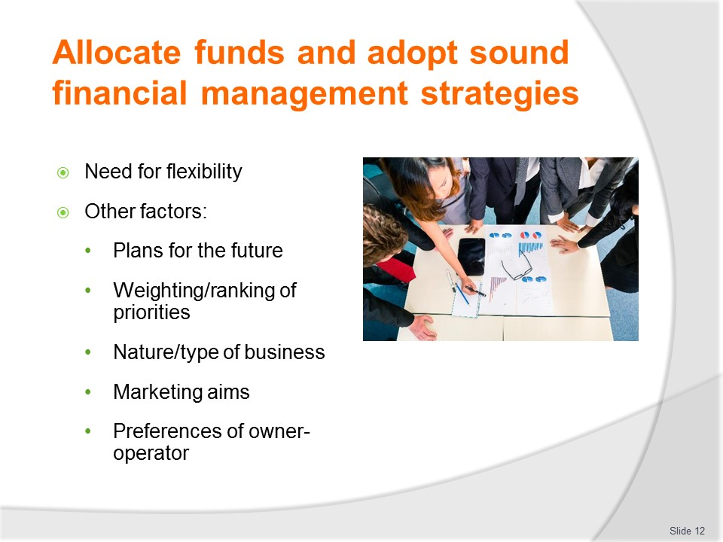
Slide No | Trainer Notes
Trainer continues discussing other factors implicit in allocating funds to budgets highlighting:
Need for flexibility
Plans of the organisation must be set 'in jelly', and not 'in concrete' in order to allow the operation to respond as required to the dynamic environment in which all businesses function.
The same applies to budgets.
Changes in legislation, world events, markets, supplies/suppliers, as well as demands from government authorities may individually, or in combination, cause such a situation.
Other factors
- Projected future plans, activities and directions of the business and of each component department – there may at certain times be a change of organisational (or departmental direction)
- This change may involve a new target market for a department or perhaps the business has decided to reorient its overall image to attract a different demographic/customer profile
- Priority ranking – using a process of negotiation and consultation at the budget meetings it is to be expected reasonable adults can eventually agree on a set of establishment-wide priorities for budget allocations to benefit the entire organisation
- By using reasoned argument, and with reference to valid data, those involved in determining resource allocations should be able to agree on the way resources are allocated
- Nature of the individual business/department(s) – precise budget allocations are, regardless of anything else, going to be influenced by characteristics such as size of businesses/departments (traditionally the bigger departments tend to be allocated an increasingly large proportion of the cake – size can also be based on number of staff, revenue generated, customers serviced)
- Specified marketing aims – while it is a given organisations seek to create a return on investment there will be times when profit is not the aim of certain activities for a given period
- At some stage it may be the case an operation (or a department within an operation) seeks to achieve a goal which is not (at least in the short term) profit related
- It may be the case management is determined to raise their profile, carve out a revised market niche, or attract a fresh market segment – in order to achieve this aim, extra funding may be allocated with no immediate expectation of increasing profit, or of even returning any profit
- The intention may be this short-term loss (or break-even) will be replaced by a substantial and long-term profit
- "I have the power and I call the shots" – in the same way owner–operators may unilaterally determine budget allocations regardless of petitions made to them by staff or departments, some managers will also be single–minded in resource allocation
- This approach may be based on their years of experience in the industry, a qualification they have earned, or on simple gut feel – in many cases their thinking may be "it's my neck that's on the line, so I'm the one who'll make the decisions!"

Slide
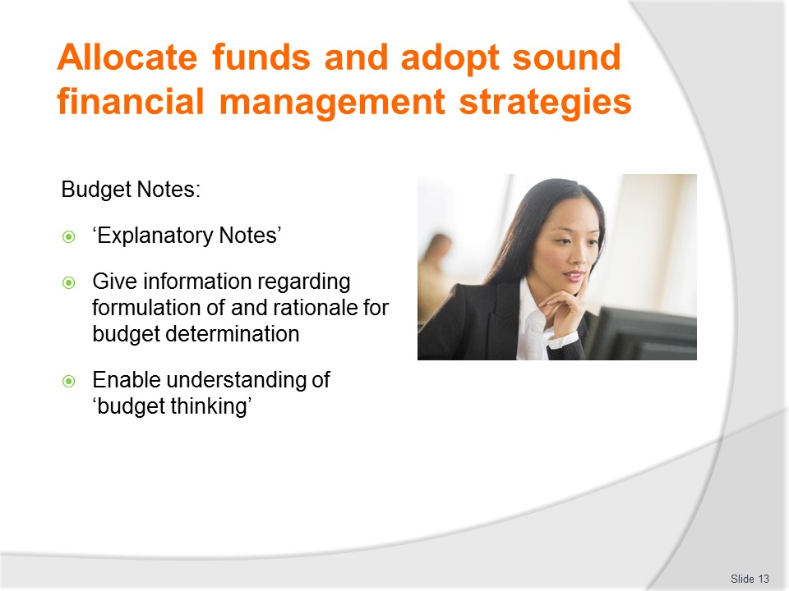
Slide No | Trainer Notes
Trainer discusses Budget Notes stating:
- Many budgets (which are statistical in nature) will have written notes attached to them
- These notes may be called ‘Explanatory notes’ or simply ‘Budget notes’
- Where they are used, they comprise numerous relatively short notes for (nearly) every budget figure
- They function to tell the reader how the figures listed in the budget were arrived at
- They explain the thinking of the person(s) who set the budget at the outset, and present the rationale behind the budget decisions/figures that were finally utilised
- This means they will not only state the expected increases or falls in certain areas, but explain why they think this will occur
- The notes assist understanding of the overall budget by including the thought processes that underpinned the decision making at the time: their inclusion is beneficial as it gives the raw statistics a basis in real life, and demonstrates how the stated expectations were arrived at.
Class Activity – Handouts
Trainer distributes and discusses sample Budget Notes.

Slide
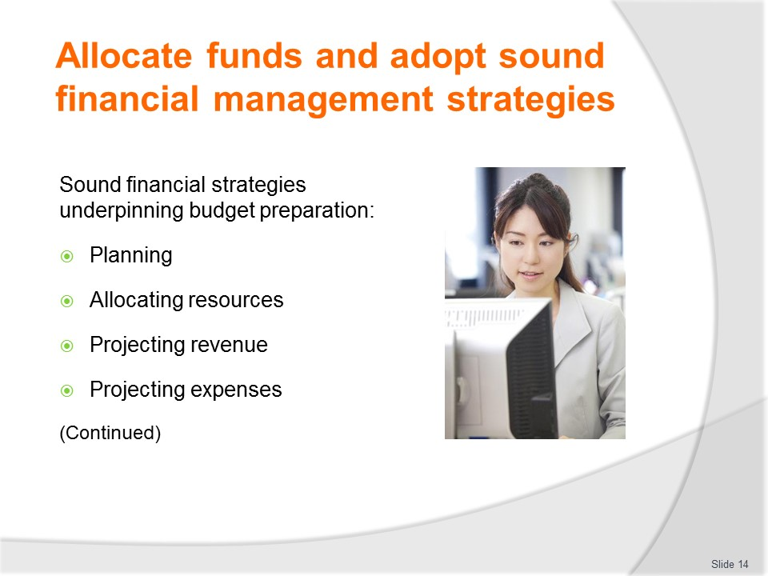
Slide No | Trainer Notes
Trainer states businesses must operate using sound financial strategies explaining strategies inherent in the budget process may be seen as comprising the following steps/stages:
- Planning – relating to the development of written plans with goals, objectives and KPIs to identify what the business wants to achieve and identify what it must consider
- Allocating resources– relating to allocating physical resources and funding to identified objectives for the business to enable attainment of the agreed plans
- Projecting revenue – forecasting sales in each identified revenue category for the business
- Projecting expenses – in relation to projected sales and identified other costs expected during the budget period.

Slide
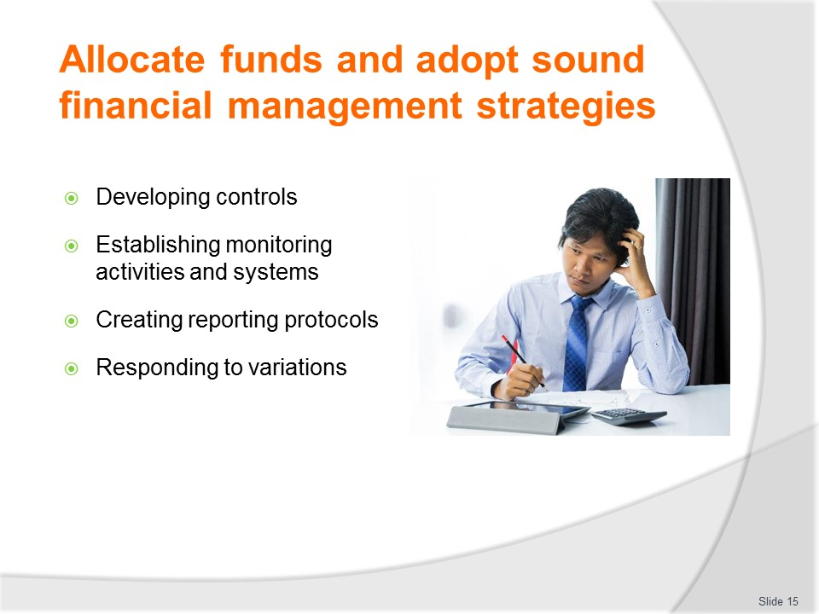
Slide No | Trainer Notes
Trainer continues identifying and explaining sound financial strategies relating to budgeting;
- Developing controls – for implementation of budgets such as creation of budget lines, determination of ‘red flags’ for variances and protocols for obtaining/releasing money and safe-guarding/banking money
- Establishing monitoring activities and systems – to enable tracking and analysis of income and expenditure against budgets/targets
- Creating reporting protocols – such as identifying depth, regularity and nature of reports to share and communicate progress of budgets and the valuation of ‘actual’ against ‘projected’ figures
- Responding to variations – when unacceptable issues are identified in order to retrieve ‘out of control’ situations or take other appropriate remedial action, and taking other actions to optimise and/or extend positive/acceptable results.
Classroom Activity – Internet research
Trainer facilitates student internet research into relevant websites such as:
http://www.accountantnextdoor.com/budgeting-and-budgetary-processes/
http://accounting-financial-tax.com/2009/02/essential-five-steps-on-budgeting-process/

Slide
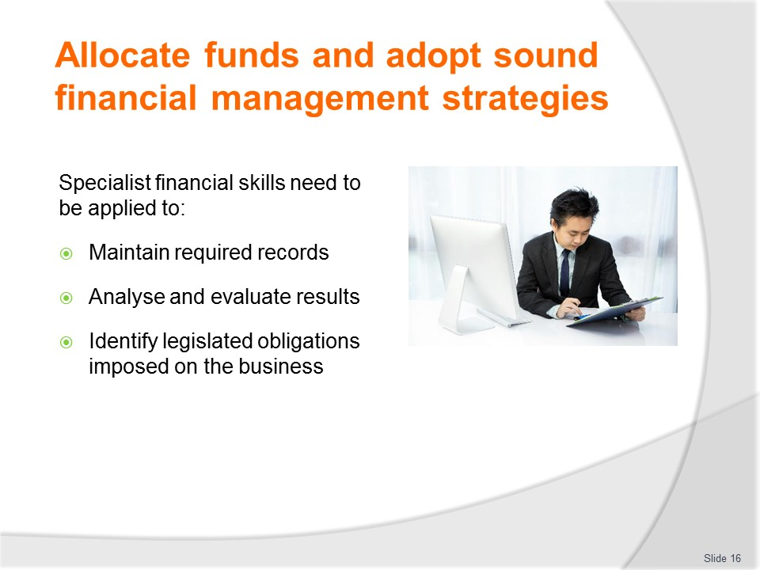
Slide No | Trainer Notes
Trainer states it is always recommended the business utilise specialist financial skills explaining this is necessary to:
- Maintain suitable/necessary financial records
- Analyse results/outcomes and compare them to projections
- Identify and advise the business in relation to relevant legal and taxation obligations.

Slide
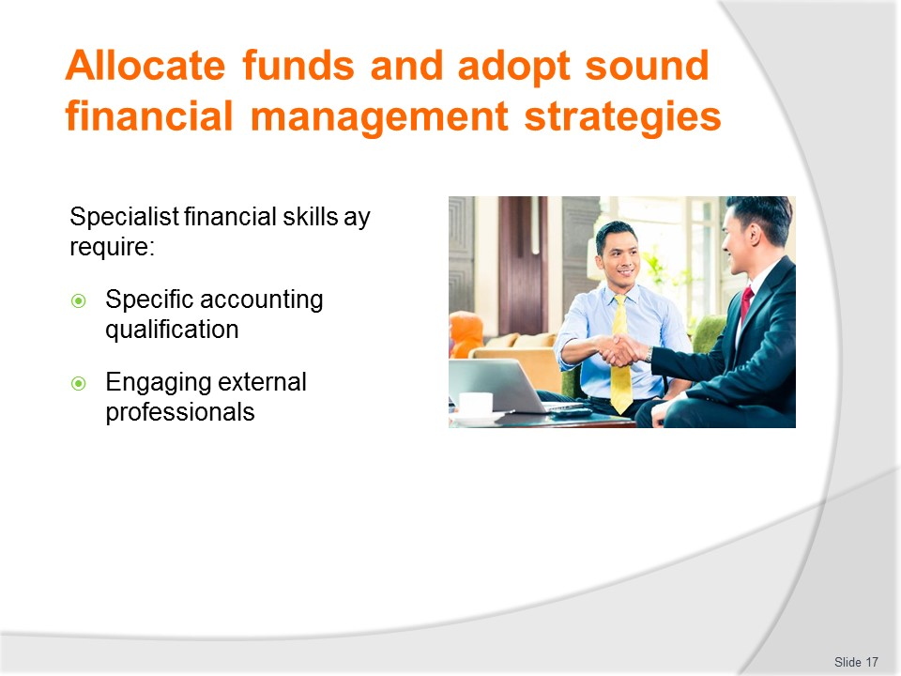
Slide No | Trainer Notes
Trainer explains specialist financial skills may require:
- Studying a specific accounting/financial qualification – as distinct to this generalist unit
- Engaging the services of a paid external professional organisation – preferably with demonstrated experience in a relevant industry type/sector.
Class Activity – Guest Speaker
Trainer arranges for professional accountant to attend and describe the services they can provide for businesses.

Slide
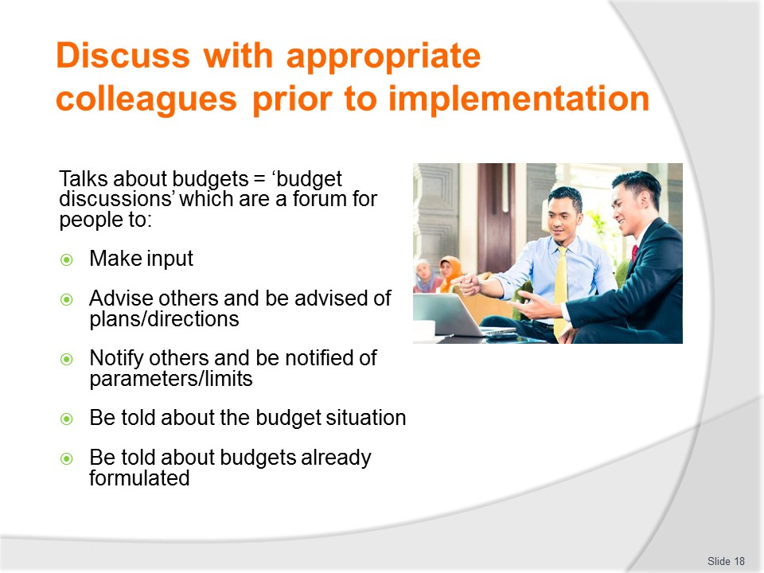
Slide No | Trainer Notes
Trainer advises talks regarding budgets are referred to as ‘budget discussions’ and they are essentially a forum for relevant people (see next slides) to:
- Make input into budget decisions – by presenting their thoughts and concerns about certain issues which will, or are likely to, affect the business
- Advise people and be advised of new/revised plans/directions – which will impact the business
- Notify people and be notified of parameters and restrictions impacting on thoughts and operations
- Be told what the budget situation is – in general terms and with respect to individual budgets
- Be told of the budgets which have been formulated – and/or approved by those responsible for budget preparations.

Slide
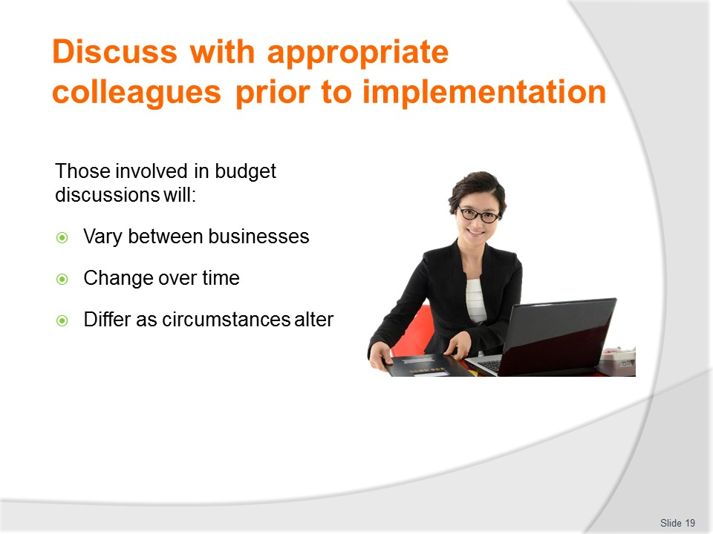
Slide No | Trainer Notes
Trainer informs about people involved in budget discussions:
- Personnel involved in budget discussions will very between organisations, and are likely to alter over time/as different circumstances change
- Those on following slides are indicative of what may apply.

Slide
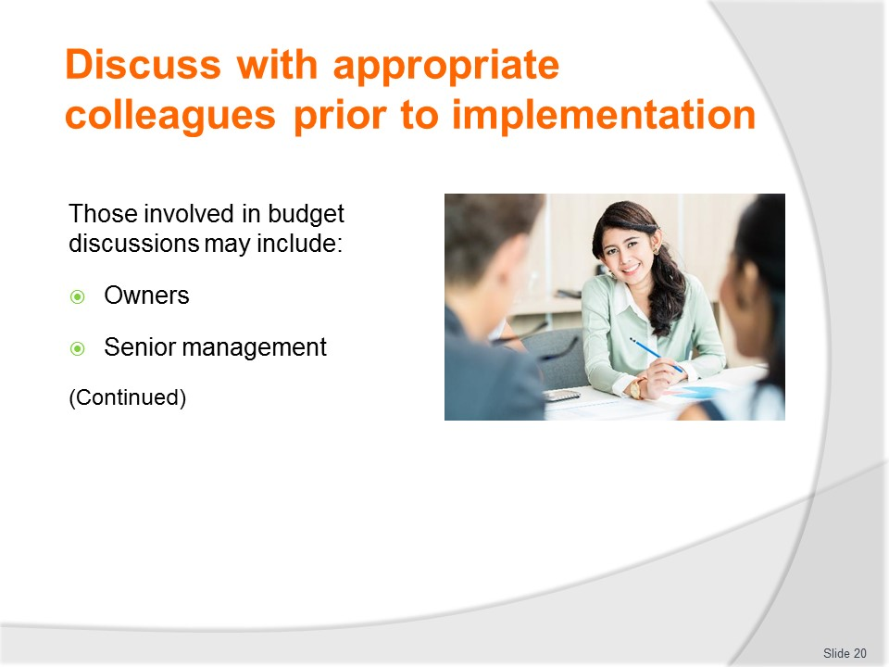
Slide No | Trainer Notes
Trainer advises of those involved in budget discussions and their role/s identifying:
Owners and senior management
The owner/s and/or senior management will always be at these meetings because:
- It is their money/business and they have responsibility for it
- They may have knowledge about the business and its future proposed direction/s which will dramatically impact on resource allocation and the spending of money – for example they may have ‘inside information’ about:
- Changes in direction of the business
- Strategic plans for the business
- Movements into or out of certain target markets
- Building new relationships with other businesses – such as mergers, agencies, franchises or joint ventures.
Class Activity – Guest Speaker
Trainer arranges for business owner and/or senior manager to attend and describe their role at budget discussions.

Slide
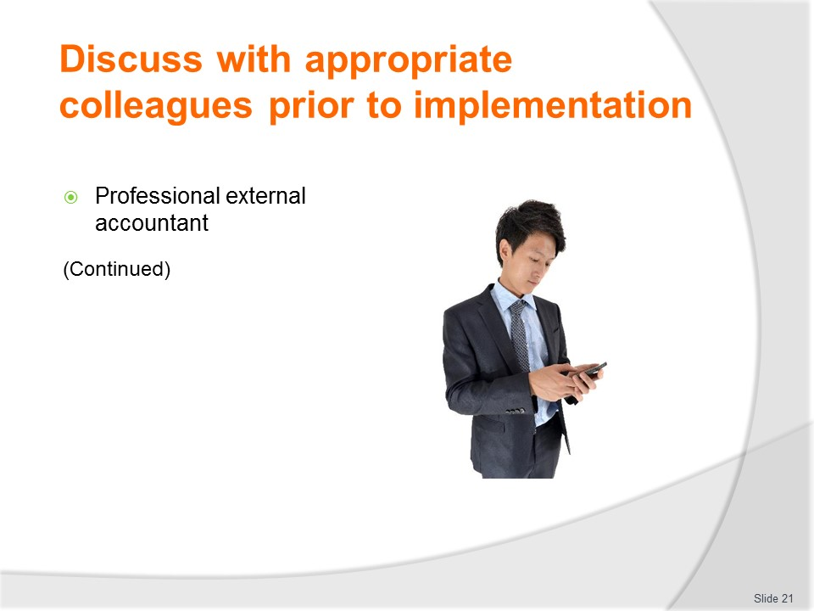
Slide No | Trainer Notes
Trainer continues advising of those involved in budget discussions and their role/s identifying:
Accountants
They are commonly involved because:
- They can bring their knowledge of the previous trading periods and financial results to the table
- They are also able to contribute suggestions relating to accounting issues such as:
- The types of budget and financial reports to be prepared
- The nature of the accounting process and internal requirements relating to compliance with both legally imposed, and internally required, obligations
- Acceptable ways to structure budgets.
Class Activity – Guest Speaker
Trainer arranges for accountant to attend and describe their role at budget discussions.

Slide
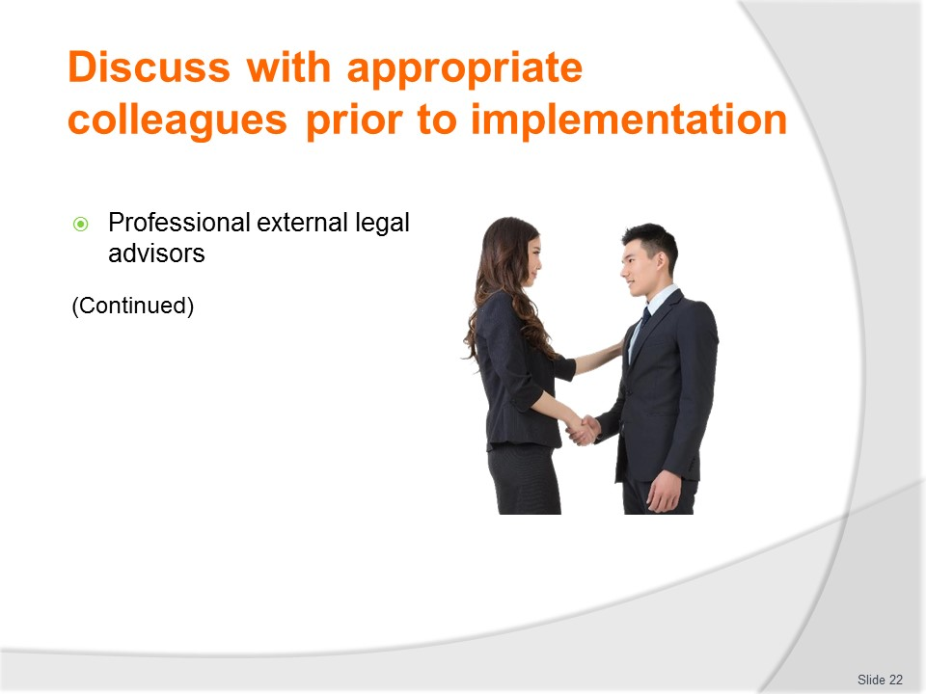
Slide No | Trainer Notes
Trainer continues advising of those involved in budget discussions and their role/s identifying:
Legal advisors
Legal advisors are not always present at budget meeting/discussions.
They tend to be contacted/involved only when an issue arises where it is believed legal input or advice is necessary.
They can advise on financial aspects such as:
- Legal responsibilities relating to reporting, record keeping and general compliance
- The legality of proposed plans to determine whether or not they breach legislated requirements
- Issues such as legal tax minimisation (in conjunction with financial advisors and accountants).
Class Activity – Guest Speaker
Trainer arranges for a legal advisor/professional to attend and describe their role at budget discussions.

Slide
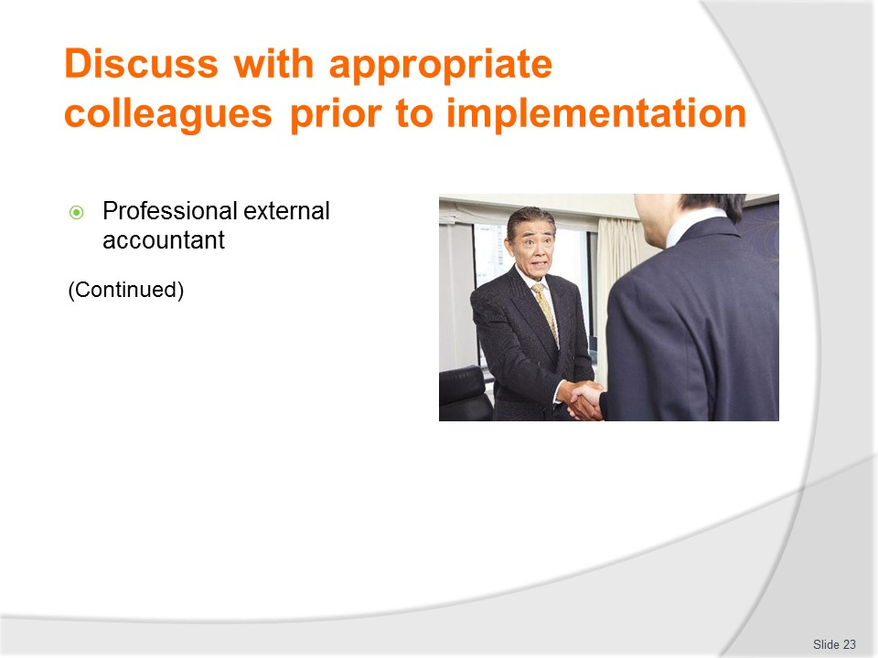
Slide No | Trainer Notes
Trainer continues advising of those involved in budget discussions and their role/s identifying:
Bankers
Again, bankers are not always present at these meetings.
Where the business is seeking a loan, or has an existing loan it needs to service, there may be a requirement the banking institution involved be included in budget discussions.
Bankers can:
- Provide advice regarding loan alternatives
- Provide investment advice for surpluses
- Give an insight (without naming names/businesses) into the financial performance and arrangements of similar other businesses for the purpose of comparison.
Class Activity – Guest Speaker
Trainer arranges for banker/person from a financial institution to attend and describe their role at budget discussions.

Slide
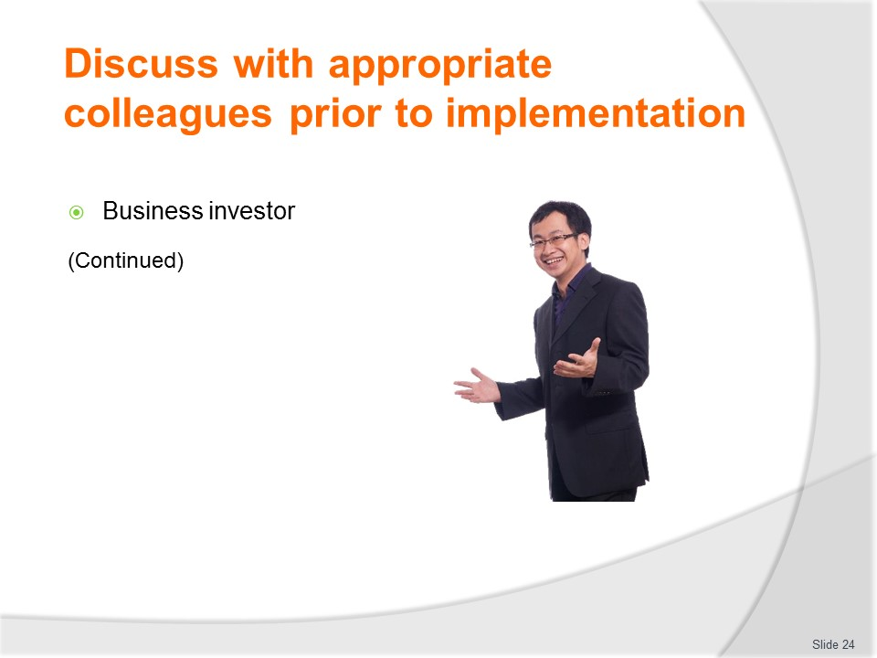
Slide No | Trainer Notes
Trainer continues advising of those involved in budget discussions and their role/s identifying:
Investors
Where the business has shareholders there may also be a need for those shareholders (or certain of them, or their representatives) to be present to make budget input.
Shareholders/investors who are entitled to attend this meeting may make comment on any aspect of the budget process but seem commonly interested in only two things:
- The amount of money being paid to management
- The return they can expect on their investment.
Class Activity – Guest Speaker
Trainer arranges for business investor to attend and describe their role at budget discussions.

Slide
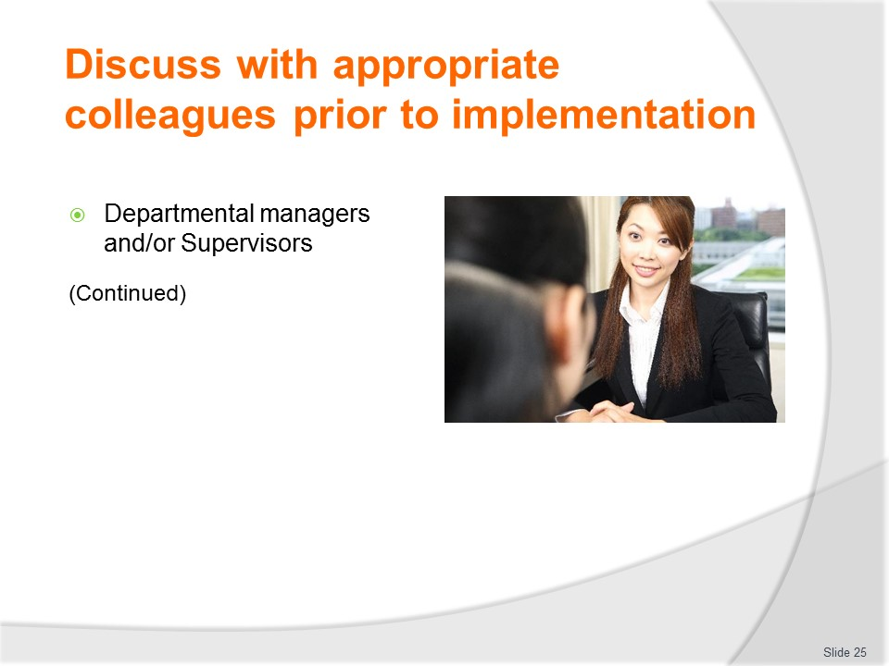
Slide No | Trainer Notes
Trainer continues advising of those involved in budget discussions and their role/s identifying:
Department managers and supervisors
For departments (managers and supervisors), participation in making input to the budget process in incredibly vital because it has the potential to have tremendous on-going impact on the running of their department, section or area in terms of:
- Funding allocation – this is (usually) the amount of money the department is allowed to spend as allocated by their various budgets and budget lines
- As a general rule most supervisors prefer to have a bigger expenditure budget than a smaller one however many expenditure budgets are calculated as a set percentage of expected/projected income/revenue figures
- Where ‘project work’ is being undertaken (such as the refurbishing of guest rooms) it is common for a nominated amount to be allocated independent of revenue projections
- Revenue targets – the budget process will need to determine potential revenue for each revenue-generating centre
- Supervisors will commonly strive to keep this ‘projected revenue’ figure as small as possible to make it easier to hit their targets (being able to attain the ‘projected’ revenue figure may be a KPI) which, in turn, can have implications for the promotion undertaken by the business, continued employment (job security for employees) and their own annual bonuses.
Class Activity – Guest Speaker
Trainer arranges for relevant Department Manager or Supervisor to attend and describe their role at budget discussions.

Slide

Slide No | Trainer Notes
Trainer continues advising of those involved in budget discussions and their role/s identifying:
Workers
Some businesses (but certainly not all) include workers in budget discussions.
They may do this to:
- Capture their input and insight – which is regarded as unique and relevant as it is always directly related to business operations
- Make sure they receive first-hand information about how the business is performing – and what it expects into the future.
Class Activity – Guest Speaker
Trainer arranges for an employee who works in a relevant business to attend and describe their role at budget discussions.

Slide
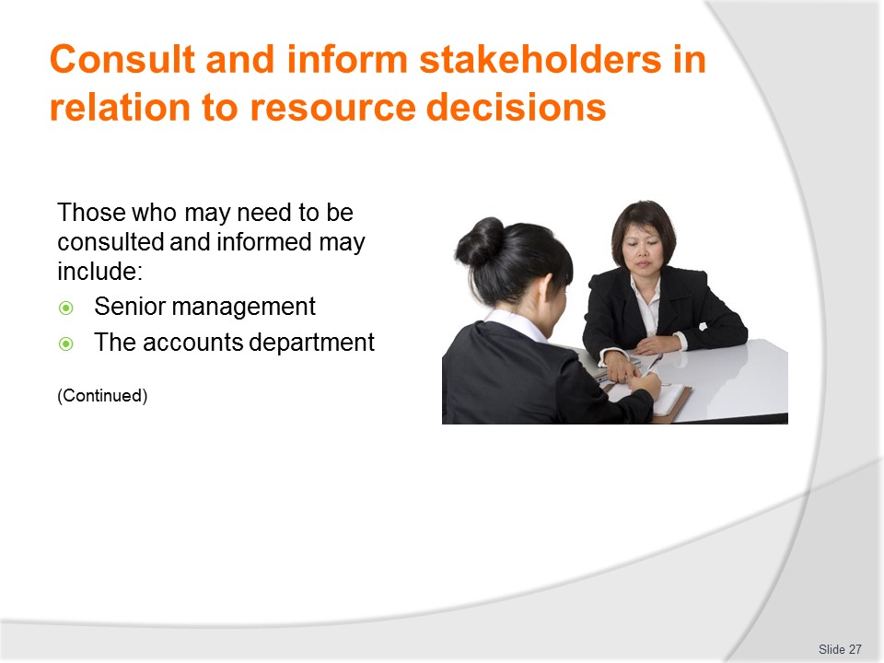
Slide No | Trainer Notes
Trainer advises those who may be informed include:
- Senior management – who are very likely to have been involved in discussions but who will still need to be notified of:
- The final result(s) and the actual figures which have been allocated to individual budgets
- Rationale for decisions made
- The accounts department – so they can:
- Enter the figures into appropriate software
- Create the required budgets
- Generate necessary budget lines and codes.

Slide
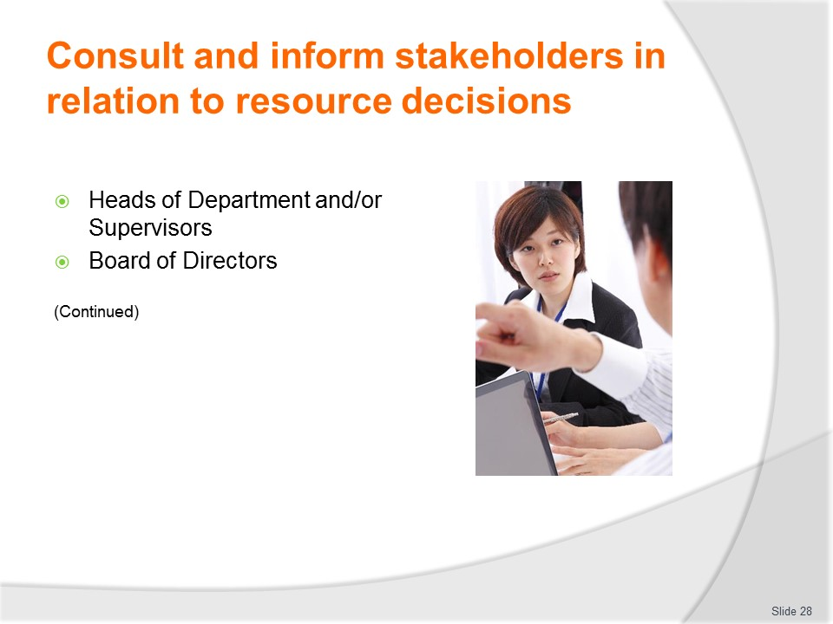
Slide No | Trainer Notes
Trainer continues advising those who may be informed include:
- Heads of Departments and Supervisors – middle-level management commonly have daily control over the revenue raising areas of the property and power over relevant areas of expenditure: it is therefore essential these personnel are informed of decisions
- It is predominantly these individuals who are responsible for generating the bulk of the income, and whose decisions have immense impact on the profitability and viability of the business: while they operate under direction from senior management, they make numerous day-to-day and on-the-spot decisions which have the potential to greatly impact on budget figures
- Board of Directors – not all organisations/businesses have a Board of Directors but where they do there is a need to advise them of the budget allocations to:
- Give them a better understanding of the organisation and its financial parameters and position
- Help compliance with legally imposed fiduciary obligations
- Assist them make business management and/or investment decisions
- Enable them better monitor, analyse and oversee the operation of the business.

Slide
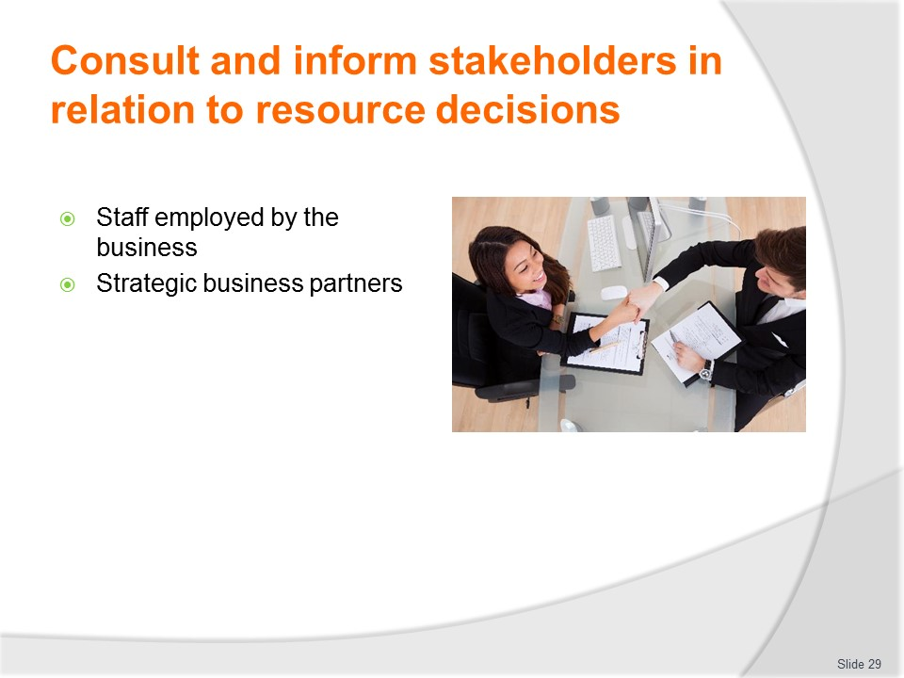
Slide No | Trainer Notes
Trainer continues advising those who may be informed include:
- Establishment staff – it will commonly fall to the head of department to explain the latest budget allocations to departmental staff
- This news is traditionally passed on verbally in a formal departmental meeting – it is not usual to have printed material passed around. The head of department/supervisor commonly sets the scene by explaining the general budgetary context and the trading situation the business finds itself in – general statements are normally used to describe the current situation as it compares to the last period
- Next, further general statements are made about what management expects from the department (and by association, the staff): it is not common to pass on exact monetary figures to the staff as this is usually seen as material which is 'commercial in confidence'
- Staff may thus be told there is an expectation, for example, they are expected to increase revenue in the upcoming 12-month period by an average of 10% over the previous year: this indicates management requirements without disclosing the actual figures involved
- Similarly, staff may be informed, for example, there is an expectation expenses are reduced by 5%
- It is always important to couch this sort of news within a positive context wherever possible to reduce the possibility of staff disillusionment, and the likelihood employees may misinterpret 'economic imperatives' as signalling their job is in jeopardy: when staff pick up this sort of message they commonly start looking for employment elsewhere because they can 'see the writing on the wall'
- Strategic alliance partners – will be informed only in relation to budgets in which they have a contractual or other financial interest.

Slide
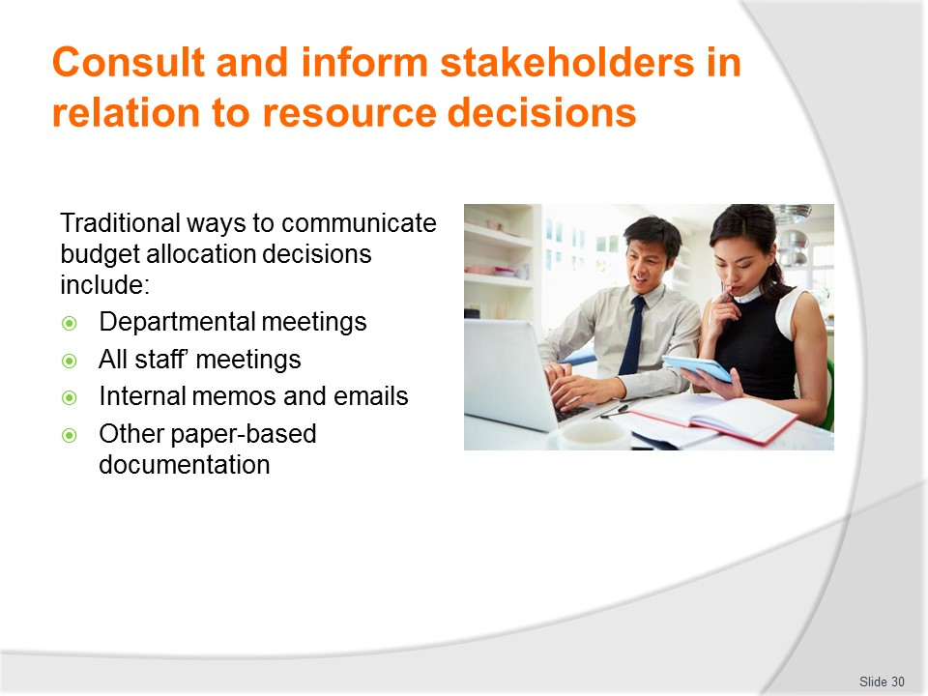
Slide No | Trainer Notes
Trainer states traditional ways to inform those concerned about budget allocations include:
- At departmental meetings – where information is delivered verbally, face-to-face. The information may be shared:
- In a special meeting convened just for this purpose
- As an agenda item within a normal/regular staff meeting
- Through all-staff meetings – where a series of overhead projections (or a PowerPoint presentation) is used to communicate relevant information to workers
- Via internal memos or emails – sent to staff, which should be headed ‘Confidential – Not for Release’ (or similar)
- Using paper-based documentation – outlining, without being too specific, the allocations which have been decided on.

Slide
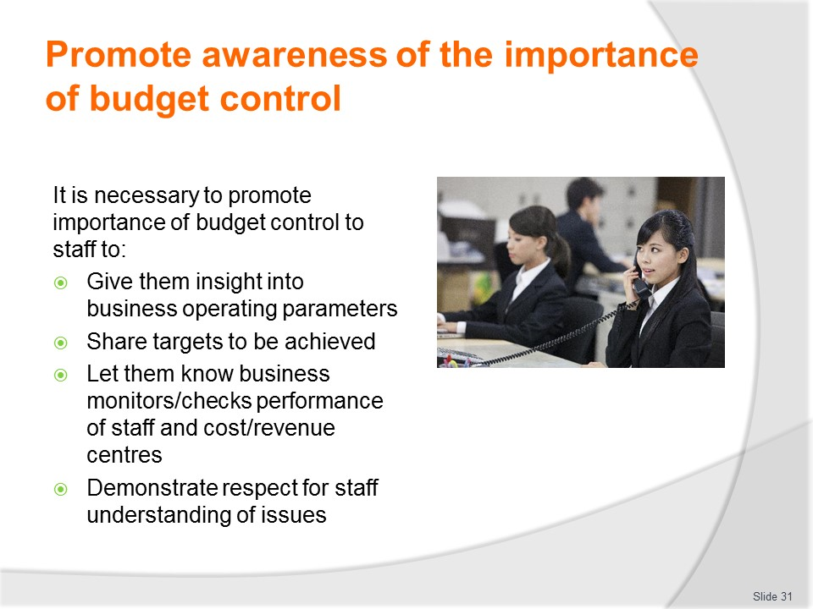
Slide No | Trainer Notes
Trainer explains not all workers know about budgets and not all employees are particularly interested in them so supervisors and managers have a duty/responsibility to educate staff, and to promote an awareness of the importance of budget control highlighting it is necessary to do this in order to:
- Give insight into the operating parameters of the business – it is important staff understand the need to pay attention to budgets and how these impact the work of the business
- Share targets to be achieved – in terms of maximum costs/expenses they need to help control and necessary sales and they need to strive to achieve
- Let them know the business monitors and checks the performance of staff and cost/revenue centres – which helps motivate them
- Demonstrate respect for their understanding of these issues – as this communication implicitly indicates the organisation acknowledges their appreciation of the factors which impact viable business operation.

Slide
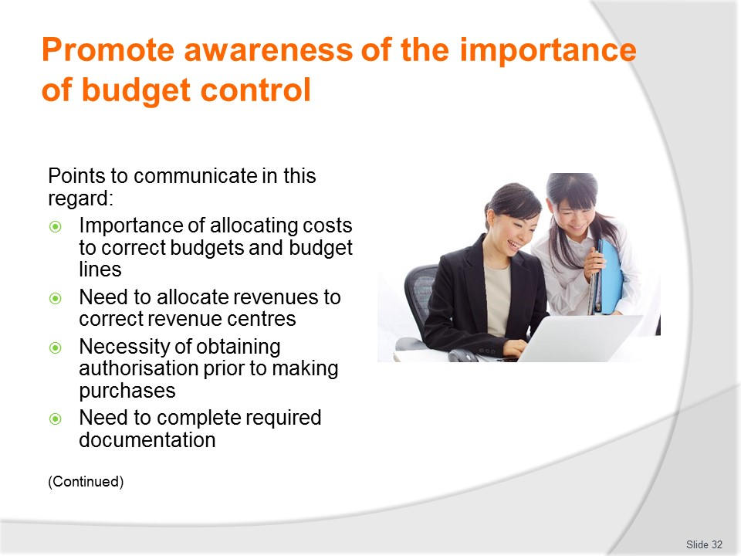
Slide No | Trainer Notes
Trainer notes the following points often need to be communicated to others:
- Importance of allocating costs to correct budgets and budget lines – as per the Schedule of Accounts
- Need to allocate revenues to correct revenue centres – in accordance with correct Schedule of Accounts coding
- Necessity of obtaining authorisation prior to making purchases – in-line with internal protocols
- Need to complete required documentation – to assist in monitoring and tracking.

Slide
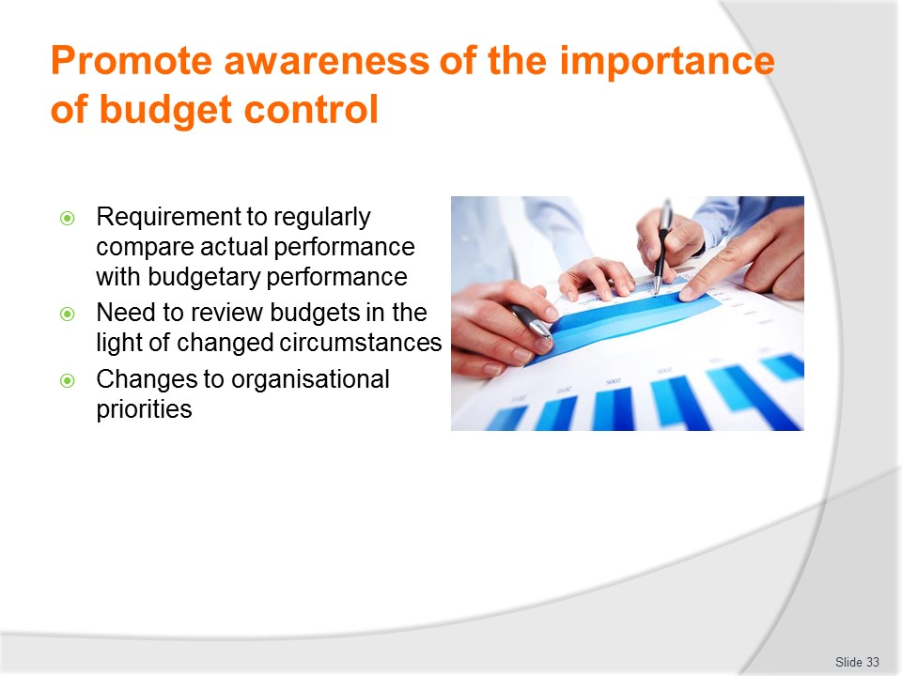
Slide No | Trainer Notes
Trainer continues noting the points which often need to be communicated to others:
- Requirement to regularly compare actual performance with budgetary performance – in order to:
- Maintain awareness of actual business performance
- Promptly identify and rectify posting errors
- Enable appropriate corrective action to be taken at the earliest opportunity
- Need to review budgets in the light of changed circumstances – as this applies in relation to:
- Internal and external causal factors
- Sales and expenditure issues
- Changes to organisational priorities – as these may apply to:
- Plans in relation to business direction, goals and objectives
- Need for increased income
- Need for decreased expenditure
- Need to generate increased trade/turnover regardless of profit outcomes
- Need to respond to opposition activities.

Slide
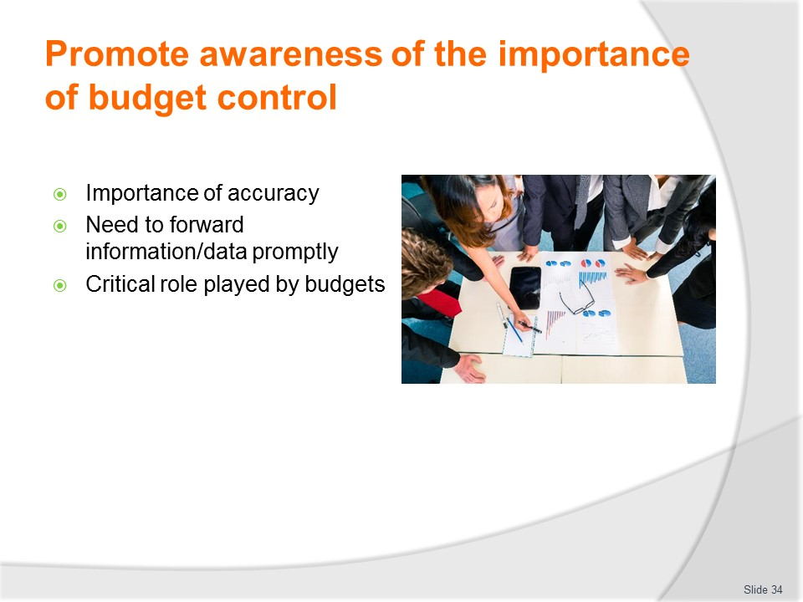
Slide No | Trainer Notes
Trainer continues noting the points which often need to be communicated to others:
- Importance of accuracy – when completing budget-related documentation
- Need to forward information/data promptly – to others and/or administration so they can process it in a timely manner
- Critical role played by budgets – in relation to:
- The overall viability of the business
- Job security
- Growth potential.

Slide
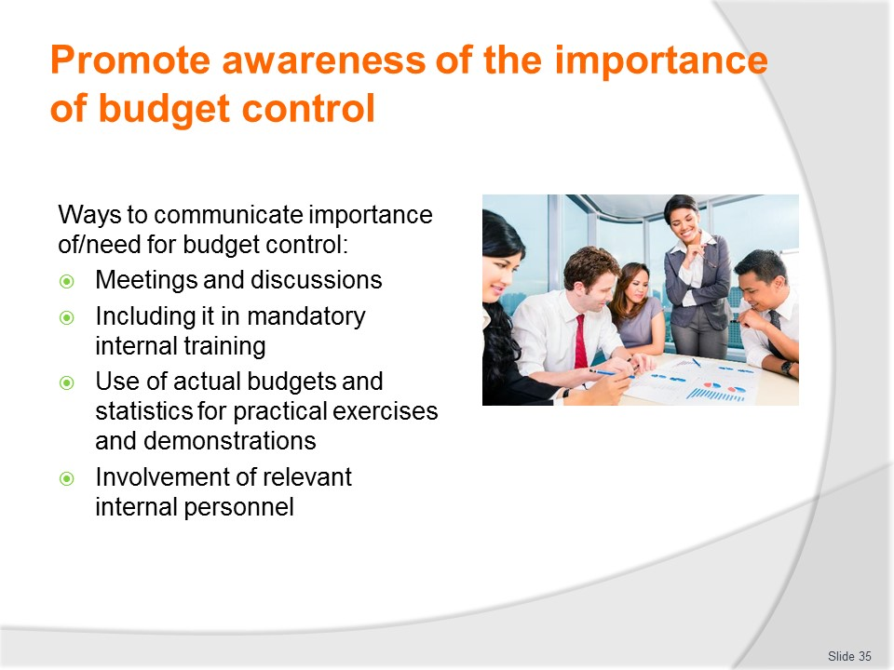
Slide No | Trainer Notes
Trainer states standard ways to communicate need for/importance of budget control include:
- Meetings and discussions – with individual staff and groups of staff at staff meetings and briefings
- As part of standard internal training – with a special focus on budgets/financial matters
- Use of actual budgets and statistics – to:
- Illustrate points
- Make comparisons
- Undertake calculations
- Draw conclusions
- Determine action required
- Discuss outcomes
- Involvement of others – as part of the information/education process, such as inclusion of owners, senior managers and/or specialist accounting staff/personnel.

Slide
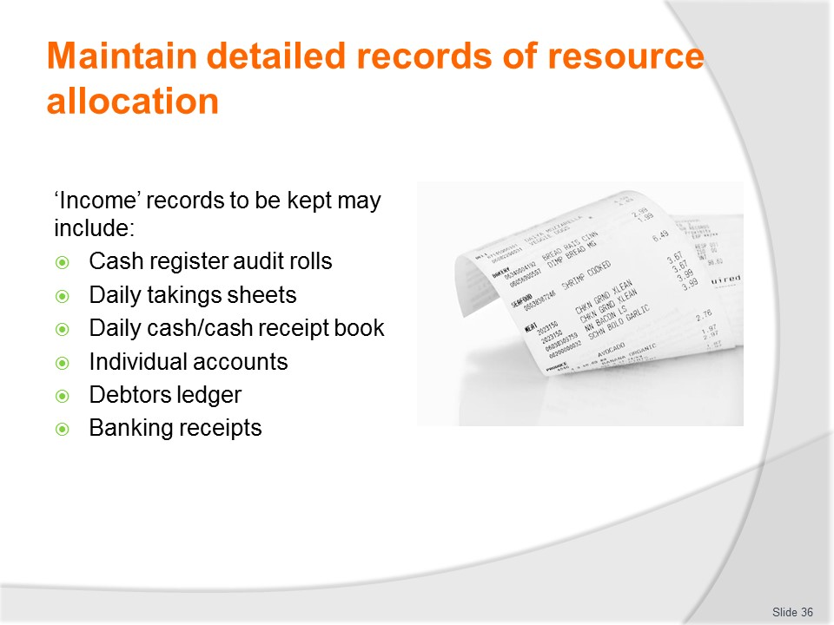
Slide No | Trainer Notes
Trainer identifies income records that need to be kept include:
- Audit rolls – from cash registers as evidence sales occurred, and from which register sales were made and from which department, the income was generated
- Daily takings sheets – these are the sheets completed at the end of each day's trading by those counting the tills, and which show an overview of income on a register-by-register and department-by-department basis
- Daily cash/cash receipt book – a more permanent record of what was contained in the Daily takings sheet together with a record of what debtors have paid to us
- Individual accounts – these may be for in-house guests or they may be for individuals or organisations who use business facilities (such as dining, accommodation, functions, account purchases) and have established credit facilities with the organisation
- Terms of these credit facilities differ, but 7 days nett and 30 days nett are common
- Debtors ledger – this is a breakdown of what each company that deals with the business owes the organisation
- Banking receipts – this is a stamped bank receipt verifying takings were paid into the bank.
Class Activity – Handouts
Trainer distributes and discusses documents/records as identified on the slide.

Slide
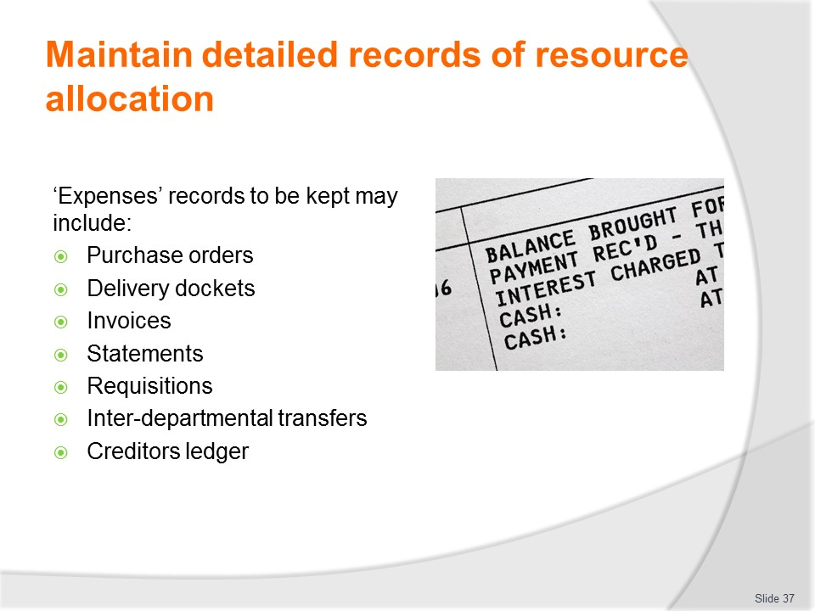
Slide No | Trainer Notes
Trainer identifies expenses records that need to be kept include:
- Purchase Orders – as proof a valid purchase was authorised, and as an initial indication as to which department (and perhaps budget line/code) the purchase was intended for
- Delivery dockets, invoices and statements – these documents demonstrate the goods which were ordered were in fact received, and provide evidence about how much was spent and with whom it was spent
- Requisition sheets – these will prove stock was issued from a central store to a specified department describing the quantity and quality of each item thereby enabling the appropriate amounts to be charged against relevant departments by correct budget line/code
- Interdepartmental transfers – similar to internal requisitions, these documents show stock issued to a certain department has been ‘on-sold’ to another department and must now be charged against them
- Creditors ledger – a detailed explanation of who the business owes money to, and how much.
Class Activity – Handouts
Trainer distributes and discusses documents/records as identified on the slide.

Slide
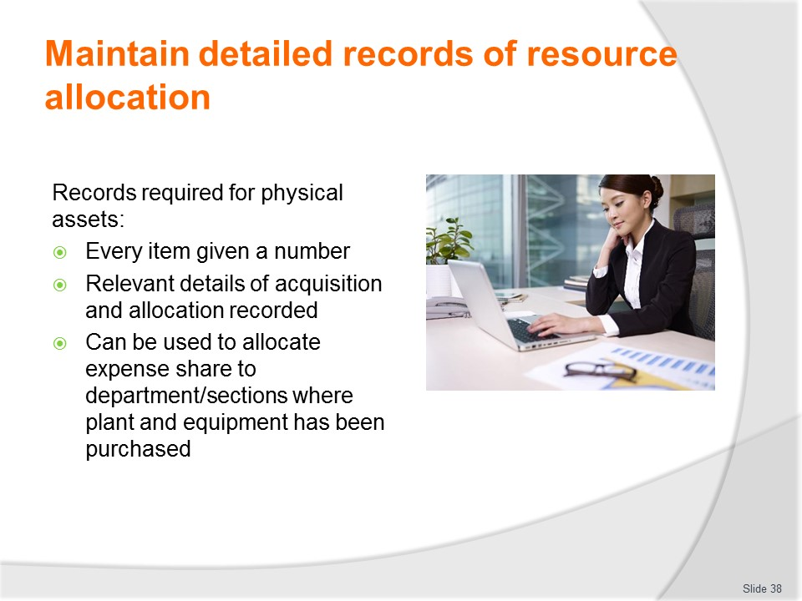
Slide No | Trainer Notes
Trainer discusses physical assets records that need to be kept stating:
- While plant and equipment are obviously not cash, most businesses keep a record of their physical stock in some form of asset register
- Every item of equipment bought is given an identifying number or code and when the item is issued to a department its whereabouts is recorded in the register
- The asset/assets register may also record the date of purchase, the supplier, when warranties/guarantees expire, the price paid, date issued to the department, and may also include details about when the item requires maintenance/service and/or replacement
- These asset registers can also be used to allocate expenses against departments when a purchase has been made, for purposes of calculating depreciation and/or for determining replacement costs.
Class Activity – Handout
Trainer distributes and discusses Asset Register as identified on the slide.

Slide
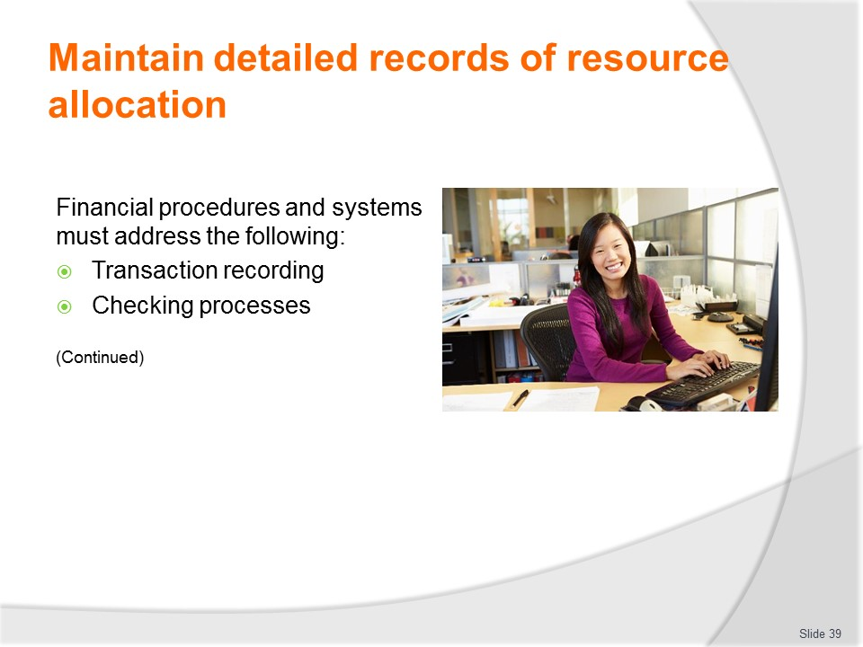
Slide No | Trainer Notes
Trainer explains financial procedures and systems must address the following:
Transaction recording
Requirements in this regard relate to recording sales made and may include:
- Ensuring all incoming money is recorded and receipted
- Identifying forms of accepted methods of payment – and not accepting payment ion other forms
- Ensuring supporting documentation to validate/authorise all expenses paid
- Providing pro forma documentation to support sales and receipts
- Setting maximum limits for spending – for certain staff so expenditure is restricted
- Requiring multiple quotes – for expenditure above a nominated amount
- Appropriate staff training – in transaction recording protocols
- Forwarding all documentation – to nominated persons/departments within designated times.
Checking processes
Requirements in this regard relate to checking of income/revenue and may include:
- Using Daily takings sheets – to record sales on a daily basis
- Reconciling takings – every day when takings are counted and entered on Daily takings sheet
- Recording variances – the unders and overs from each register/POS terminal
- Investigating variances – and reporting/recording findings
- Forwarding supporting reconciliation documentation – with cash/payments received
- Appropriate staff training – in checking and reconciliation protocols.
Class Activity – Demonstration and Exercise
Trainer shows students how to apply/implement the practices identified above and provides an opportunity for them to practice same.

Slide
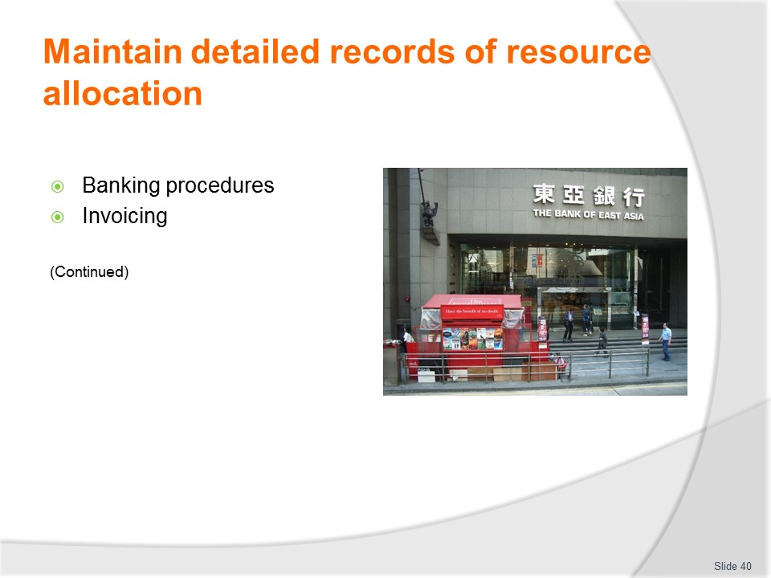
Slide No | Trainer Notes
Trainer continues explaining financial procedures and systems must address the following:
Banking procedures
Requirements in this regard may include:
- Designating banks/branches to be used – for depositing takings
- Implementing security cash pick-ups – when takings are high and/or on days banks are closed
- Developing operational protocols for banking the takings – to be adhered to by staff with responsibility for banking money
- Generating paper-trail of documentation – form sales to banking
- Requiring receipts – for all money banked
- Appropriate staff training – in banking protocols.
Invoicing
Requirements in this regard relate to outgoing invoices and may include:
- Requiring all invoices to be prepared for all sales – as appropriate to the sale type/transaction
- Insisting invoices are prepared at all times- where required
- Checking invoices – to verify correct charges are levied and all legitimate charges are being included
- Processing invoices – within designated timelines
- Forwarding invoices and/or duplicates – to nominated personnel and/or customers
- Appropriate staff training – in invoicing protocols.
Class Activity – Demonstration and Exercise
Trainer shows students how to apply/implement the practices identified above and provides an opportunity for them to practice same.

Slide
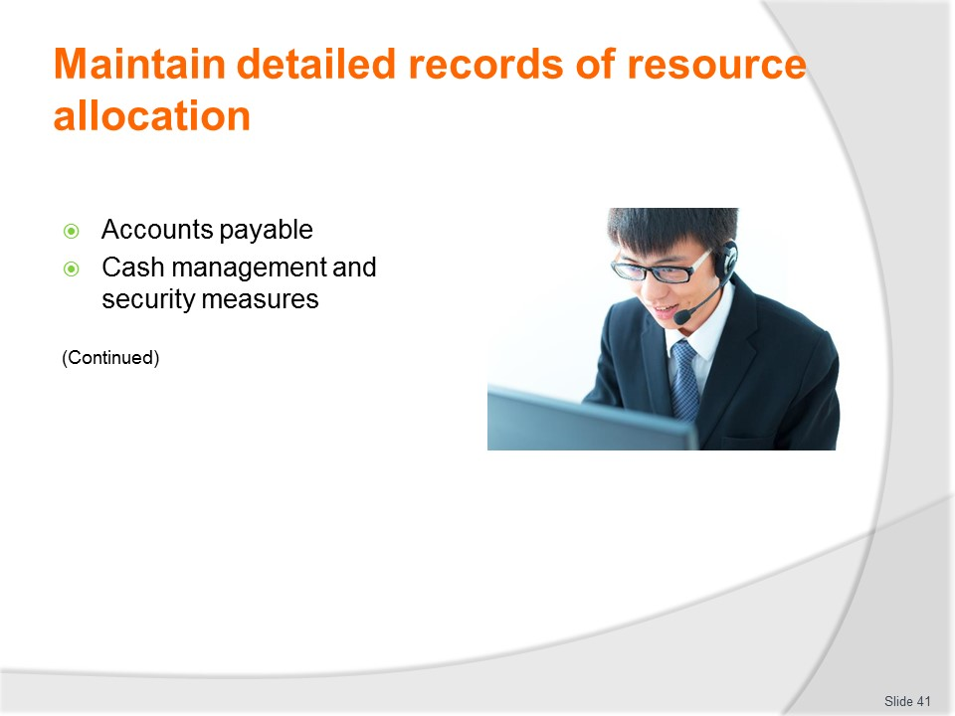
Slide No | Trainer Notes
Trainer continues explaining financial procedures and systems must address the following:
Accounts payable
This relates to money owed by the business to its suppliers and requirements in this regard may include:
- Verifying accounts received – by matching them with purchase orders and/or other internal authorisations to purchase
- Checking the amounts payable – to confirm they are correct
- Following up discrepancies – and resolving them as appropriate
- Posting charges to the correct budget line/code – according the Schedule of Accounts
- Posting charges internally in accordance with bookkeeping protocols in use – as designed/developed for the business
- Noting payment of accounts – by type/cheque number and date
- Appropriate staff training – in accounts payable protocols.
Cash management and security measures
Requirements in this regard may include:
- Designating currencies which the business accepts – and does not accept
- Identifying currency conversion rates – to be used when processing sales
- Insisting cash registers are never left unattended – at any time the business is open
- Requiring registers to be locked – if the cash area is left unattended
- Stipulating protocols for cash handling and giving change – such as:
- Stating aloud the cash tendered by customers
- Counting out the change into customer’s hand
- Leaving notes on register until transaction has been completed
- Never paying accounts using cash – but always by cheque/card
- Closing the business before registers are counted – to guard against theft
- Taking money from register cash drawers when large amounts are present – to limit loss in the event of theft and to reduce temptation for theft
- Dismissing any staff found to be stealing – and taking follow-up legal action
- Keeping cash in safes while on the premises – as opposed to drawers/cupboards
- Appropriate staff training – in cash handling and cash security protocols.
Class Activity – Demonstration and Exercise
Trainer shows students how to apply/implement the practices identified above and provides an opportunity for them to practice same.

Slide
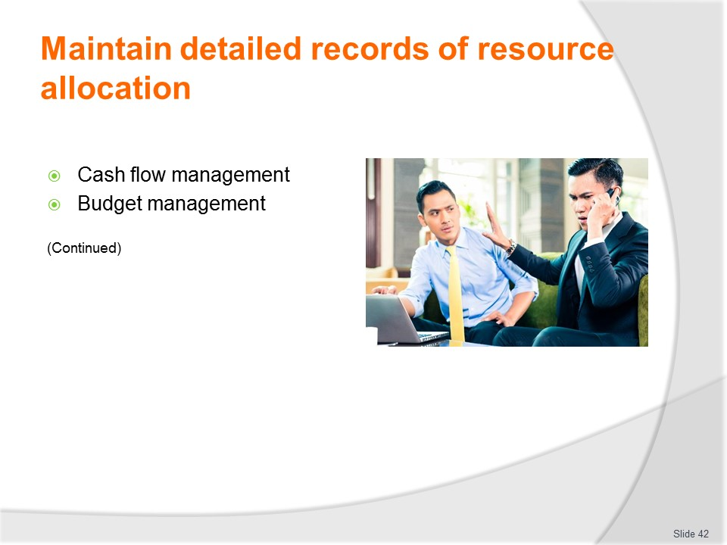
Slide No | Trainer Notes
Trainer continues explaining financial procedures and systems must address the following:
Cash flow management
Requirements in this regard may include:
- Realising and communicating the importance of liquidity to the business – by appreciating ‘cash is king’
- Identifying major known, expected or anticipated cash outflows – by date/timing and amount
- Identifying major projected cash inflows – by date/timing and amount
- Determining cash flow status (positive or negative) – across the year/budget period
- Tracking actual income and expenditure – on a regular basis
- Planning in advance – to:
- Capitalise on investment opportunities
- Source alternate funds/arrangements where deficiencies are anticipated
- Ensuring collectibles are received – when they are due
- Taking action to increase sales/cash flow – where decreased cash flow/negative cash flow is anticipated.
Budget management
Requirements in this regard may include:
- Developing budgets – as appropriate for the business
- Preparing a Schedule of Accounts – to support the budget process
- Including all relevant persons in the budget process – as appropriate to the individual business
- Allocating appropriate funds to budgets – based on business plans, reason, logic, historic data and sound financial planning
- Insisting budgets are read and reviewed regularly – by all relevant supervisors/managers
- Determining ‘red flags’ for each budget – which serve as triggers for remedial action
- Creating schedules for senior management/the Board to review all budgets – to check, verify and endorse them
- Appropriate staff training – in budget protocols.
Class Activity – Demonstration and Exercise
Trainer shows students how to apply/implement the practices identified above and provides an opportunity for them to practice same.

Slide
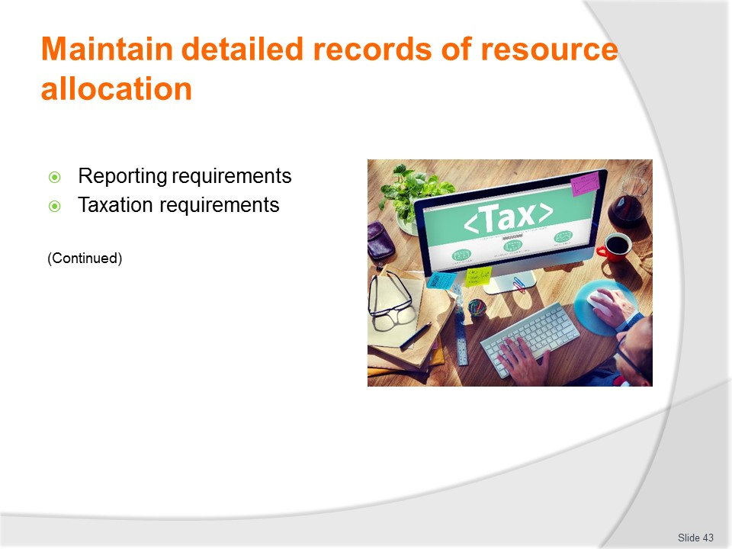
Slide No | Trainer Notes
Trainer continues explaining financial procedures and systems must address the following:
Reporting requirements
Requirements in this regard relate to internal business performance reporting and may include:
- Determining reporting frequency – with which financial and performance reports need to be prepared
- Identifying responsible persons – who are required to generate the nominated reports
- Providing standards report formats – to facilitate reporting and interpretations and understanding of same
- Creating a distribution list – identifying those who are to receive nominated reports
- Requiring reports to be discussed – at identified meetings by nominated persons and for the discussion to be recorded/minuted
- Requiring the outcomes of reports to be incorporated into future budgets and actions – as appropriate to the results, the plans of the business and interpretation of prevailing market/business conditions
- Filing requirements for reports – for future reference.
Taxation requirements
Requirements in this regard may include:
- Establishing protocols to determine taxation obligations – as imposed by current legislation and as laws change over time
- Setting up a compliant record keeping system – as required by the taxation authority for financial and business records/information and data
- Hiring external professionals with suitable qualifications and experience and expertise – in managing the taxation obligations of other businesses in the same industry/industry sector
- Calculating required taxation payments on a regular/ongoing basis – instead on just once a year at the end of the financial year
- Setting aside money for taxation payment throughout the financial year – instead of trying to find lump sums at the end of the period
- Identifying and aligning with requirements for deducting taxation from employee wages – and forwarding same to the authority
- Seeking advice from the taxation authority – about what is required and regarding compliance procedures.
Class Activity – Demonstration and Exercise
Trainer shows students how to apply/implement the practices identified above and provides an opportunity for them to practice same.

Slide
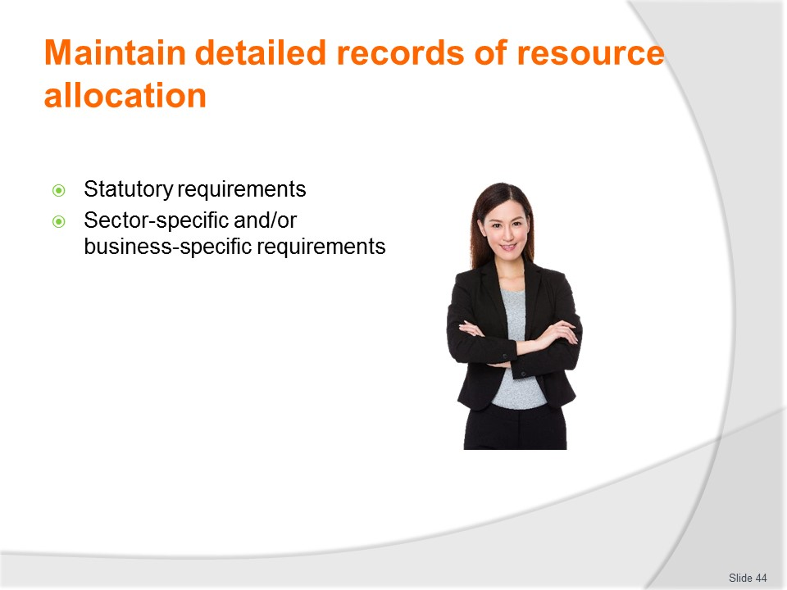
Slide No | Trainer Notes
Trainer continues explaining financial procedures and systems must address the following:
Statutory requirements
This refers to obligations imposed on businesses by their specific business structure. For example, a business may operate as:
- A sole trade
- A partnership
- A company/corporation.
Different statutory requirements can apply to different business structures in terms of issues such as:
- Taxation
- Reporting.
Requirements in this regard may relate to:
- Sourcing suitable/experienced professional assistance – to help determine the range of obligations which apply to the business structure being operated
- Establishing appropriate internal polices and polices – to ensure compliance with what is required
- Liaising with appropriate government/statutory agencies – to determine their requirements and obtain advice on compliance.
Sector-specific and/or business-specific requirements
Requirements in this regard relate to funds, schemes or initiatives imposed by government, semi-government bodies, industry bodies or joint venture partners and may include:
- Paying membership, subscriptions or other fees, levies and charges – as directed
- Maintaining for sale nominated services, standards, products or offers – as required
- Participating in schemes/initiatives – as appropriate to the business, industry, contract or sector
- Collecting monies – on behalf of a third party
- Forwarding monies collected – with supporting documentation and evidence of reconciliation.

Slide
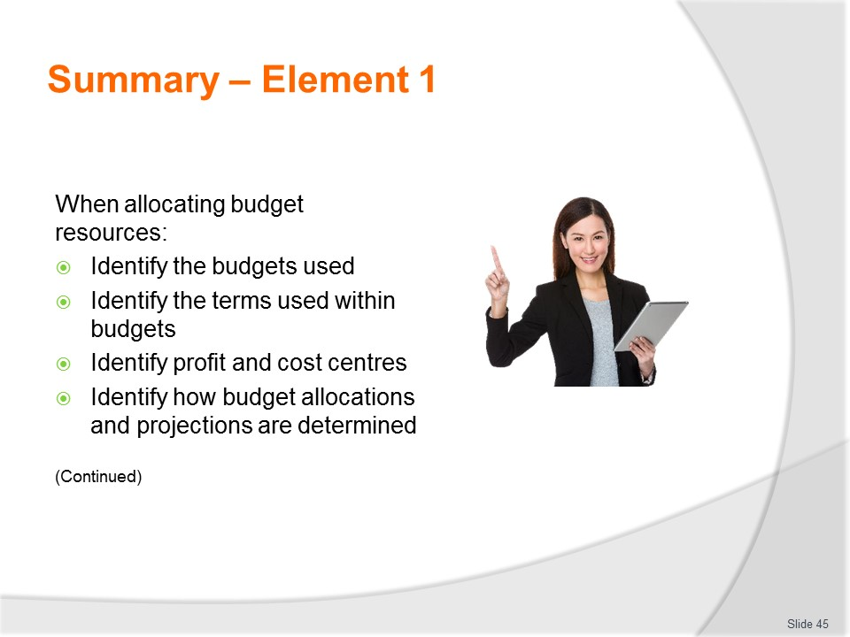
Slide No | Trainer Notes
 | Trainer provides a recap of the Element asking questions to check trainee understanding and responding to questions from trainees, as required.

Slide
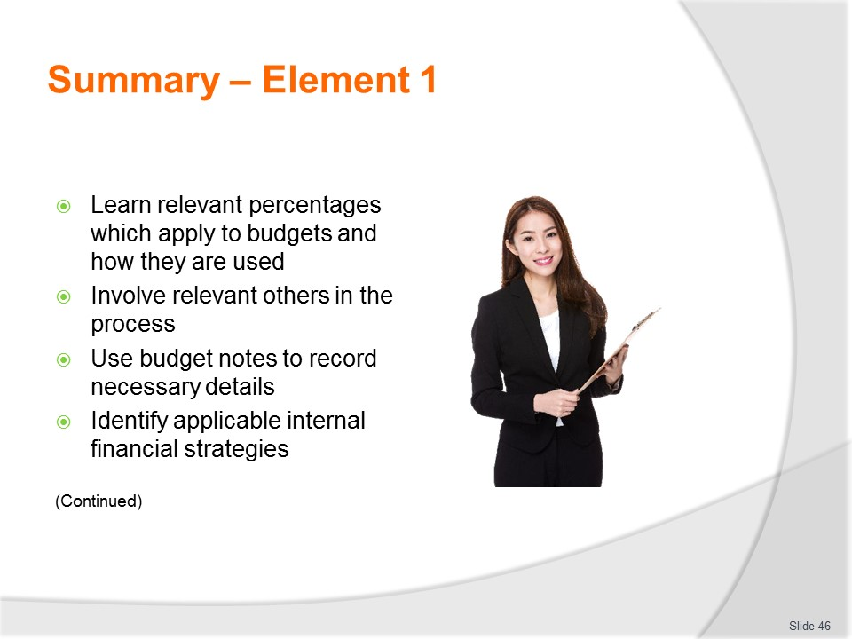
Slide No | Trainer Notes
 | Trainer provides a recap of the Element asking questions to check trainee understanding and responding to questions from trainees, as required.

Slide
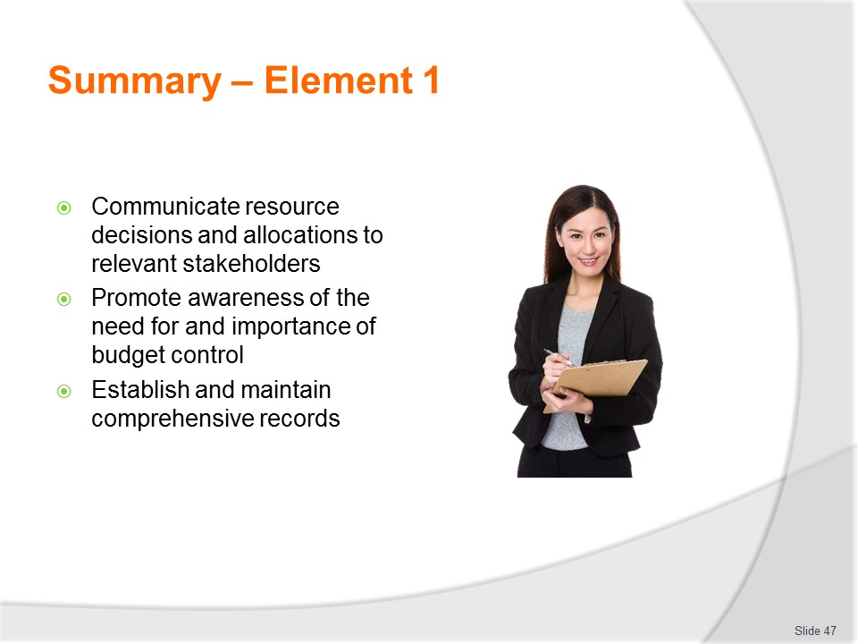
Slide No | Trainer Notes
 | Trainer provides a recap of the Element asking questions to check trainee understanding and responding to questions from trainees, as required.

Slide
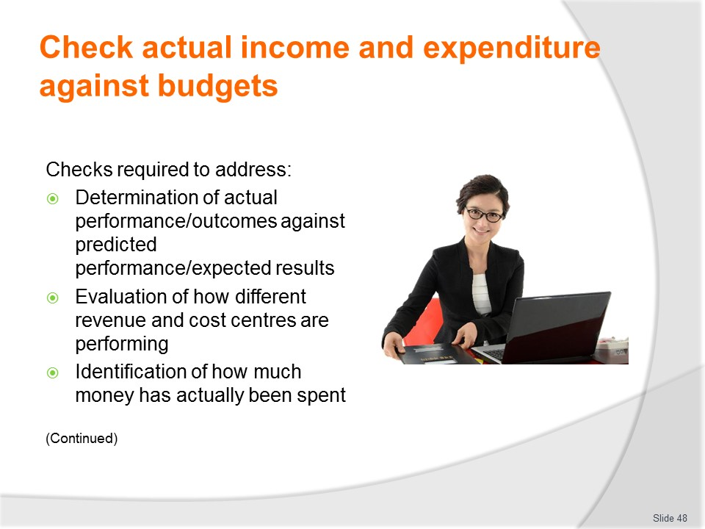
Slide No | Trainer Notes
Trainer advises the focus of this section are individual budgets as developed for the department/business highlighting checks must be undertaken to address all of the following on every occasion:
- Determination of actual performance and outcomes against predicted performance/expected results – in order to identify if the budget is ‘on track’ or not
- Evaluation of how different revenue and cost centres are performing – in comparative and real-world terms
- Identification of how much money has actually been spent – in certain areas/budgets and budget lines.

Slide
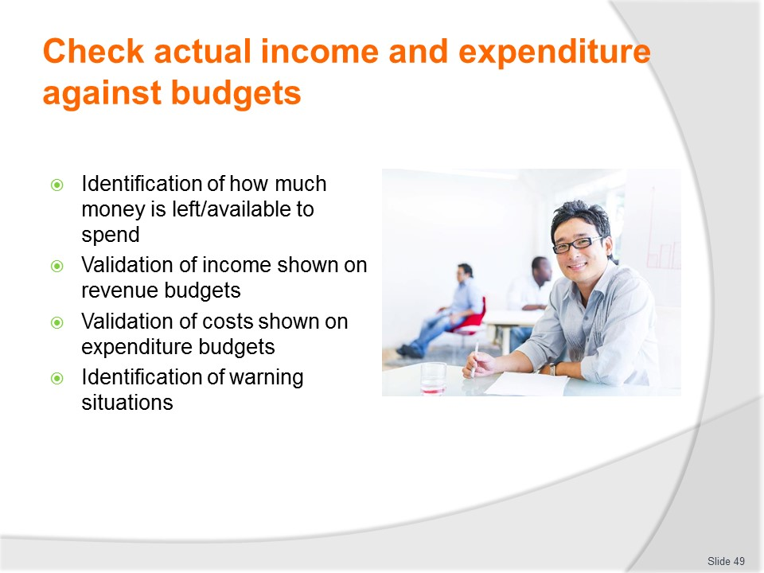
Slide No | Trainer Notes
Trainer continues advising checks must be undertaken to address all of the following on every occasion:
- Identification of how much money is left/available to spend – by individual budget and different budget lines
- Validation of income shown on revenue budgets – by verifying revenue generated has in fact been allocated/posted to the correct department or budget line
- Validation of costs shown on expenditure budgets – giving an opportunity to verify costs recorded against a department have in fact been created by that department and not by another department, and have been charged against the correct budget and budget line/s
- Identification of warning situations – in circumstances where performance/reality is not matching or meeting expectations and ‘red flags’ are being raised to indicate the need for appropriate remedial action to be taken to improve, retrieve or redress outcomes.

Slide

Slide No | Trainer Notes
Trainer states to gain a full appreciation of the business and how it is performing:
- There will be a need to consider more than just budgets for the department or business explaining there can be a need to prepare nominated financial and/or statistical reports
- The information on following slides provides information and detail regarding the areas of Financial and Management accounting, identifying and explaining relevant reports commonly prepared.

Slide
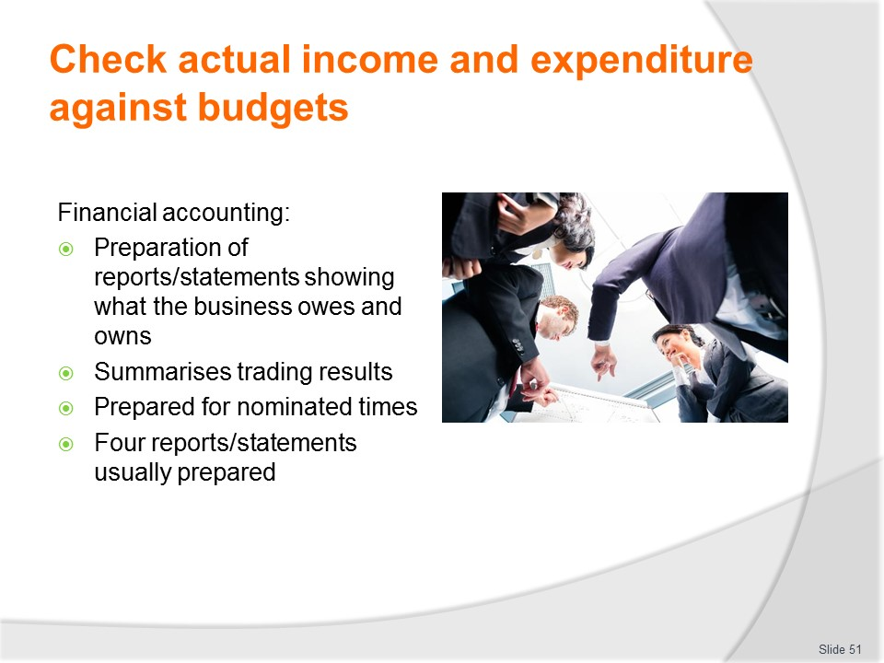
Slide No | Trainer Notes
Trainer explains Financial accounting includes:
- The preparation of financial reports or statements that accurately represent what the business own and owes
- This is called the financial position of the business
- Reports also summarise the results from buying and then selling goods or services that is the profit or loss of the organisation
- It is important to appreciate these reports are produced for a given period of time, usually determined by organisational and external requirements
- There are generally four financial statements or reports (see following slides) produced and whilst their names may differ across countries and regions, the accounting information contained therein remains similar.

Slide
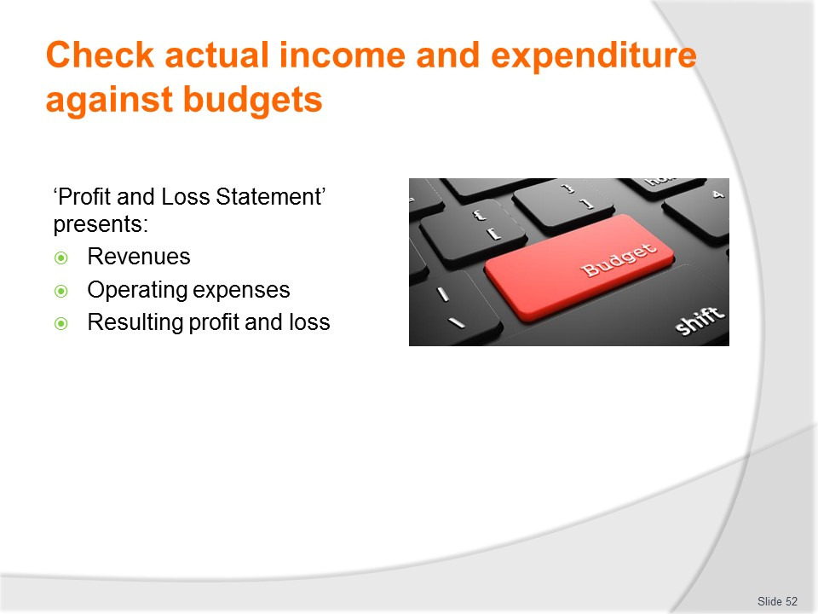
Slide No | Trainer Notes
Trainer discusses first of the four Financial accounting statements/reports:
Profit and Loss Statement/Income Statement/Statement of Financial Performance
The profit and loss statement presents:
- Revenues earned from sales
- Operating expenses and other expenses been incurred
- Resulting profit or loss over a given period of time – such as six months or one year.
The contents and format of this statement is standardised even though the title may differ.
Class Activity – Handout
Trainer distributes and discusses example of statement/report as identified on the slide.

Slide
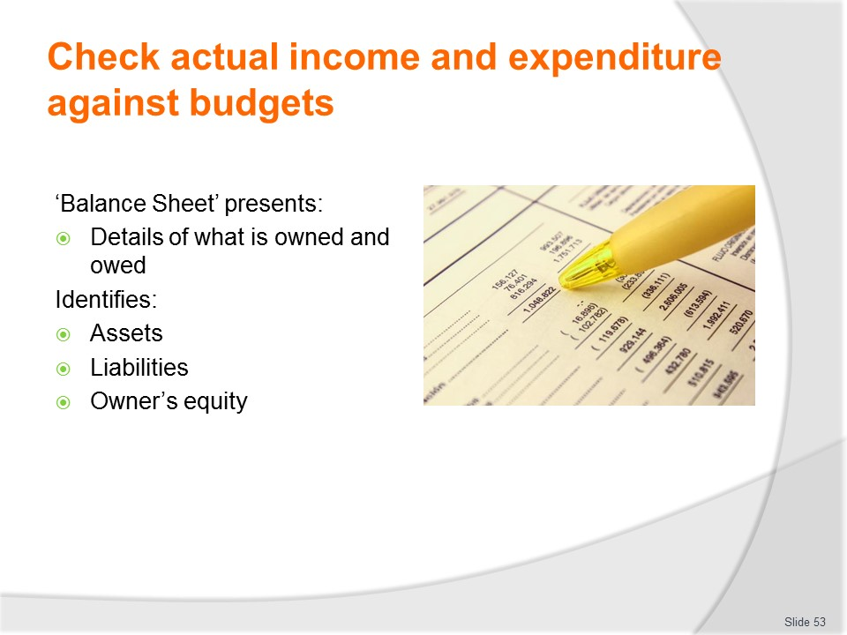
Slide No | Trainer Notes
Trainer discusses second of the four Financial accounting statements/reports:
Balance Sheet/Statement of Financial Position
- The balance sheet provides a snapshot of what is owned and what is owed by an organisation at a particular point in time.
- Balance sheets are produced at least annually and often every six months.
- There are three main sections in a balance sheet:
  - Assets
  - Liabilities
  - Owner’s equity.
Class Activity – Handout
Trainer distributes and discusses example of statement/report as identified on the slide.

Slide

Slide No | Trainer Notes
Trainer discusses third of the four Financial accounting statements/reports:
Statement of Owner’s Equity/Statement of changes in Equity
- This report summarises the changes to owner’s interests in an organisation.
- Owner’s interests are the difference between what is owned and owed as well as any profits made by the business, either current or past profits.
- Sometimes organisations include all details of changes to Owner’s Equity in the Balance Sheet and others summarise Owner’s Equity in the balance sheet and produce a Statement of Owner’s Equity separately.
Class Activity – Handout
Trainer distributes and discusses example of statement/report as identified on the slide.

Slide

Slide No | Trainer Notes
Trainer discusses fourth of the four Financial accounting statements/reports:
Cash Flow Statement/Statement of Cash Flows/Statement of Cash flow
- The cash flow statement details the movement of cash both in and out of the organisation.
- These movements are classified into three categories:
- Operating
- Investing
- Financing.
- The change in cash balances over the reporting period is also summarised.
Class Activity – Handout
Trainer distributes and discusses example of statement/report as identified on the slide.

Slide
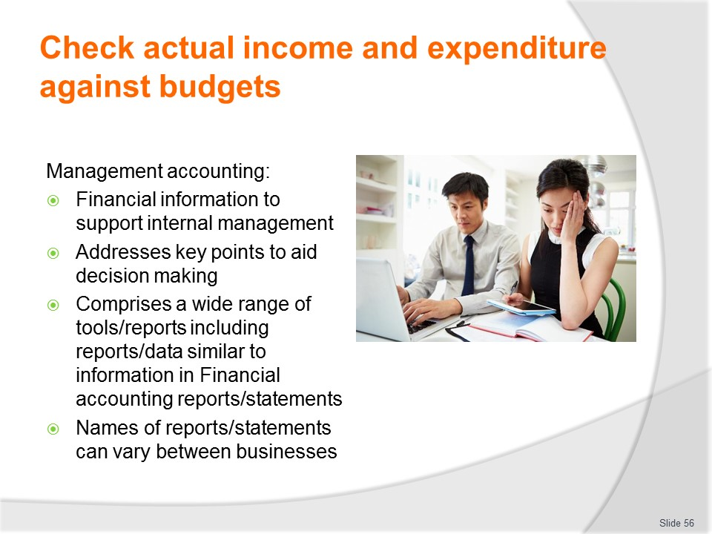
Slide No | Trainer Notes
Trainer explains Management accounting includes:
- Management accounting includes the preparation of financial information to support internal management
- The provision of information that addresses the key characteristics of the tourism and hospitality industries will assist managers with decision-making and the control of the business
- There are also a wide variety of reports, tools and techniques that management accounting offers that are generic to all organisations, large or small
- Management accounting reports also include the same or similar reports as discussed under financial reporting. It is simply the purpose for which the report is produced that changes. For example, a profit and loss statement for financial accounting purposes may be prepared annually but for management accounting purposes may be prepared monthly
- It is likely the format and content will differ slightly as is required by users of the data.

Slide
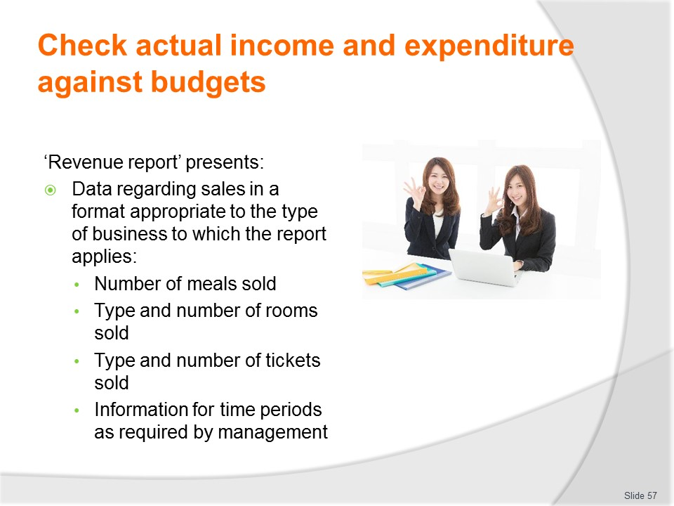
Slide No | Trainer Notes
Trainer discusses Management accounting statements/reports:
Revenue report
- The revenue report for an establishment offering accommodation services provides information to the front office manager regarding occupancy, average daily rates, and comparisons between different periods of time and summarises other revenue sources as required
- A restaurant may seek a report detailing the number of covers and the average spend from each cover
- The revenue report is produced for the period of time as required by managers using the information
- This may be daily, especially in larger accommodation venues, but perhaps only weekly in smaller, owner operated establishments.
Class Activity – Handout
Trainer distributes and discusses example of report as identified on the slide.

Slide
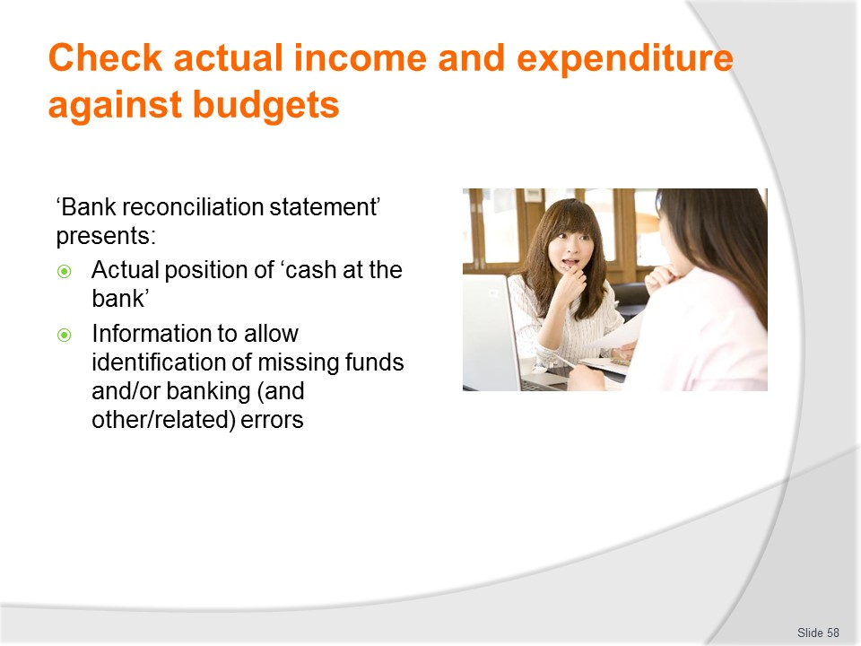
Slide No | Trainer Notes
Trainer discusses Management accounting statements/reports:
Bank reconciliation statement
- A bank reconciliation statement summarises the differences between the cash balance recorded by the accounting system and the cash held in the organisation’s bank account and shown on a bank statement
- Cash is often at risk from being lost or stolen and preparing a bank reconciliation will reveal any funds that are missing and any errors made either by the financial organisation or within the accounting information system
- It is also important for an organisation to appreciate exactly the funds available
- Differences between the balances from the two sources arise due to timing, errors, fees and charges and delays to deposits
- Reconciling these differences helps to ensure the organisation does not spend funds that are not available.
Class Activity – Handout
Trainer distributes and discusses example of statement as identified on the slide.

Slide
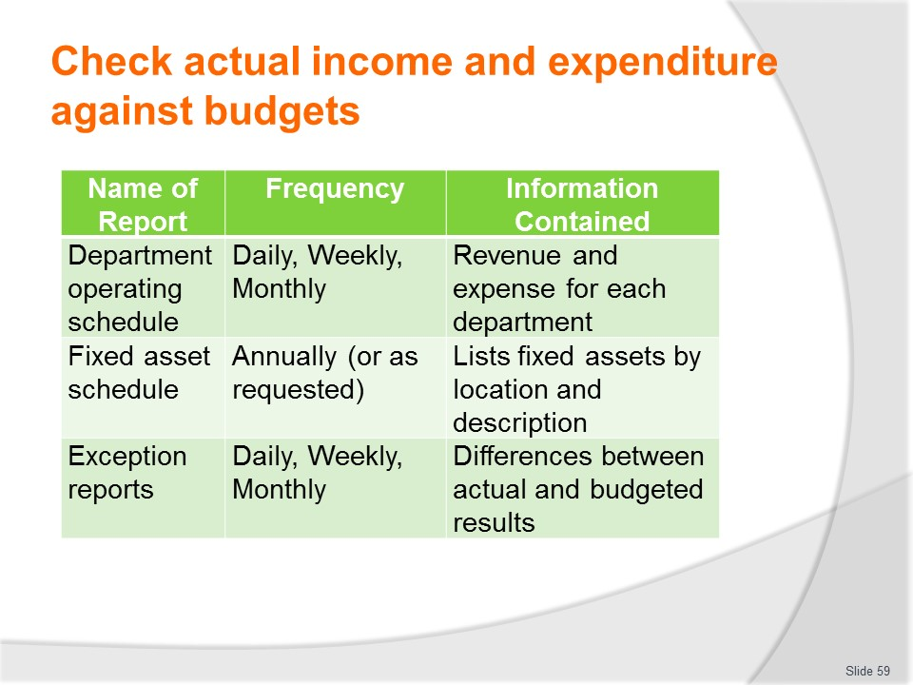
Slide No | Trainer Notes
Trainer lists additional Management accounting reports which may be required/produced as indicated on side.
Class Activity – Handout
Trainer distributes and discusses example of reports as identified on the slide.

Slide
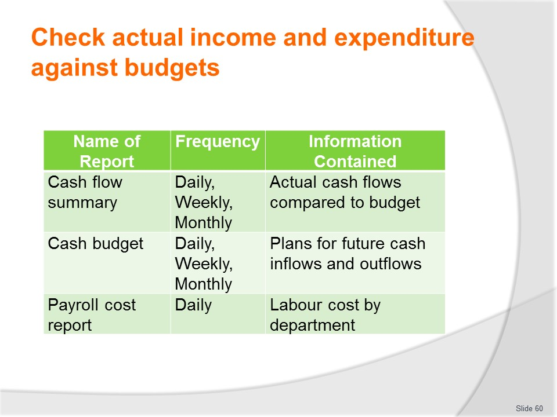
Slide No | Trainer Notes
Trainer lists additional Management accounting reports which may be required/produced as indicated on side.
Class Activity – Handout
Trainer distributes and discusses example of reports as identified on the slide.

Slide
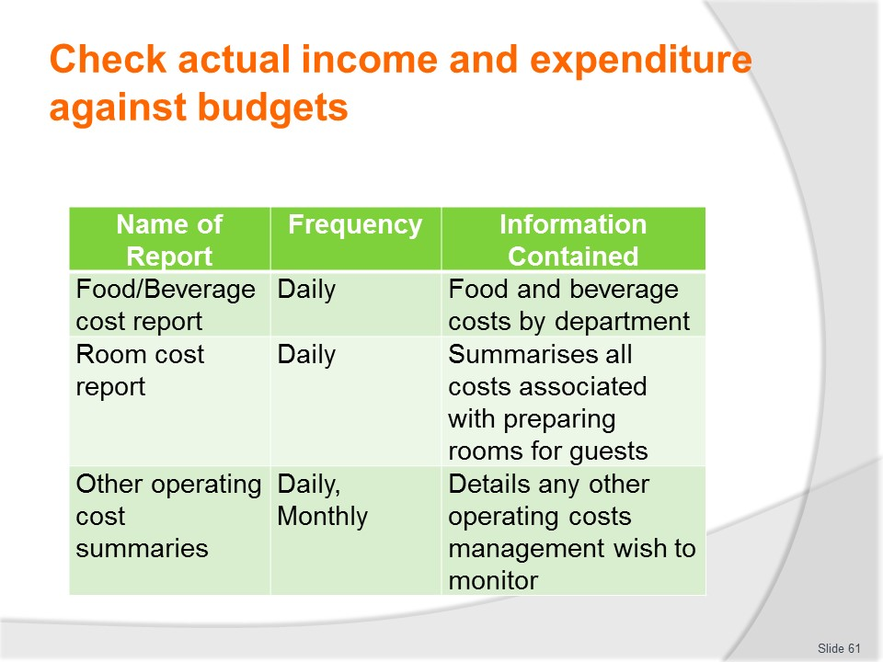
Slide No | Trainer Notes
Trainer lists additional Management accounting reports which may be required/produced as indicated on side.
Class Activity – Handout
Trainer distributes and discusses example of reports as identified on the slide.

Slide
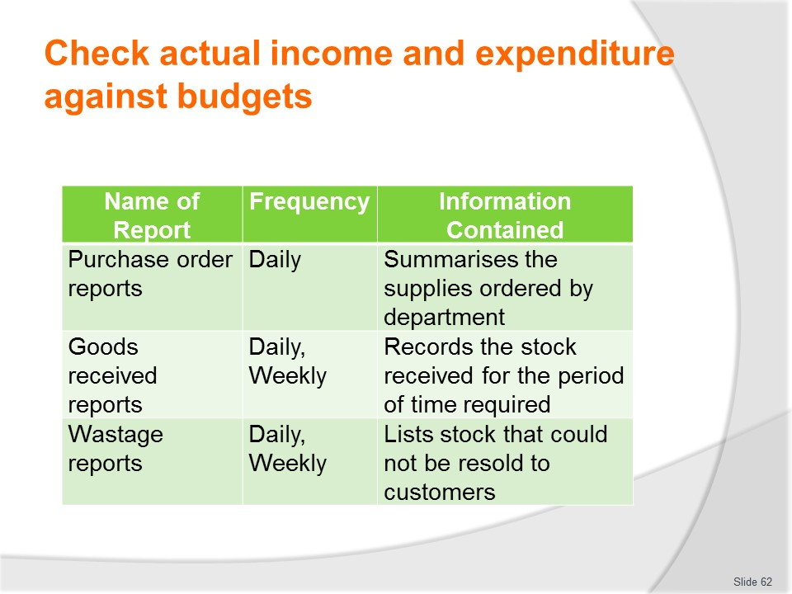
Slide No | Trainer Notes
Trainer lists additional Management accounting reports which may be required/produced as indicated on side.
Class Activity – Handout
Trainer distributes and discusses example of reports as identified on the slide.

Slide
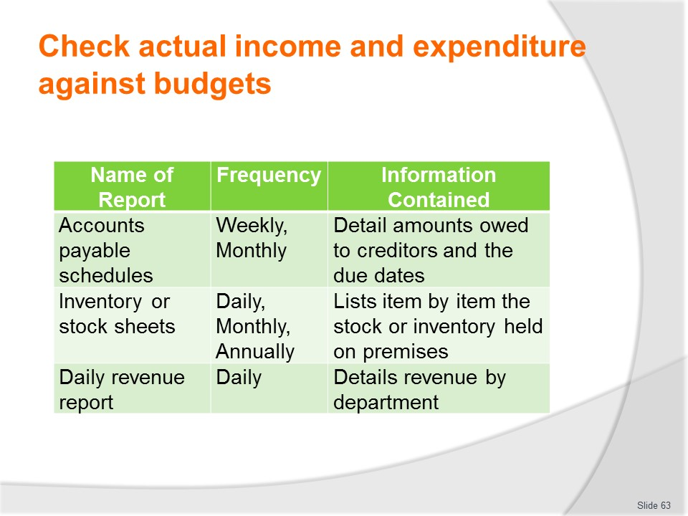
Slide No | Trainer Notes
Trainer lists additional Management accounting reports which may be required/produced as indicated on side.
Class Activity – Handout
Trainer distributes and discusses example of reports as identified on the slide.

Slide
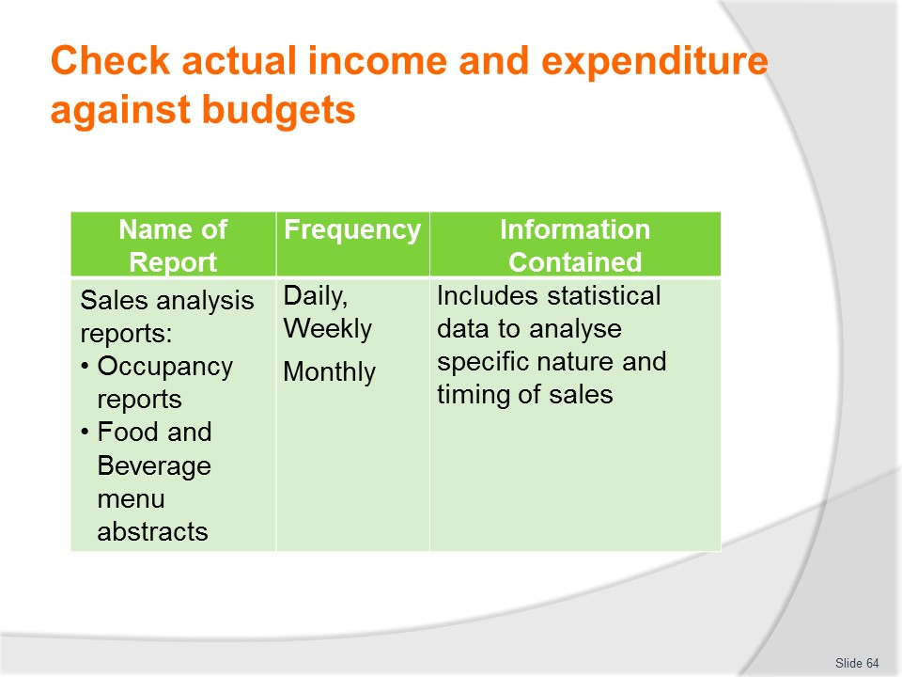
Slide No | Trainer Notes
Trainer lists additional Management accounting reports which may be required/produced as indicated on side.
Class Activity – Handout
Trainer distributes and discusses example of reports as identified on the slide.

Slide
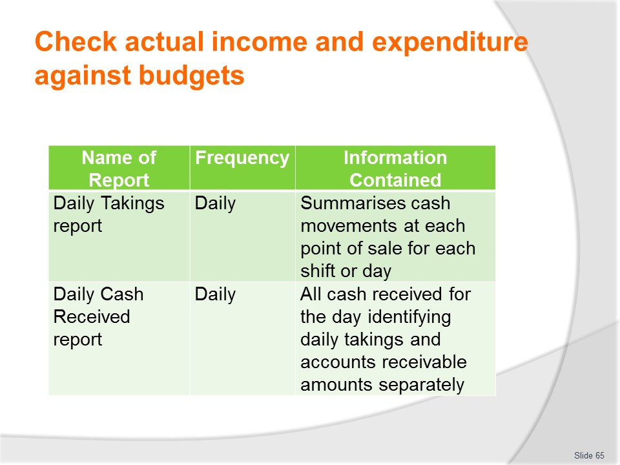
Slide No | Trainer Notes
Trainer lists additional Management accounting reports which may be required/produced as indicated on side.
Class Activity – Handout
Trainer distributes and discusses example of reports as identified on the slide.

Slide
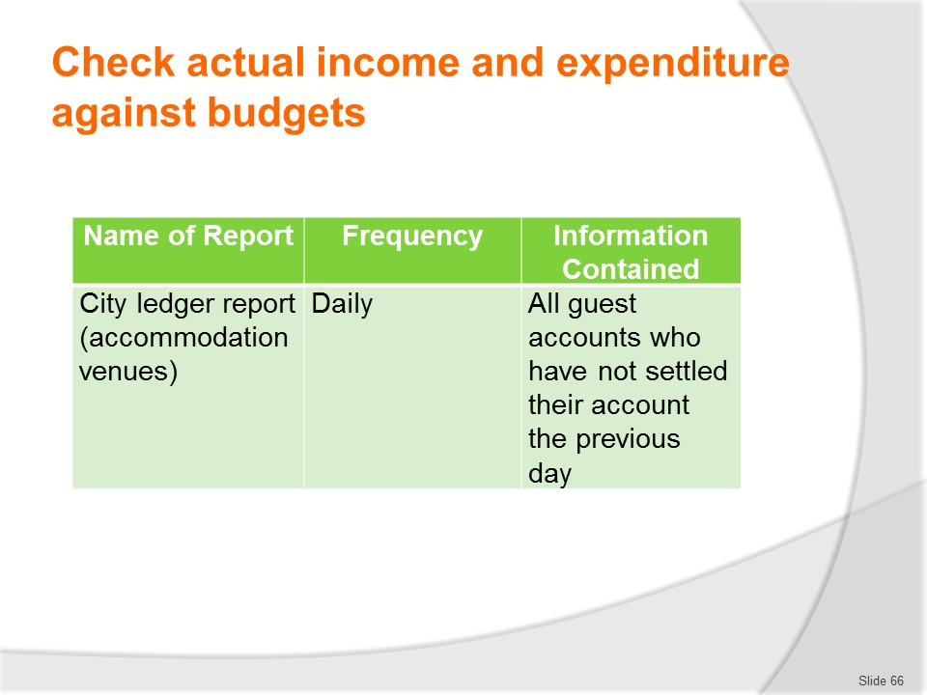
Slide No | Trainer Notes
Trainer lists additional Management accounting reports which may be required/produced as indicated on side.
Class Activity – Handout
Trainer distributes and discusses example of report as identified on the slide.

Slide
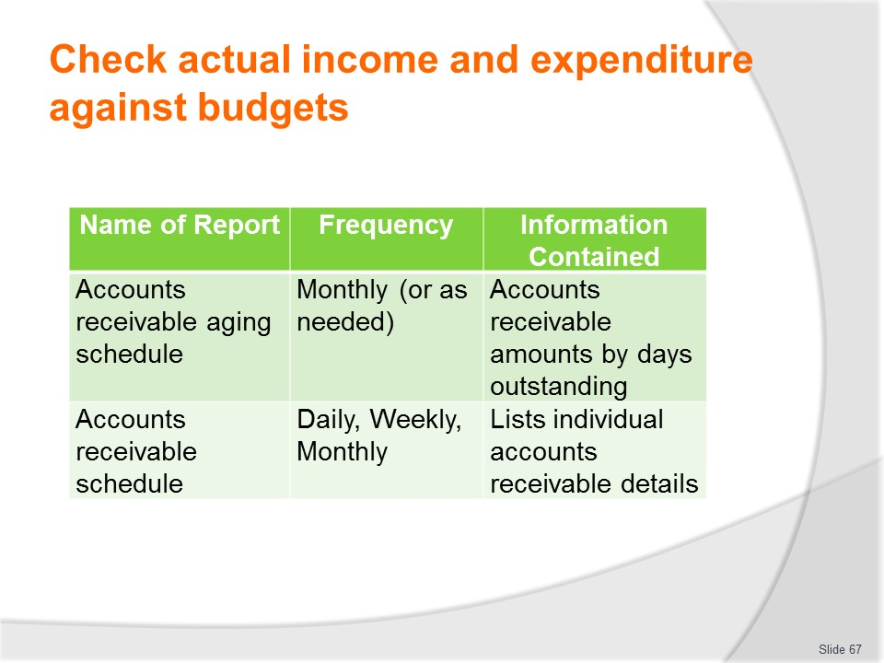
Slide No | Trainer Notes
Trainer lists additional Management accounting reports which may be required/produced as indicated on side.
Class Activity – Handout
Trainer distributes and discusses example of reports as identified on the slide.

Slide
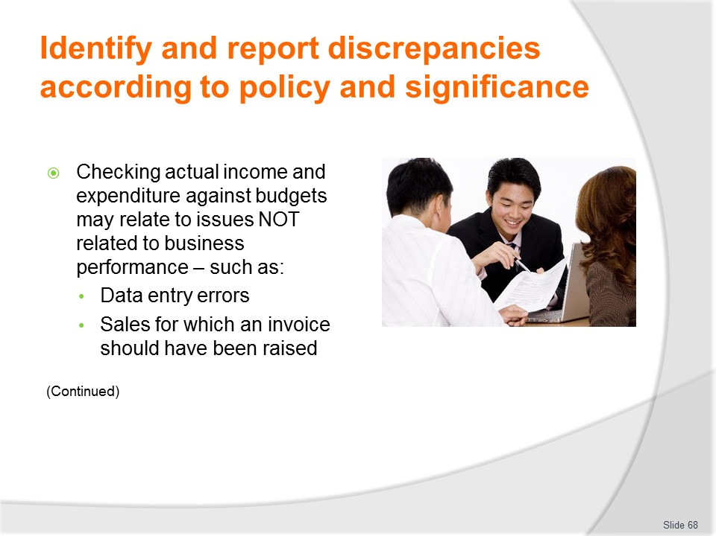
Slide No | Trainer Notes
Trainer states when checking actual income and expenditure against budgets possible discrepancies may relate to factors not related to business performance explaining these may relate to:
- Data entry errors – due to simple mistakes made by staff when entering information into systems and files, such as:
- Transpositional or transcription errors – where figures/numbers are inadvertently mixed up and put/entered in the wrong sequence: for example, entering ‘1234’ when it should have been ‘1324’, or entering ‘123’ when ‘1234’ should have been entered
- Errors in reading and/or interpreting hand-written figures
- Hitting the wrong key when entering an amount or code
- Rushing the work being done – and not undertaking proper checks of the completed work
- Sales that should have had an invoice raised – but by error or oversight did not.
- Obviously important where the sale was man account sale and not a cash (on-the-spot) transaction where payment was received at the time for products/services provided.

Slide
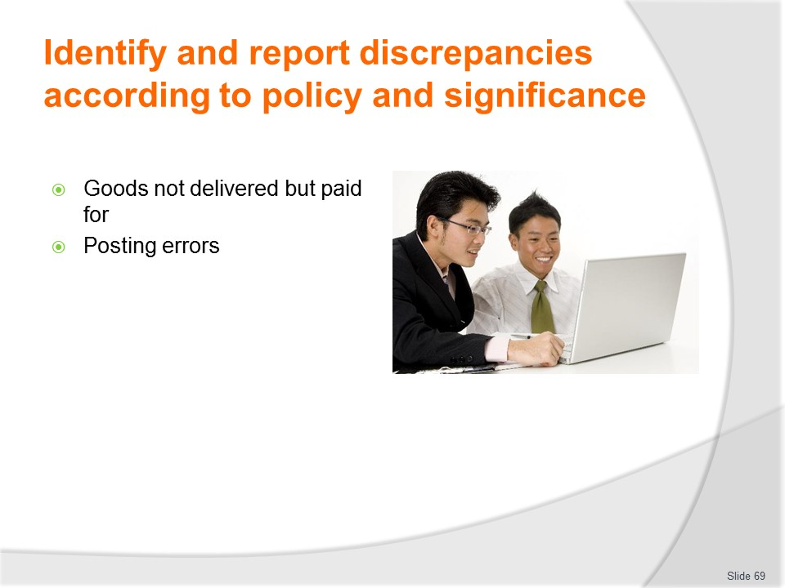
Slide No | Trainer Notes
Trainer continues identifying factors which should be identified when states when checking actual income and expenditure against budgets:
- Goods not delivered to the business but charged for – for example in situations where an invoice/delivery docket indicates:
- The business received goods which, in fact, were not supplied
- The amount/number of items received were less than shown on the accompanying documentation
- Goods provided were not the same as shown as good ordered/listed on Purchase Orders
- Goods were returned to the suppliers but no credit has been received for those items
- Posting errors – which might include:
- Posting of the wrong amount – due to human error or misinterpretation
- Omitting a posting – where a source documents was simply overlooked, lost or assumed to have been already processed
- Posting in the wrong column – meaning, for example:
- Income was shown as an expenses
- Expenditure on food was shown as expenditure on another classification/category of materials
- Posting a transaction more than once – caused by human error of failure by data entry staff to note the source document had already been processed.

Slide
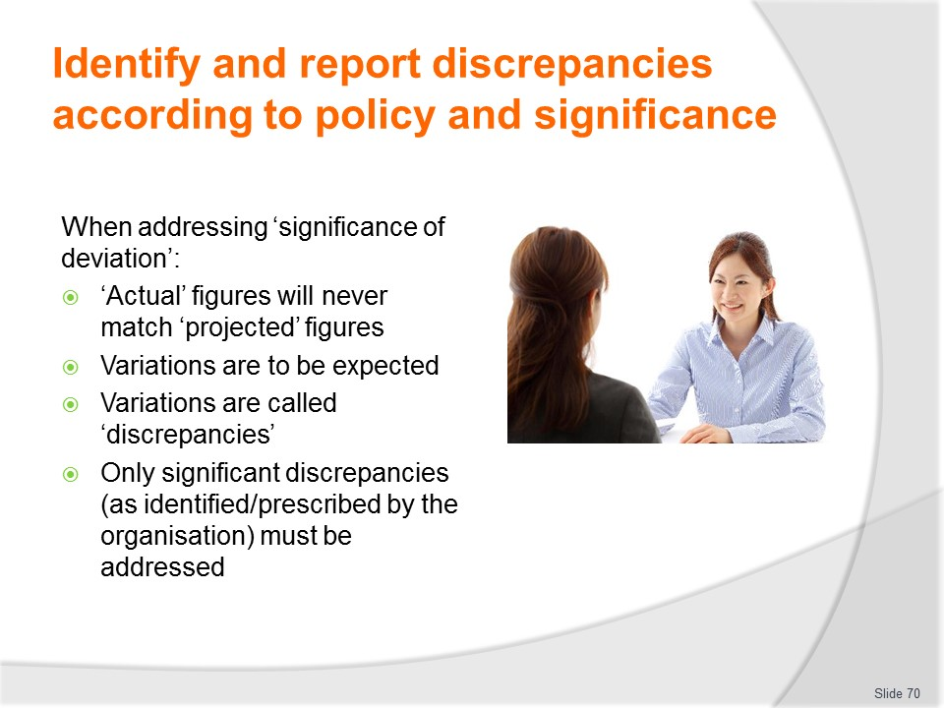
Slide No | Trainer Notes
Trainer discusses significance of deviation offering:
- When checking budgets there will rarely (if ever) be a situation where ‘actual’ figures exactly meet ‘projected’ figures
- There will (nearly) always be a variation between the two sets of figures
- This variation is called a ‘discrepancy’.
Management by exception
In most cases discrepancies are to be expected and can be effectively noted but otherwise ignored.
- However where these deviations are ‘significant’ they must be acted on in accordance with whatever action is deemed necessary to retrieve/resolve the situation. This is known as ‘management by exception’
- This is where (in the context of talking about budgets), management only concerns itself with those figures which fall outside acceptable parameters – that is, figures which are the exception (to the rule)
- It is up to each organisation/manager to set the parameters for what constitutes 'exception', and these parameters will vary between businesses and may even be set at different levels for different revenue centres within the one organisation
- For example, management may determine 5% (or 1%, or 2½%) is their 'exception' limit. Therefore when any report shows figures falling outside this limit, the printout will flag (‘red flag’) them for attention
- In other cases, management may elect to set a monetary figure as their exception limit: in these cases, where revenue is X below budget – or expenditure is X above budget – these lines will be flagged for attention.
Class Activity – Guest Speaker
Trainer arranges for manager/suitable person from local business to attend and talk about identifying and reporting discrepancies and the organisational policies and protocols which apply.

Slide
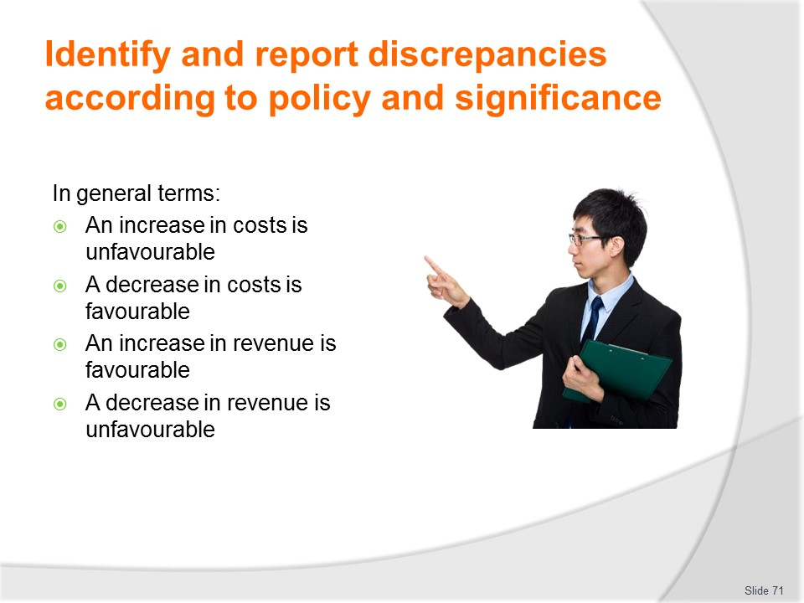
Slide No | Trainer Notes
Trainer provides an overview of general considerations which apply, in practice, when considering comparisons of actual figures against budgeted projections:
- An increase in costs is unfavourable
- A decrease in costs is favourable
- An increase in revenue is favourable
- A decrease in revenue is unfavourable.
There are certain circumstances, however, in which these generalities do not apply.

Slide
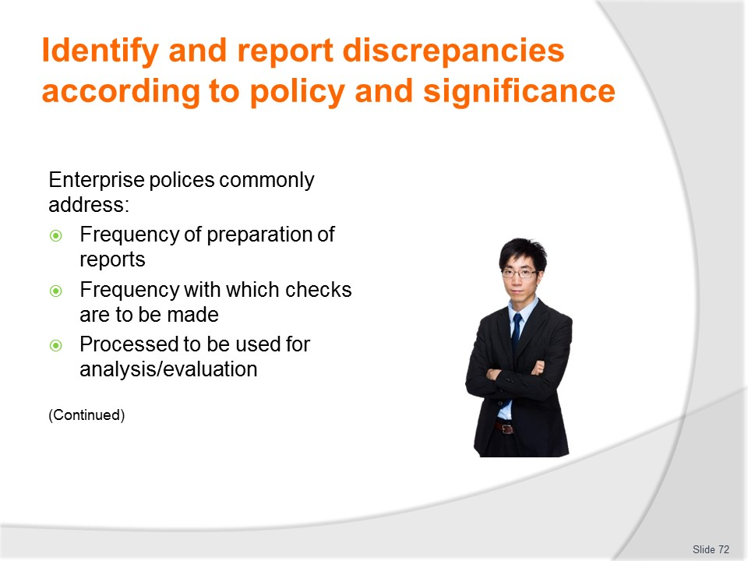
Slide No | Trainer Notes
Trainer indicates enterprise policy in relation to checking budgets and identifying and reporting discrepancies are usually supported by a range of operational procedures and commonly address:
- Frequency with which nominated budgets and reports need to be prepared – and distributed for checking/analysis
- Frequency with which checks are to be made – for nominated budgets and other reports/statements
- Processes/protocols for analysing the documents and statistics – which will be supported by appropriate in-house and on-the-job training.

Slide
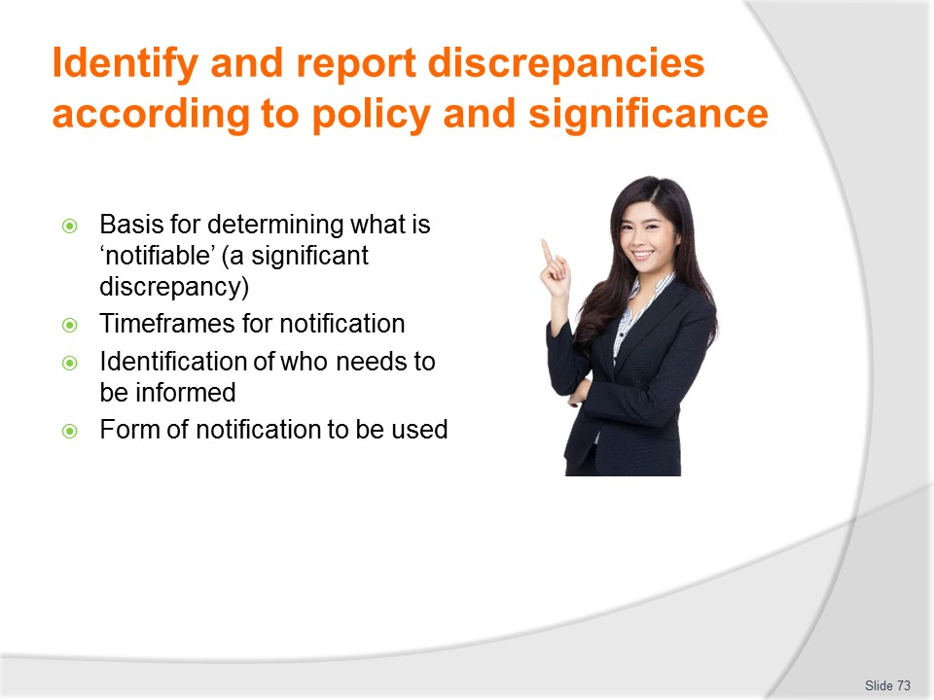
Slide No | Trainer Notes
Trainer continues discussing enterprise polices which apply:
- Basis for determining parameters which constitute notifiable deviations – these are the discrepancies which need to be reported and have recommended action developed to address the situation
- Timeframe within which notifications must be made – when unacceptable situations have been identified
- Personnel/departments who must be informed – when notifiable deviations are identified
- Form of notification – detailing how reports are to be made and identifying required content and/or supporting or allied information and evidence.
Class Activity – Guest Speaker
Trainer arranges for suitable person to attend and discuss enterprise policies and procedures for identifying and reporting significant deviations.

Slide
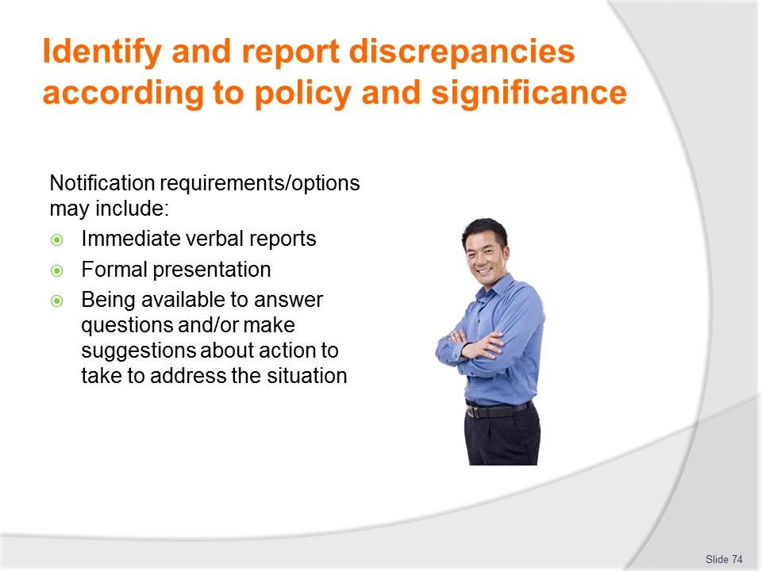
Slide No | Trainer Notes
Trainer notes where notifications are required in relation to budgetary discrepancies the standard options and requirements are:
- Immediate verbal report made face-to-face or using the telephone – to the nominated person (such as immediate super-ordinate) or department (accounts, finance, purchasing or other as appropriate to the type of discrepancy)
- Formal presentation – to nominated group/committee
- Being available and prepared to:
- Respond to questions – form management and relevant others
- Recommend action – to take in response.

Slide
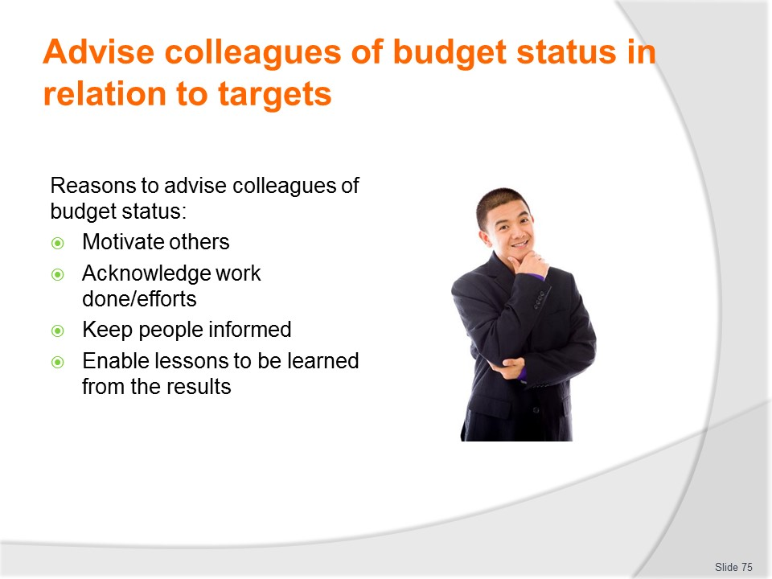
Slide No | Trainer Notes
Trainer states some organisations require ‘others’ to be advised of analysis of budgets (and other financial and management/operational reports) and some do not explaining there is a wide variation in orientations to sharing/disclosing this information with others within the industry and industry sectors advising notification may be required to:
- Motivate others – to change their actions to what is required on the basis of recent results/financial performances
- Acknowledge the work of others – whose efforts have enables achievement of positive outcomes
- Keep others informed – of the performance/results of other areas within the larger organisation so they can factor this knowledge into their planning and preparation
- Allow others to learn lessons contained within the results – this can:
- Prevent others making similar mistakes
- Enable positive actions to be spread throughout the wider organisation.

Slide
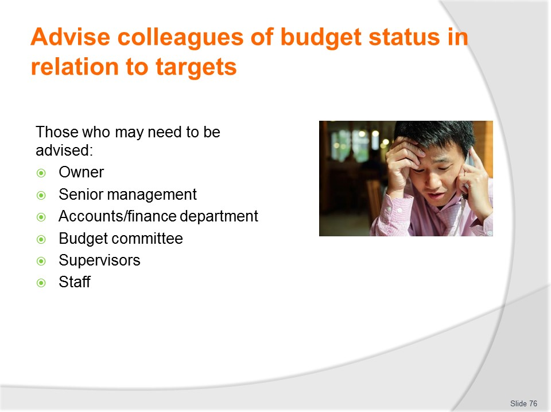
Slide No | Trainer Notes
Trainer identifies those who may need to be informed in relation to findings may include:
- Owner
- Senior management
- The accounts/finance department
- Budget committee
- Supervisors
- Staff – which may relate to:
- All staff – regardless of role/position or capacity
- Nominated/key staff – as identified by management.

Slide
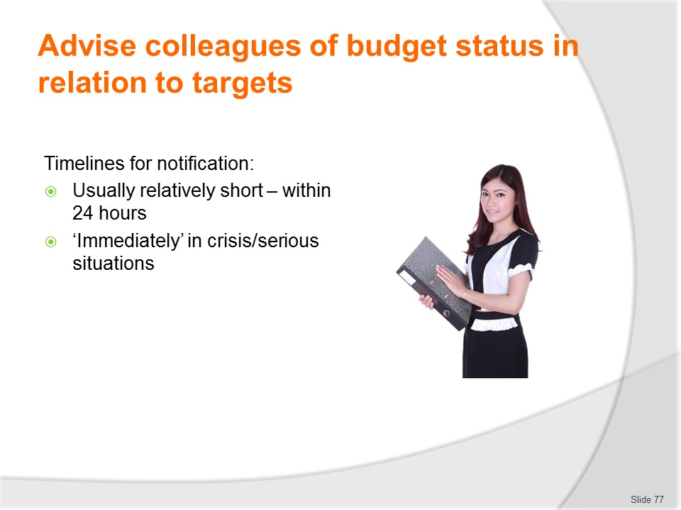
Slide No | Trainer Notes
Trainer discusses timelines for notification/advisement stating:
- Agreed timelines are traditionally relatively short for the advising of budget results.
- Within 24 hours would be a common timeline
- In most cases – especially where there is a problem or 'crisis' – such information should be communicated ‘immediately/as soon as possible’
- It is also common for departmental heads to communicate the thrust of the report/budget to staff immediately in a condensed/short-form verbal manner and to then follow-up with a more detailed discussion of the situation at a formal and scheduled departmental meeting.

Slide
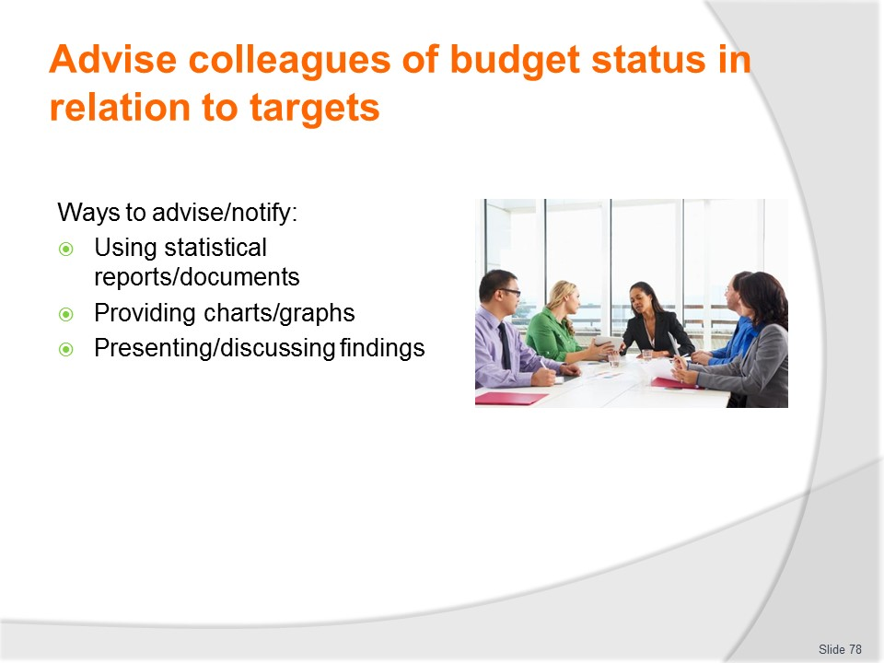
Slide No | Trainer Notes
Trainer states colleagues can be advised of the status of their budget in the following ways:
- Using written/printed documents such as reports, financial statements and spreadsheets – note there may be internal guidelines and requirements limiting or controlling the detail of financial matters which can be passed on to staff, and these must be adhered to
- Nonetheless these hard copy documents may contain tabulated statistics, ratio calculations, and various percentages
- The astute reader will no doubt realise almost any situation can be revealed to staff using percentages, as these statistics do not disclose actual monetary figures
- However, internal protocols in this respect should be identified and followed to the letter
- Using graphs, charts or diagrams – graphical representation of the printed word/statistic is often the best way to communicate accounting-based information
- Many people will have trouble reading and understanding a written word/statistic-based budget but will quickly appreciate a well-drawn pie chart, bar graph or line graph
- These graphical representations may be printed on paper as a handout, converted to an overhead projection sheet, or used in a PowerPoint presentation
- Providing a verbal presentation/discussion – where information is considered appropriate for release at the time an effective approach in sharing information can be to discuss matters verbally with suitable examples, illustrations and explanations
- This said, it is a fact of business life much of the accounting/finance information available to management-level personnel does not need to be passed on to staff
- Talking to staff about the situation can be an appropriate way of disseminating information which is especially useful where things are going well
- It is quick to do, requires little or no preparation and can send a very positive message to staff in the simplest of forms.

Slide
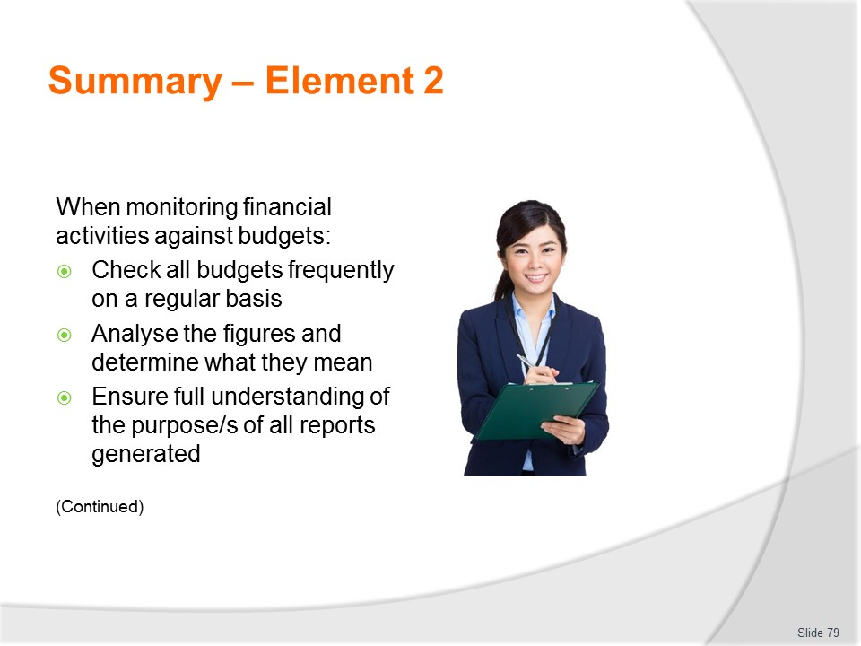
Slide No | Trainer Notes
 | Trainer provides a recap of the Element asking questions to check trainee understanding and responding to questions from trainees, as required.

Slide
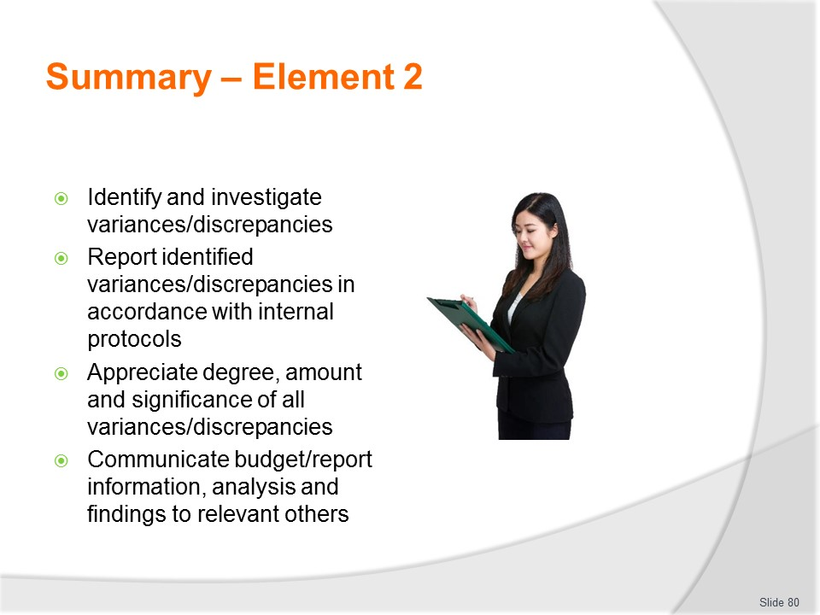
Slide No | Trainer Notes
 | Trainer provides a recap of the Element asking questions to check trainee understanding and responding to questions from trainees, as required.

Slide
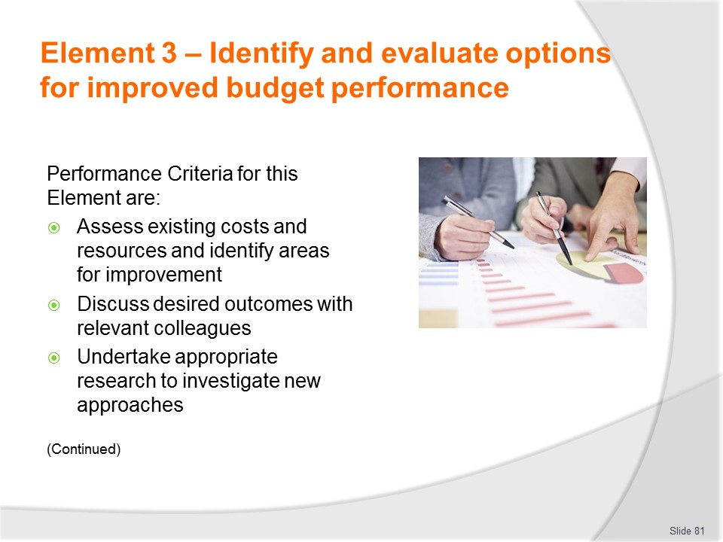
Slide No | Trainer Notes
 | Trainer identifies for trainees the Performance Criteria for this Element, as listed on the slide.

Slide
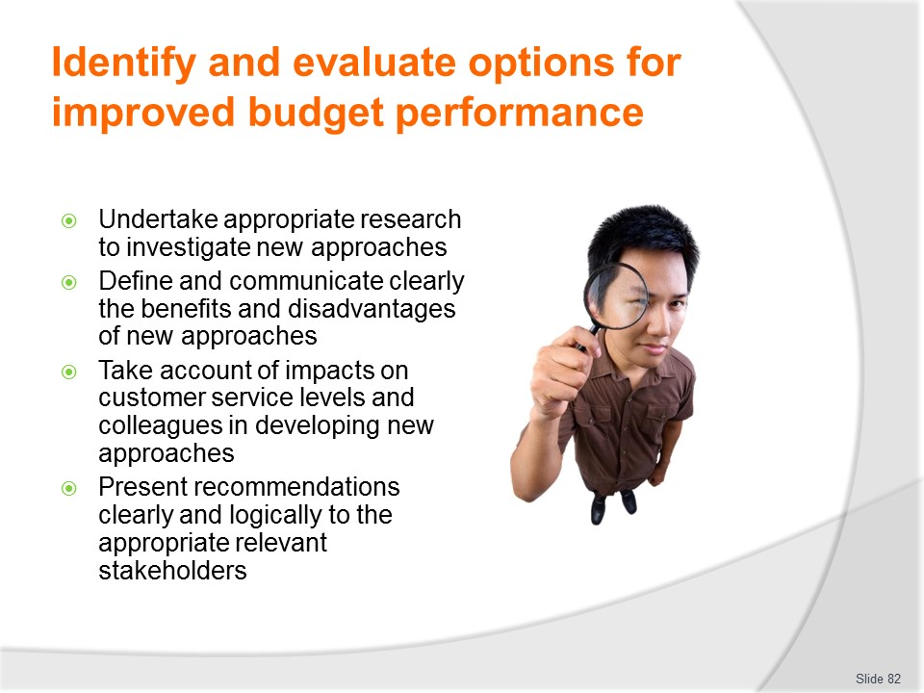
Slide No | Trainer Notes
Trainer identifies for trainees the Performance Criteria for this Element, as listed on the slide.
Class Activity – General Discussion
Trainer leads a general class discussion by asking questions such as:
- Why is there a need to improve budget performance?
- What might happen if this is not done?
- How can it be done?
- Who would be involved?

Slide
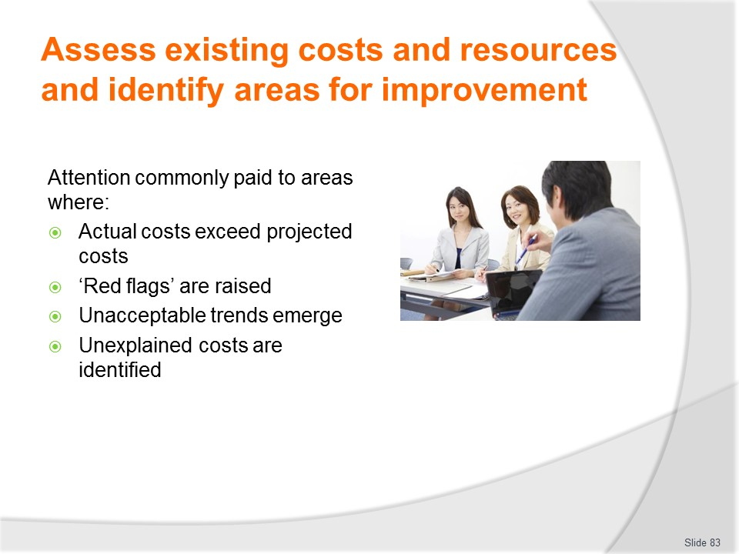
Slide No | Trainer Notes
Trainer notes:
- Part of the requirements of most managerial roles is to identify and evaluate workplace options for improved budget performance
- This will traditionally require assessment of existing costs and practices so areas for improvement can be identified
- Attention will commonly need to be paid to all areas where:
- Actual costs are exceeding projected costs
- Red flags have been raised
- Unacceptable trends are emerging/have emerged
- Unexplained costs have been identified
- The following slides will indicate possible actions – or possible areas for investigation – that may be able to reduce costs and/or increase revenue.

Slide
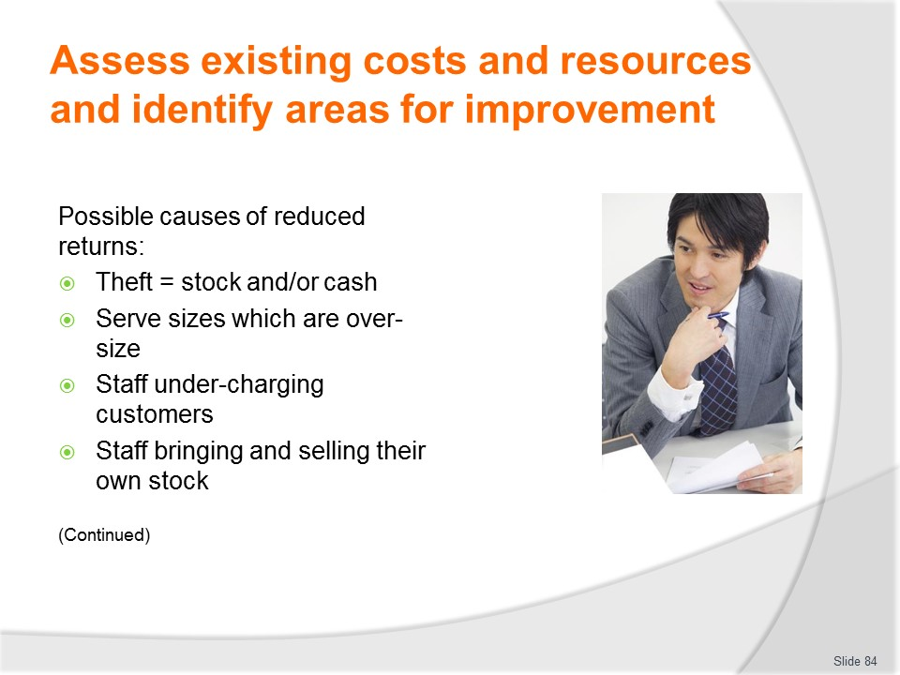
Slide No | Trainer Notes
Trainer explains reduced returns – that is, less revenue than projected – may be caused by operational issues such as:
- Theft – either of stock (liquor, non-liquor, commodities, food – raw or prepared) or of cash
- Service staff giving serve sizes (food and/or drinks) to friends or other staff that are intentionally or accidentally too big
- Staff undercharging customers or other staff – intentionally or accidentally
- Staff bringing in their own stock (such as bottles of spirits), selling it and pocketing the cash – a 700ml bottle of scotch costing the staff member 25 can be converted into around 100 making this an attractive/tempting means of defrauding the business by robbing it of revenue.

Slide
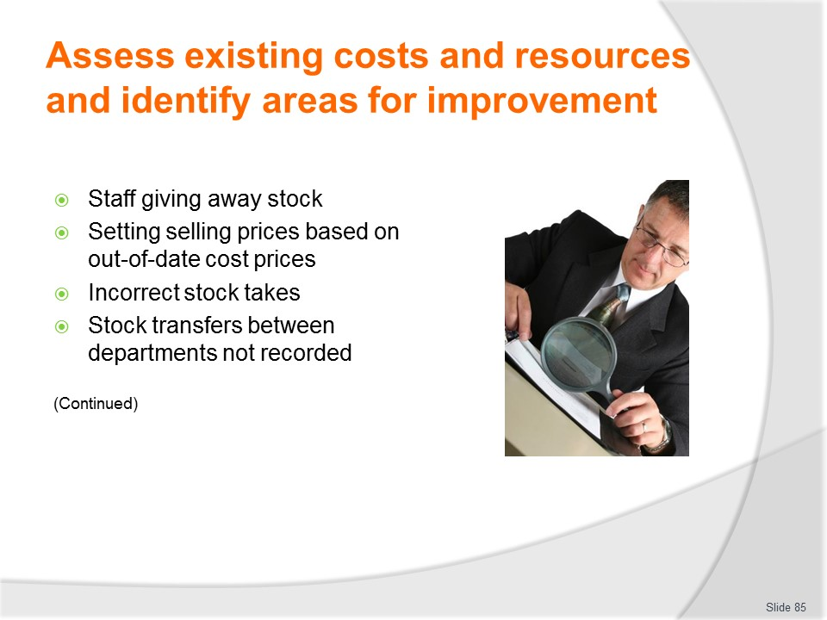
Slide No | Trainer Notes
Trainer continues explaining possible reasons for reduced returns:
- Staff giving away stock – such as meals, drinks, or in-room complimentary gifts to each other or friends
- Setting selling prices calculated on out-of-date cost prices – meaning a lower-than-expected return is achieved
- Incorrect stock takes being done resulting in stock not being included in the stock take and hence not being attributed to the department – which will give a misleading lower performance figure for the department
- Stock being transferred/taken from one department to another without the appropriate internal paperwork (such as an interdepartmental transfer being completed) – this results in a lower performance figure for the department from which the stock was taken, and a higher performance figure for the department that received the stock.

Slide
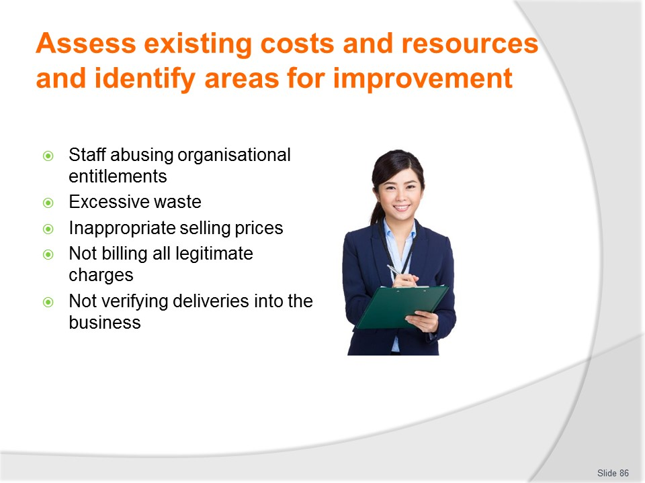
Slide No | Trainer Notes
Trainer continues explaining possible reasons for reduced returns:
- Where staff are entitled, according to house policy to a free ‘knock off’ drink or free staff meal, this privilege may be abused – and staff may be consuming more than one drink for free, or drinking a more expensive drink than what is allowed
- Excessive waste – which may be caused by reasons such as incompetence, inattention/lack of concentration, poor attitude, incorrect techniques, and/or faulty equipment
- Inappropriate selling prices – where selling prices do not reflect the required return such as when 'package deals' are put together, or where items are offered 'on special'
- Failure to bill for all charges – a failure on the part of staff/the property to charge customers for all items sold/used
- Failure to check deliveries – to ensure what is being paid for has actually been delivered to and received by the business.
It is an unfortunate fact all aspects of the features cash and other items people are commonly tempted to steal.

Slide
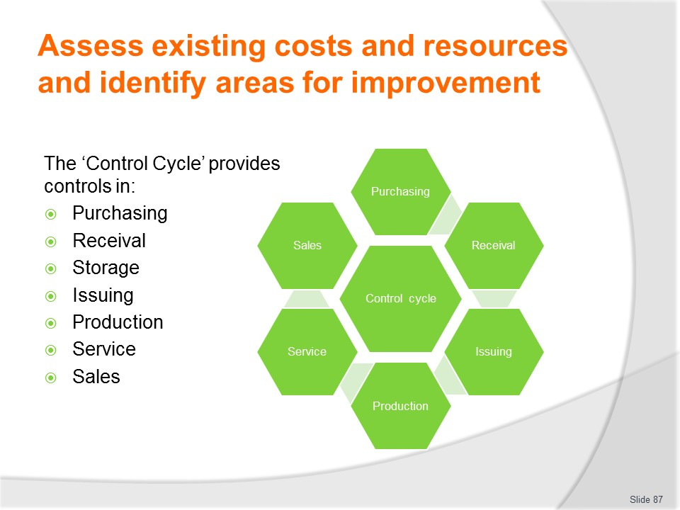
Slide No | Trainer Notes
Trainer informs:
- Effective control of revenue and costs requires an integrated approach – that is, each aspect of the control system must function in co–operation with every other aspect
- In addition, control must be applied at every stage where stock and cash/revenue is involved
- No part of the operation can be allowed to take place without some form of control being in place.
The Control Cycle
A total control cycle has seven integrated elements – purchasing, receival, storage, issuing, production, service and sales.
Class Activity (1) – Discussion
Trainer discusses relevant industry examples of application of principles to be applied for each of the seven elements of the control cycle.
Class Activity (2) – Guest Speaker/s
Trainer arranges for Guest Speaker/s to attend and discuss various elements of the control cycle explaining/illustrating how they are applied in practice to the operation of a business and the financial control and management of same.

Slide
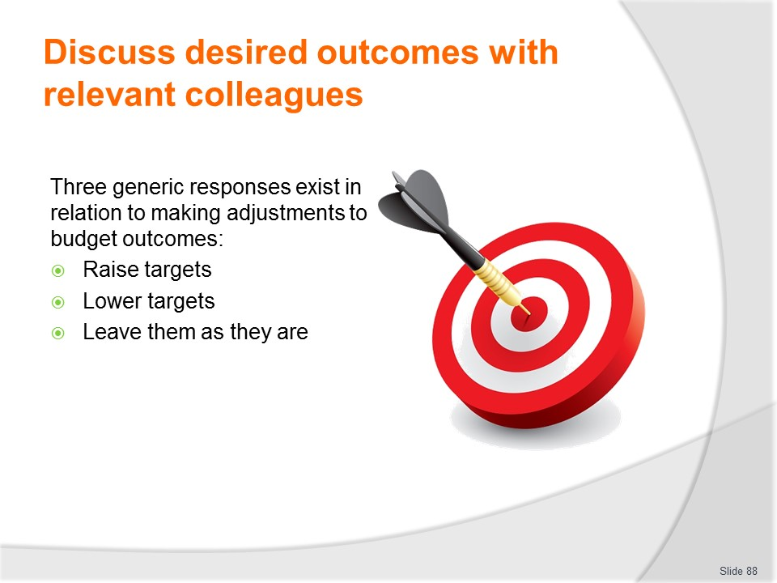
Slide No | Trainer Notes
Trainer states in relation to budget performance only three possibilities (plus their combinations) exist in relation to making adjustments to projected budget outcomes:
- Raise targets
- Lower targets
- Leave them as they are.
Debate often takes place not over which option to select but by how much initial targets will be modified.

Slide
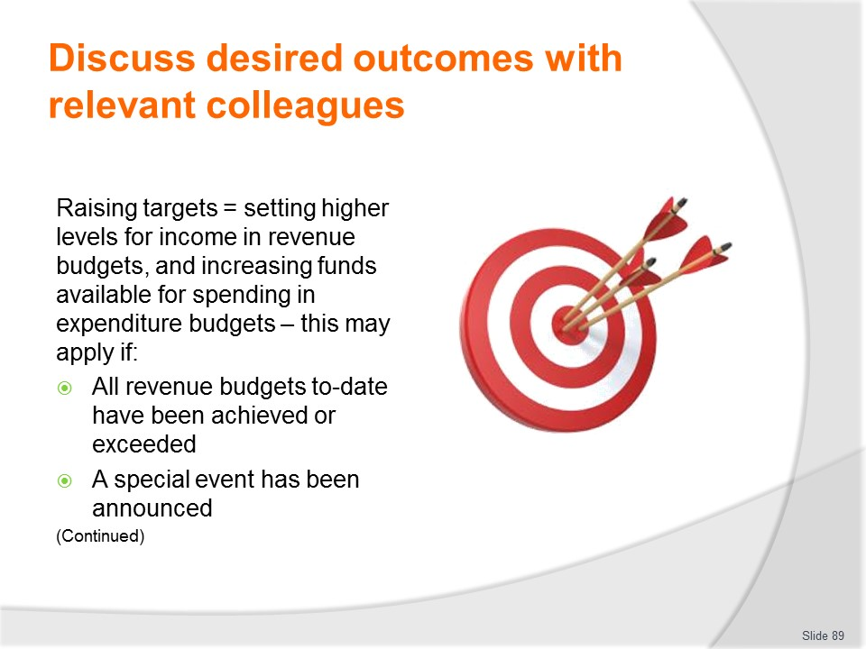
Slide No | Trainer Notes
Trainer discusses raising targets observing this means setting a higher level for income on the revenue budgets, and increasing the amount available for spending on the expenditure budgets stating examples include:
- All revenue budgets to-date have been achieved or exceeded – so it appears logical to revise the figures to make them more representative of the actual situation
- A special event has been announced – which will draw more people into the area and present the opportunity for increased sales.

Slide
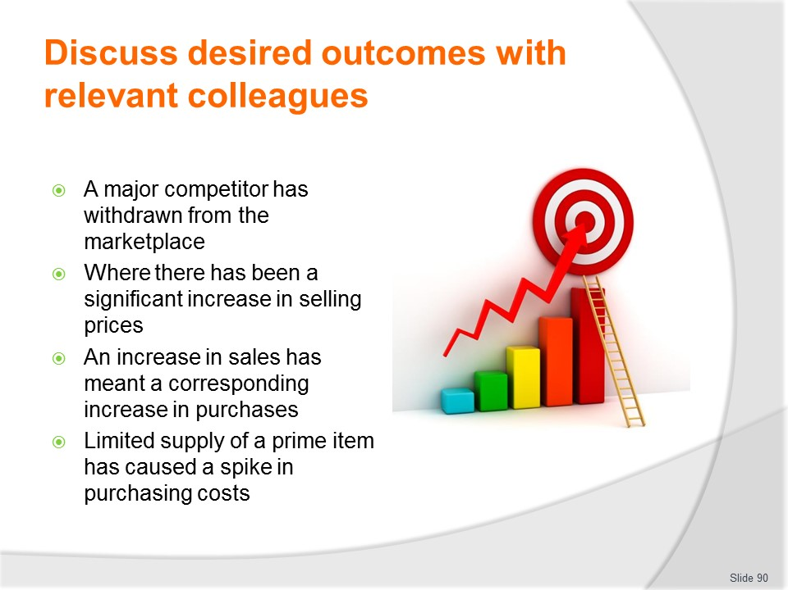
Slide No | Trainer Notes
Trainer continues giving information about raising budget targets and when this can apply:
- A major competitor has withdrawn from the marketplace – meaning the potential for more sales based on less opposition for the same money in the same geographic area or market space
- Where there has been a significant increase in selling prices – which should mean projected sales volumes will return substantially more revenue
- An increase in sales has meant a corresponding increase in purchases – so extra money for materials will need to be allocated
- Limited supply of a prime item has caused a spike in purchasing costs which the business is unable to control – due to the basic economic law of ‘supply and demand’, so more money for materials is required.

Slide
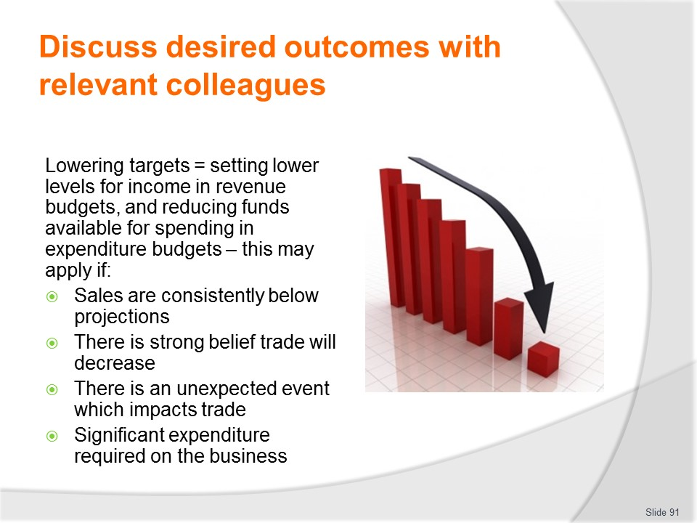
Slide No | Trainer Notes
Trainer discusses lowering targets observing this means setting a lower level for income on the revenue budgets, and reducing the amount available for spending on the expenditure budgets stating examples include:
- Situations where there have been consistent below-budget sales figures
- Information indicating events will be taking place which are going to impact negatively on trade – such as being advised about road works, knowing the area will not be attracting as many tourists as hoped because of a specific regional problem, losing a significant local sporting or other event
- The realisation of any unexpected event – strike, natural disaster, outbreak of some disease
- Major repairs to some part of the premises that have necessitated reduced expenditure in other areas – while still striving to maintain the same income stream.

Slide
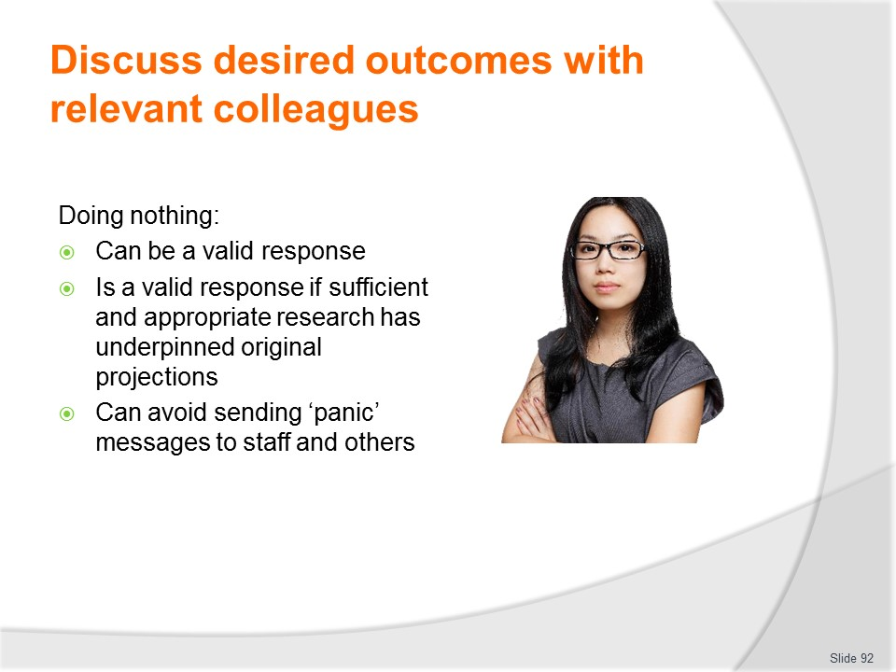
Slide No | Trainer Notes
Trainer offers in many aspects of management doing nothing is a valid managerial response suggesting in reality it is probably the most common managerial response:
- Where an adequate amount of planning and preparation has gone into creating the budgets, and information, feedback and statistics have been sought from a wide variety of sources, it is most likely predictions will be fairly accurate and there will be no need to amend the projections
- While constant fine-tuning of budgets may be seen as active, hands-on management, it can also be counter-productive in that it has the potential to unsettle staff and send messages to staff there are problems (and they may decide to seek employment elsewhere)
- Such constant alterations may also give the impression of 'change for change's sake', and a sense management are unable to get it right in the first place
- This can destroy staff loyalty to the company, commitment to its aims and credibility in the management.

Slide
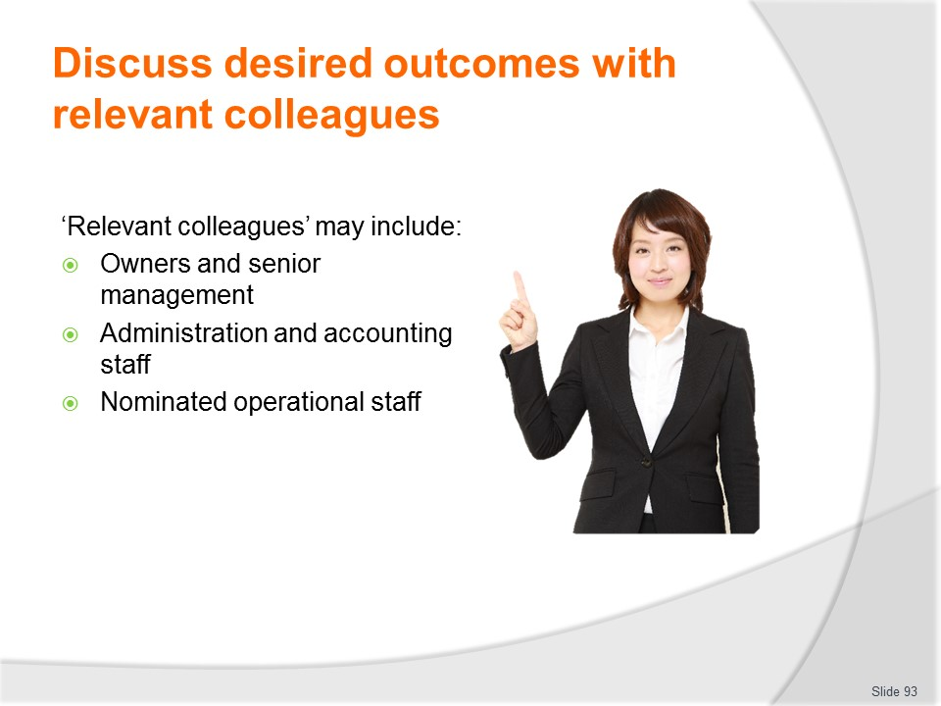
Slide No | Trainer Notes
Trainer explains in this context ‘relevant colleagues’ include:
- Owners and senior managers
- Middle-level managers and supervisors
- Administration and office staff with bookkeeping/accounting responsibilities
- Operational staff – who have responsibilities for:
- Spending money on behalf of the business
- Making sales and/or processing transactions for the organisation.
Class Activity – Guest Speaker
Trainer arranges Guest Speaker to discuss management responses to situations where budget projections (income and expenditure) are not being met/realised.

Slide
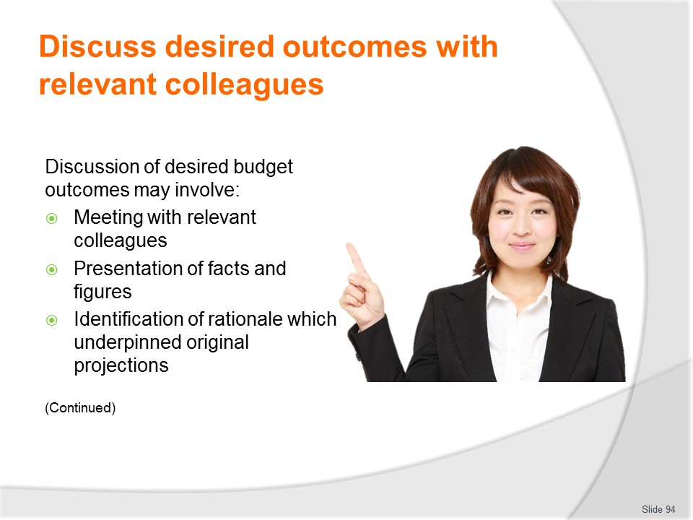
Slide No | Trainer Notes
Trainer notes discussion of desired budget outcomes will usually require/involve the following activities:
- A special meeting with all relevant colleagues – convened just for the purposes of discussing budgets, outcomes and action to be taken
- Presentation of figures and budgets – which are the focus of the discussion/ the reason for the meeting: presenting ‘projections’ and ‘actual’ figures
- Identification of the rationale/s which underpinned the establishment of allocations/projections – explaining the economic/trading environment at the time and the assumptions on which figures were determined.

Slide
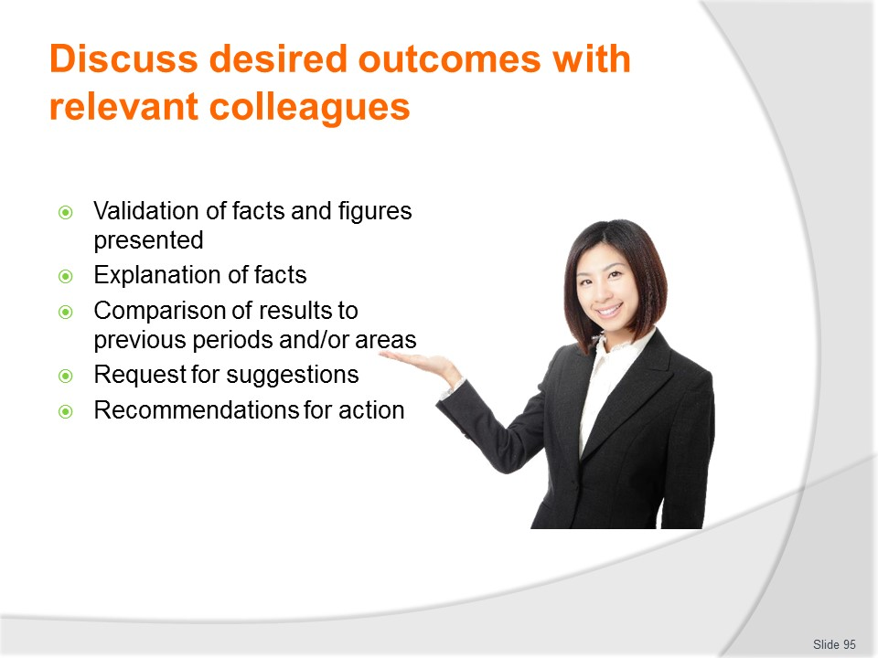
Slide No | Trainer Notes
Trainer continues providing information on activities related to these discussions:
- Validation of the facts and figures as presented – to prove/verify the situation and demonstrate it is genuine
- Explanation of the facts – describing how the current situation has occurred
- Comparison of results – to:
- Previous periods
- Other departments, branches, offices, revenue/cost centres or businesses
- Request for suggestions – to address the identified problem, unacceptable or out-of-control situations
- Recommendations for action – to address/retrieve identified situations.

Slide
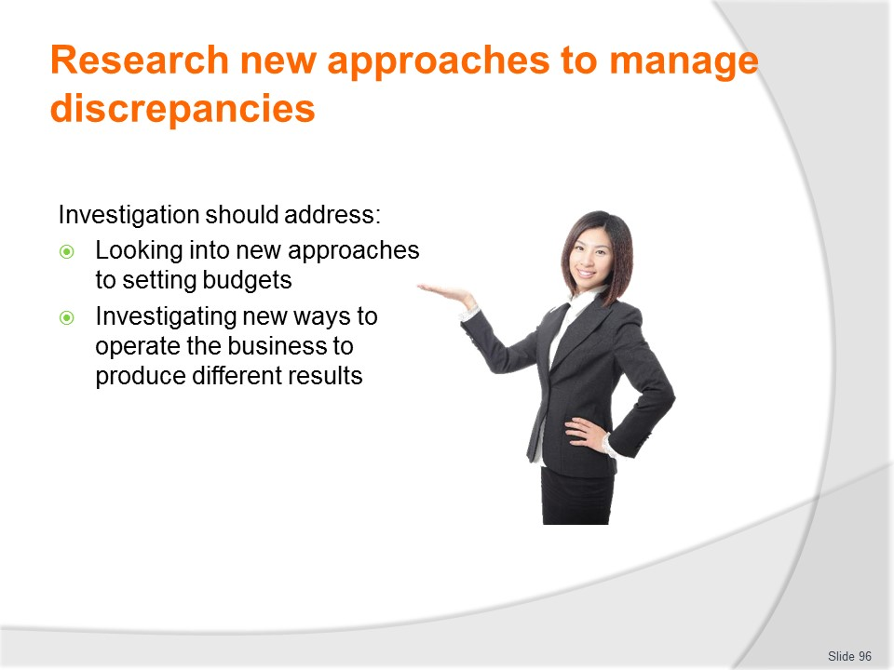
Slide No | Trainer Notes
Trainer identifies:
- Investigation in this situation should address two primary goals:
- Looking into new approaches to setting the budgets – to make them more realistic
- Investigating the operation of the business – so targets can be achieved.

Slide

Slide No | Trainer Notes
Trainer states research can take place into:
- Verifying the variances/discrepancies are accurate – by:
- Checking all data has been included for the period and according to the type of document, budget or report
- Checking there are no arithmetic/calculation errors in the information provided
- The cause of variances – where there appears no obvious reason for the discrepancies, all possibilities are open to investigation from theft to a simple downturn in trade.
- The aim is to determine actual causal factors.
- Identifying whether or not the intended customer/guest profile has changed – and if the business has failed to alter facilities and operations (including image, price levels, service standards, promotions, products) to match such change.
- The nature of the historical data used to generate the budget – commonly some form of historical data is used to guide the development of budgets for this current period: problematic is the figures being used may relate to a time which is not in-keeping with all the circumstances existing/applying today.
- Businesses often pay lip service to the fact they operate in a dynamic environment, but often forget to factor this dynamism into their predictions.

Slide
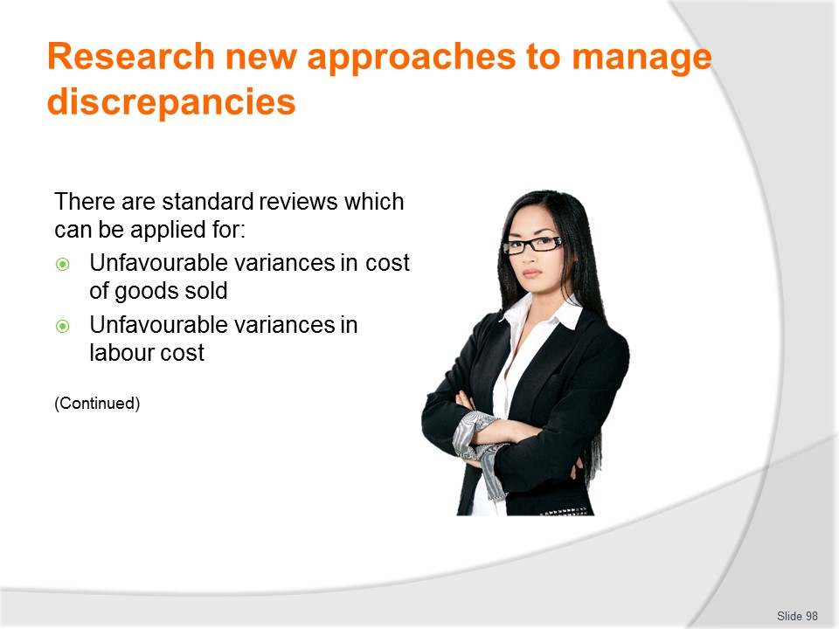
Slide No | Trainer Notes
Trainer observes there are a range of standard reviews which should be undertaken given certain outcomes identifying these outcomes and giving examples of the reviews:
For unfavourable variances in cost of goods sold there is a need to review:
- Purchase specifications
- Receiving and storing practices
- Issuing practices
- Production practices
- Front of House practices/wastage
- Bookkeeping.
For unfavourable variances in labour cost
In these situations there is a need to review:
- Mix of casual and full time staff
- Specific training of individuals
- Multi-skilling of labour force
- Motivation of staff
- Changes to workplace productivity.

Slide

Slide No | Trainer Notes
Trainer continues observing there are a range of standard reviews which should be undertaken given certain outcomes identifying these outcomes and giving examples of the reviews:
For cash flow/liquidity problems
In these situations there is a need to consider:
- Reducing average inventory to free up cash
- Offering no or restricted credit sales
- Leasing versus buying equipment
- Delaying payments to creditors
- Selling unused assets
- Increasing sales.
For unfavourable variance with sales
In these situations there is a need to consider:
- Auditing internal controls around sales
- Reviewing quality of products being sold
- Analysing competition actions
- Reviewing marketing strategies
- Reviewing adequacy of initial forecast
- Reviewing adequacy of record keeping.
Class Activity – Small Group Exercise
Trainer divides students into small groups and asks them to generate possi9ble actions to take in response to the identified variances.
Trainer assists students with their deliberations and then facilitates sharing of suggestions and provision of feedback about ideas produced.

Slide
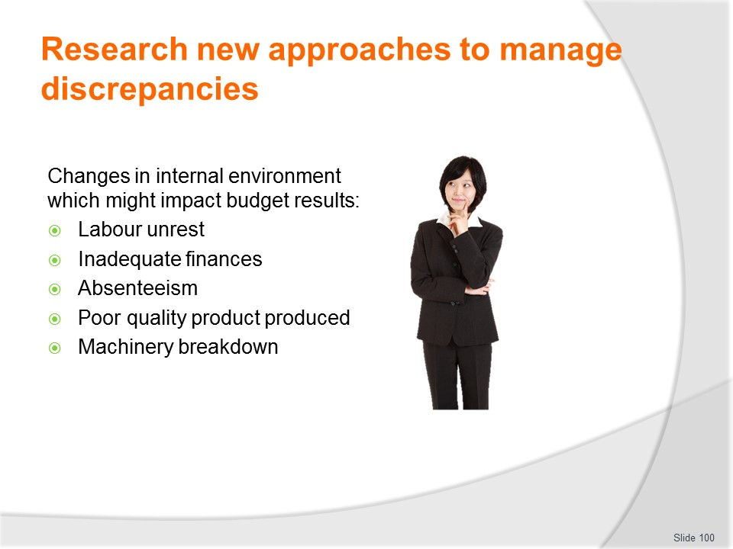
Slide No | Trainer Notes
Trainer identifies changes in the internal and external environments can impact budget outcomes offering examples of changes to the Internal Environment may be due to:
- Labour unrest – staff unhappy with management
- Inadequate finances – such as inadequate working capital
- Absenteeism – staff unhappy and using up their sick leave
- Poor quality food produced – due to poor quality staff, training, ingredients
- Machinery break down – caused by inadequate maintenance, inferior machinery, improper operation.

Slide

Slide No | Trainer Notes
Trainer identifies causes of changes in the external environment which might impact budget outcomes:
- Economic conditions – such as decline in general economic outlook
- Changing legislation – such as new employment laws requiring increased labour cost
- Population change – such as reduced or increased numbers in the local area
- Fashion/taste changes – for example, a style of cuisine is no longer fashionable, or is becoming fashionable

Slide
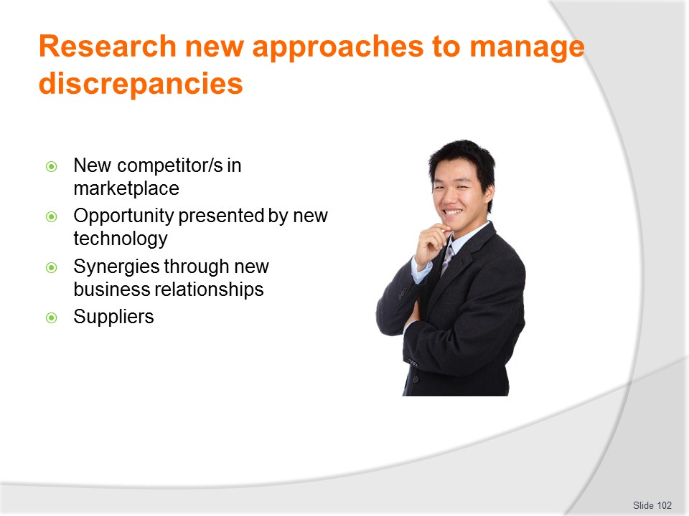
Slide No | Trainer Notes
Trainer continues identifying causes of changes in the external environment which might impact budget outcomes:
- The appearance of a strong new competitor into the marketplace
- Opportunity available through the advent of new technology
- Synergies created as a result of new business partnerships/relationships
- Suppliers – which may require action to:
- Determine if current suppliers can reduce their selling prices – or generate some cost-saving protocols (such as quantity-based discounts or standing orders)
- Identify if new, lower-priced suppliers are available – to provide the same products at a lesser cost
- Evaluate alternative lower-priced products – so the same suppliers provide different products/materials at a reduced cost
- Discuss with them whether processing of certain items can occur on-site – as opposed to buying in pre-processed, and hence more expensive, products.
Class Activity – Guest Speaker
Trainer arranges for relevant business manager/owner to attend and talk to students about their efforts and actions at identifying causes of budget variances and taking appropriate remedial action based on findings.

Slide

Slide No | Trainer Notes
Trainer states standard market research techniques coupled with basic research activities can be used to provide feedback/data on which to base future action/responses to budget circumstances identifying in practice this can involve:
- Personal, targeted observation – take a proactive approach to monitoring and observing what is happening within the business with a view to identifying changes which can (or need to be) made
- Questionnaires – asking guests/customers to complete questionnaires designed to elicit their thoughts about why things are the way they are, and what the organisation can do to better serve them
- Panel interviews/focus groups – assembling groups of past and present customers and asking them about their thoughts.

Slide

Slide No | Trainer Notes
Trainer continues describing possible research techniques:
- Analysis of industry information provided by reputable industry sources – such as peak industry bodies/groups, banks, government authorities and suppliers
- Literature and internet research – involving:
- Reading texts, industry reports and industry journals and reports
- Visiting relevant websites
- Discussion with others – who may be:
- Managers/supervisors within the same business
- Managers at other offices/operations within the same organisation
- Previous incumbents
- Owner-operators of competitor businesses – strange as this sounds, much useful information can be exchanged with those who are essentially competing for the same market especially when the problem being discussed is one of mutual concern.

Slide
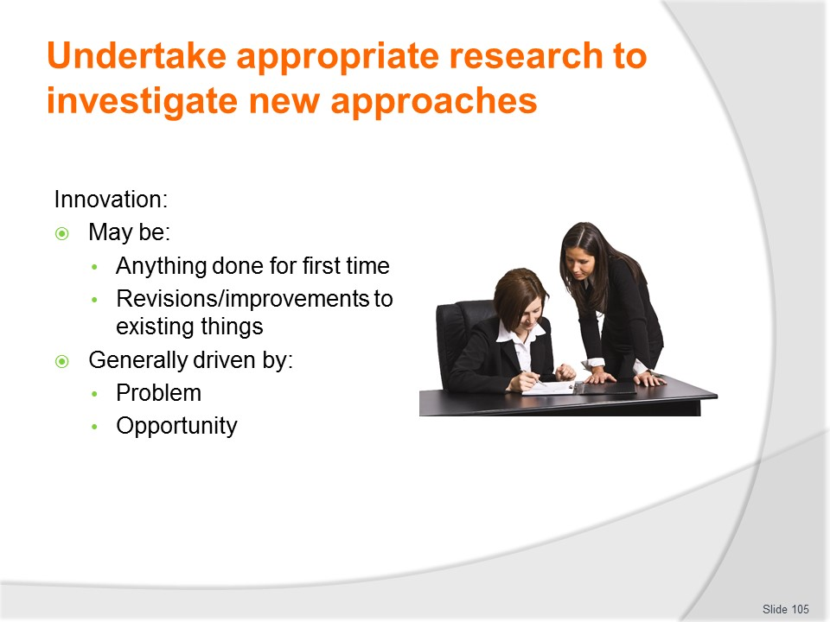
Slide No | Trainer Notes
Trainer discusses innovation as important in developing new approaches observing:
- Innovation can be seen as:
- Anything done for the first time
- Revisions and improvements to existing things
- Innovation in the workplace is generally driven either by:
- A problem, or
- An opportunity.

Slide

Slide No | Trainer Notes
Trainer discusses innovation noting:
- It is a process embracing concepts such as:
- Initiative – being proactive and seizing the moment when a problem or opportunity presents
- Invention – being creative in developing a new (or revised or improved) product, service or response to a given situation or set of circumstances
- Initiation – implementing, monitoring, supporting and reviewing the new, revised or improved product, service or response.

Slide

Slide No | Trainer Notes
Trainer further notes:
- Innovation can be applied to just about anything in the workplace and can be effectively and successfully applied to:
- Systems
- Processes
- Products and services.

Slide
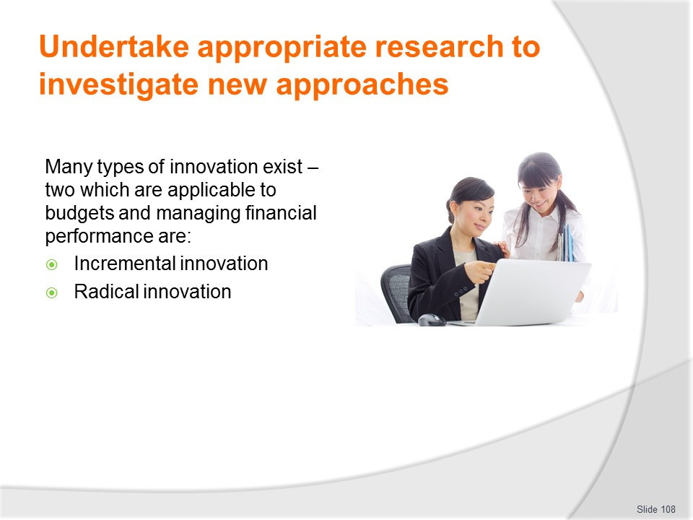
Slide No | Trainer Notes
Trainer discusses types of innovations stating:
- Debate exists about the different types of innovation which exist. Some sources will suggest there are two types and other sources offer up to 15 different types.
- Incremental innovation – where small/modest changes and improvements are made
- Radical innovation – focussing on totally new products and processes.
Classroom Activity – Internet research
Trainer facilitates student internet research into relevant websites such as:
http://www.business.qld.gov.au/business/business-improvement/becoming-innovative-business/innovation-types

Slide
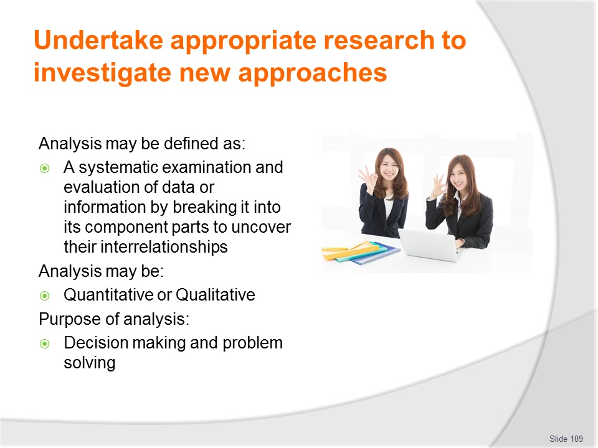
Slide No | Trainer Notes
Trainer highlights:
- Analysis underpins investigation and innovation offering it may be defined as:
- ‘A systematic examination and evaluation of data or information by breaking it into its component parts to uncover their interrelationships’.
- Analysis may be:
- Quantitative – focussed on statistics, numbers, figures, ratios, percentages and hard data
- and/or
- Qualitative – focussed on personal thoughts, opinions and reasons (soft data) which answers business questions such as ‘Why do customers think this way? Why do they act this way? Why do they come to our venue? Why don’t they come to our venue? What would make them visit us?
- The purpose of analysis is to enable fact-based:
- Decision making, and
  - Problem solving
- In relation to ‘innovation’ with respect to managing financial performances within budgets, analysis is seeking to provide facts about:
- What has caused the budget problem to be addressed?
- What is the most effective response to the problem?
- What opportunities in relation to budgets have arisen?
- What is the best response to capitalise on those opportunities?
Class Activity – Discussion
Trainer asks students to identify situations where analysis might be used to address problems with budget performance, and to identify examples of quantitative and qualitative analysis.

Slide
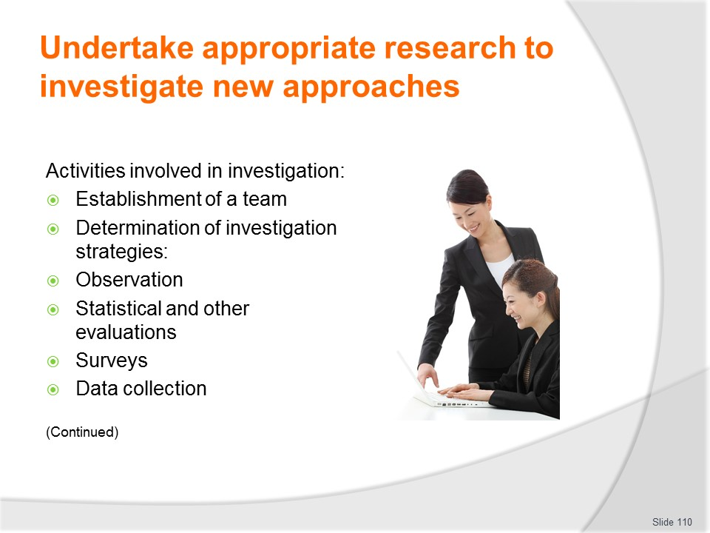
Slide No | Trainer Notes
Trainer notes investigation should involve a range or combination of activities highlighting action relying on just one method/option is highly likely to be flawed and unreliable and identifying activities which are necessary and have proved effective in the process of investigations of this nature include:
- Establishment of team to conduct the investigation – comprising relevant management, support and operational staff appropriate to the nature of the topic (problem or opportunity) being addressed
- Determination and development of strategies to constitute the investigation process – which may include:
- Observation and targeted examination – of:
- Staff practice
- Customer/guest responses to service delivery and products
- Queues and waiting times
- Bottlenecks
- The actions of competitors
- The wider (national and international) business environment
- Evaluation of statistical and written reports – such as:
- All other budgets associated with the budget which is the subject of investigation/action
- All relevant financial and statistical reports
- Costs – this focuses not an amount of expenditure but on type of cost, suppliers used, terms of trade, special deals
- Revenue – with a focus on identification/breakdown (composition) of sources rather than totals looking at (for example) number of persons/tickets sold; types of tickets; number and type of rooms sold; menu items ordered by guests
- Incident and accident reports
- Conducting surveys – face-to-face interviews of, and the application of questionnaires to customers (individuals, families, school groups, tourist groups):
- On arrival – what are they expecting? How did they buy their ticket?
- During their tour, visit or stay
- On departure – to identify visitor satisfaction, suggestions for improvement
- Collection/capture of data and information – involving:
- Review of secondary data – business records and statistics which are available/on file
- Generation of primary data – to fill the gaps left by consideration of your secondary data
- Compilation, manipulation and consideration of soft and hard data.

Slide

Slide No | Trainer Notes
Trainer continues discussing investigation activities:
- Identification of support for implementation of the investigation process – such as:
- Allocation of responsibility for action to nominated persons
- Allocation of resources required to undertake the identified activities which comprise the agreed research/investigation
- Determination of timelines for action, reporting and final analysis and decision making
- Decision making based on analysis and investigation – which may indicate need to:
- Conduct a trial, test or pilot of a proposed initiative – to monitor and evaluate results/outcomes in order to determine viability
- Revise the budget – as appropriate based on findings/analysis, for example in terms of:
- Changing basis on which funds are allocated
- Allocating more/less funds
- Re-calculating projections/expectations
- Take operational action to reflect indicators/facts revealed by the research/analysis/investigation – which can cover an extremely wide range of options such as:
- Altering prices, service standards, suppliers, product mix
- Targeting new markets and revised market positioning
- Closing departments, areas, offices, individual businesses – or expanding the services/hours.
Classroom Activity – Practical Exercise
Trainer provides student with an ‘unacceptable budget outcome/performance’ for a nominated business and asks students to undertake research to identify new approaches to retrieve/improve the budget results.

Slide

Slide No | Trainer Notes
Trainer advises communication methods used will generally involve:
- Written information – which may take the form of:
- Hard copy handouts
- Memorandum
- Emails
- Verbal information – provided at:
- Budget meetings
- Specially convened meetings
- Staff meetings
- Management meetings
- Formal presentation – featuring:
- Written information on boards
- Handouts
- Overhead slides or PowerPoint slides
- Verbal explanations
- Training – which may comprise:
- Theory
- Practical demonstrations
- Case studies
- Exercises.

Slide

Slide No | Trainer Notes
Trainer identifies those who may need to be communicated with can include:
- Owners
- Senior managers
- Head office representatives
- Administration and office/support (accounting and bookkeeping) staff
- Operational staff – with direct involvement with the initiative to be introduced.

Slide
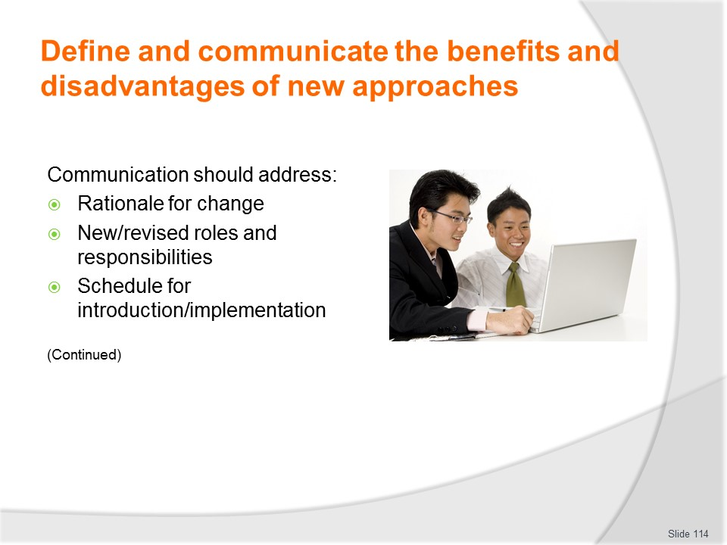
Slide No | Trainer Notes
Trainer advises content of communication relating to new approaches should address:
- Rationale for the changes – explaining why the changes were needed, what triggered them and what was likely to happen if the changes were not introduced
- Identification of options considered but rejected – as part of the investigation process, together with:
- Details of the research undertaken
- Reasons for rejection
- New/revised roles and responsibilities – of individual staff impacted by the initiatives
- Schedule for introduction – which may detail:
- Transitional arrangements
- Dates for implementation.

Slide

Slide No | Trainer Notes
Trainer continues advising content of communication relating to new approaches:
- Support for the change – for example in terms of:
- Resources
- Training
- New/revised authorisations/scopes of authority
- Policies and procedures
- Benefits and disadvantages attaching to the new approach – as appropriate to:
- Business viability and expected results/outcomes
- Operations on a practical day-to-day basis
- Customers
- Strategies/advice for dealing with identified potential customer disappointment/dissatisfaction as a result of the new approaches must also be included.
- Distribution of relevant documentation – such as:
- New/revised budgets
- New/revised formulae for determining budget percentages
- New/revised pro forma documents
- New/revised policies and procedures to support the new/revised approaches.
Classroom Activity – Guest Speaker
Trainer arranges Guest Speaker to attend and talk to students about addressing unacceptable budget results and the action they take to identify causal factors and determine appropriate action to take in response/to retrieve the situation.

Slide
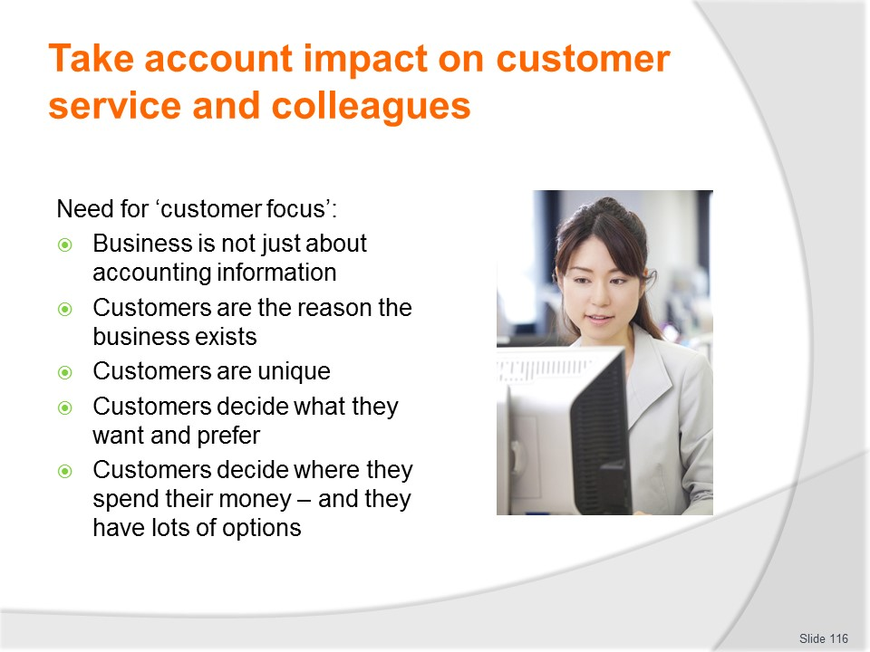
Slide No | Trainer Notes
Trainer presents information about need for customer focus in business stating:
- In what is essentially an accounting/financial-based unit it is important to be reminded of the customer in a business sense
- A customer can be seen as:
- A person on the receiving end of what the business offers
- Someone who is willing to pay a fair price for a quality product and wants to be neither over-charged nor under-served
- The reason the company is in business
- Someone who has certain needs and wants them filled and who, if the business cannot fill those needs will go to a competitor who will
- Unique.
Class Activity – Handout and Discussion
Trainer distributes ‘The Customer is …’ from Trainee Manual and leads a discussion about exactly what customers are and their importance to business.

Slide
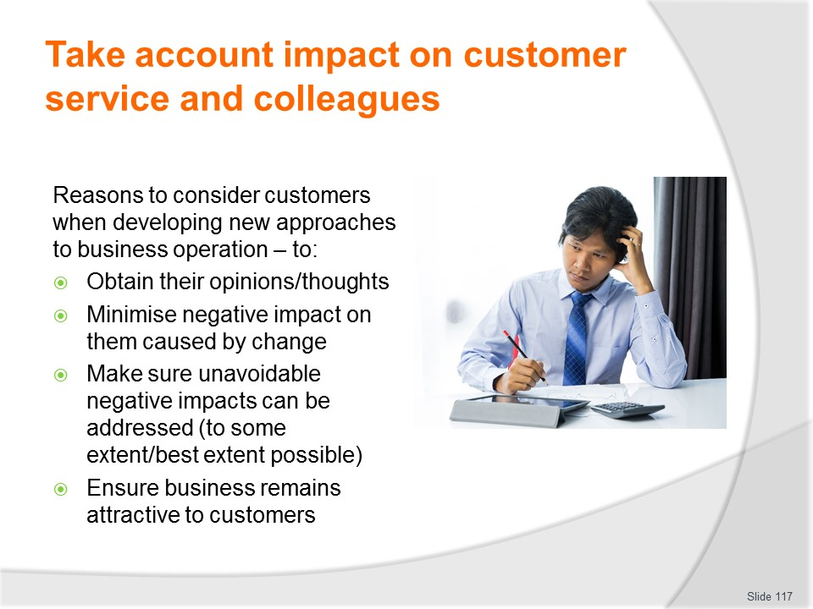
Slide No | Trainer Notes
Trainer highlights reasons to consider the customer when developing new approaches are to make sure:
- Their opinions and thoughts are captured – and factored into decisions
- Negative impacts on them are eliminated or at least minimised
- Action is developed to address potentially negative impacts
- The business and what is provides remains attractive to the customers the organisation wants to serve.

Slide
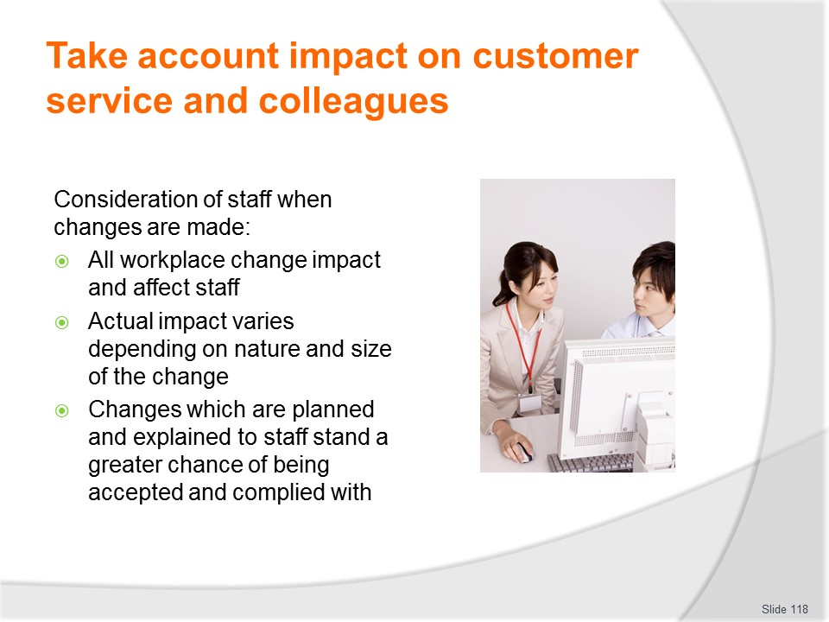
Slide No | Trainer Notes
Trainer introduces consideration of staff when new approaches are considered stating:
- Any changes made in the workplace – regardless of how small they may appear – are likely to have repercussions
- The impacts of the changes will vary depending on the nature and size of the changes, together with those who are affected, and how the change is explained and introduced
- Any change that is explained to those whom it affects stands a much greater chance of being accepted and genuinely complied with
- Change may be planned or unplanned
- While it is not possible to plan all changes required in the workplace, planned change stands a far better chance of effective implementation than unplanned change does.

Slide
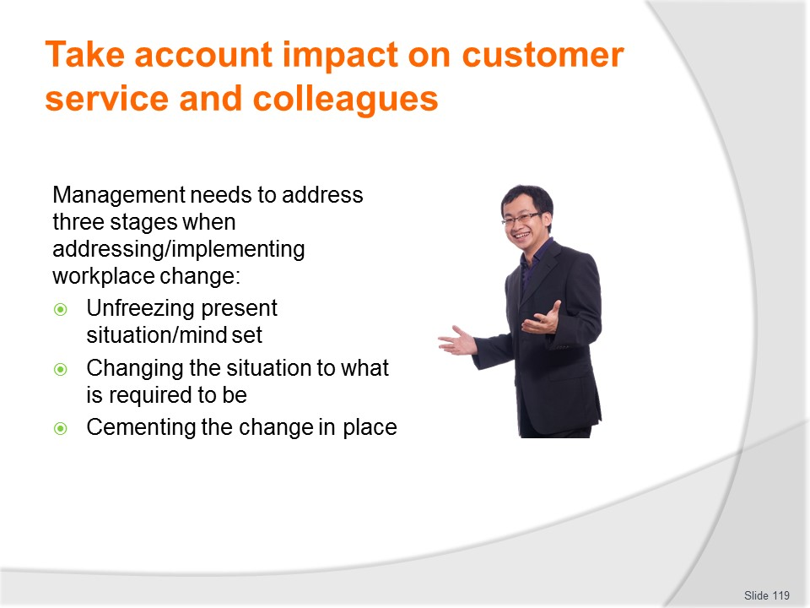
Slide No | Trainer Notes
Trainer provides further information regarding ensuring changes impacting on staff are considered before implementation and are effectively implemented stating:
- Whether the change is planned or unplanned, it may be seen as requiring the supervisor to work through three phases:
- Unfreezing the present situation/mind set
- Changing the situation to the way it is to be
- Resetting the change into the established and accepted working routine of staff
- The basis for successfully implementing change is the provision of sound, honest, accurate, up-to-date information about the topic in question
- Supervisors and managers wanting to implement workplace change must be able to access/source sufficient information to pass on to staff to allay their fears, explain the change and ‘prove’ its worth
- Explanation and a timeline for introduction will smooth the transitions: adjustments can always be made to anything provided sufficient attention and support is provided.

Slide
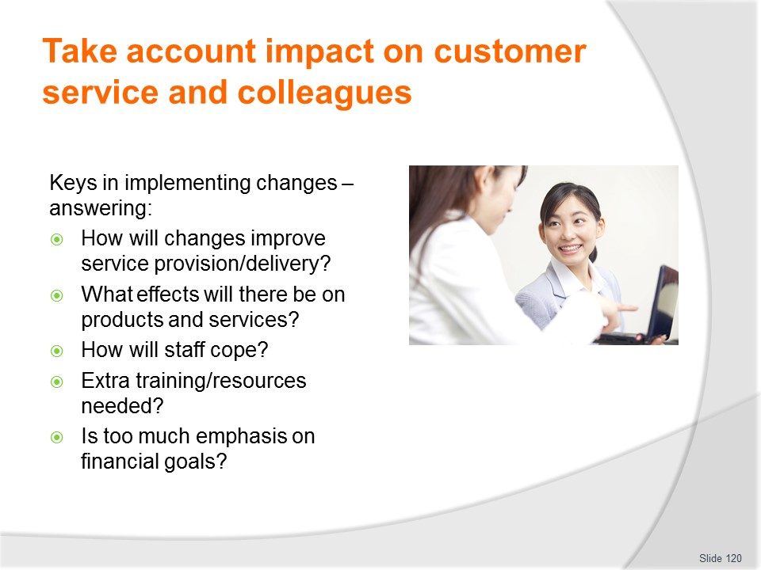
Slide No | Trainer Notes
Trainer identifies keys to implementing the changes include being able to provide answers to the following questions:
- How will this improve customer service?
- What effects will it have on products and services?
- How will the staff cope?
- Are extra training/resources required?
- Is there now too much emphasis on financial goals?
Class Activity- Small group work
Trainer presents several options for change to be introduced to a business and asks groups to consider:
- Impacts of these on customers
- Responses to optimise acceptance and minimise negative impact on them
- Impacts of changes on staff
- Ways to minimise negative impact on staff and optimise compliance with new approaches.

Slide
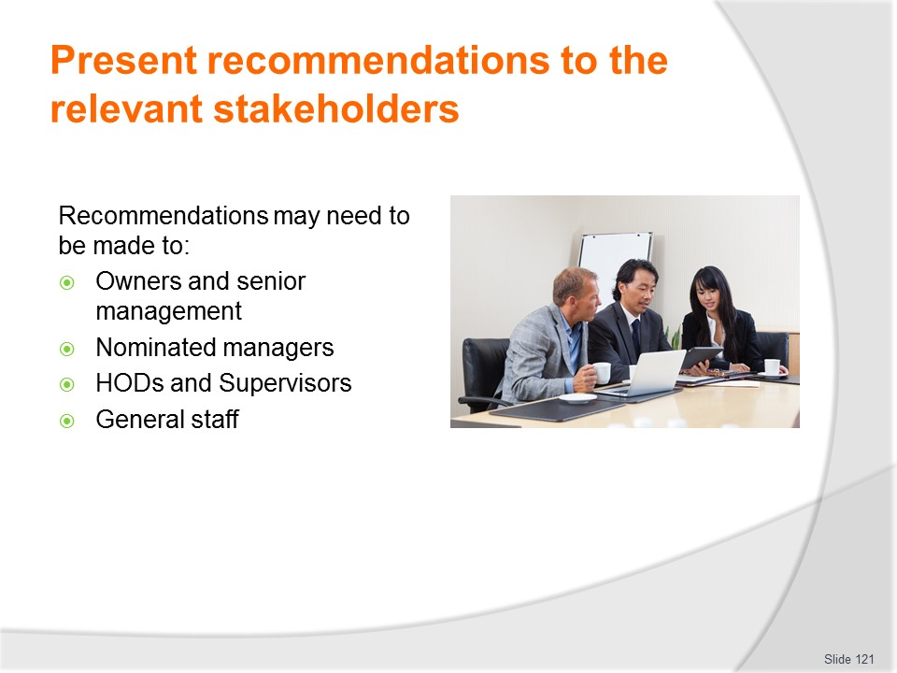
Slide No | Trainer Notes
Trainer advises recommendations may need be presented to:
- Senior management
- Owners
- Personnel manager
- Sales manager
- Finance manager
- Heads of departments
- Supervisors
- General staff.

Slide
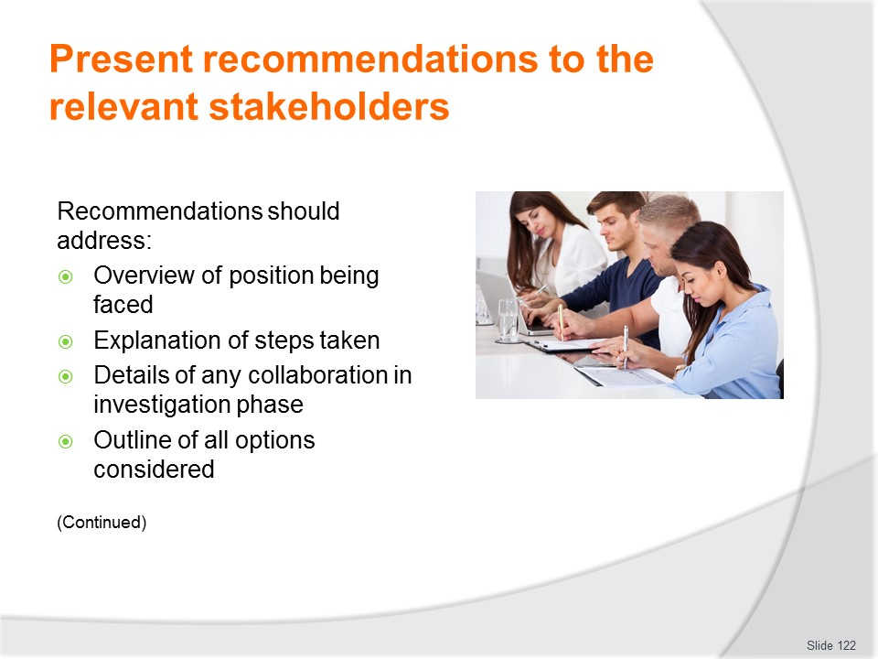
Slide No | Trainer Notes
Trainer stresses it is essential recommendations are made in a clear, logical and in a timely fashion highlighting they should address the following points:
- An overview of the position being faced – and some background to the problem/issue being addressed
- Explanation of the steps which have been taken – to investigate, research and illuminate the issue
- Detail of any collaboration that was undertaken as part of the research/investigation process – including co-operation from various areas, and input made from different sources
- An overview/outline of all the possible solutions which were identified – this should include relevant costs, any perceived difficulties with implementation (legislative problems; staff training requirements; alterations to policies, procedures and practices; changes to service times or standards).

Slide
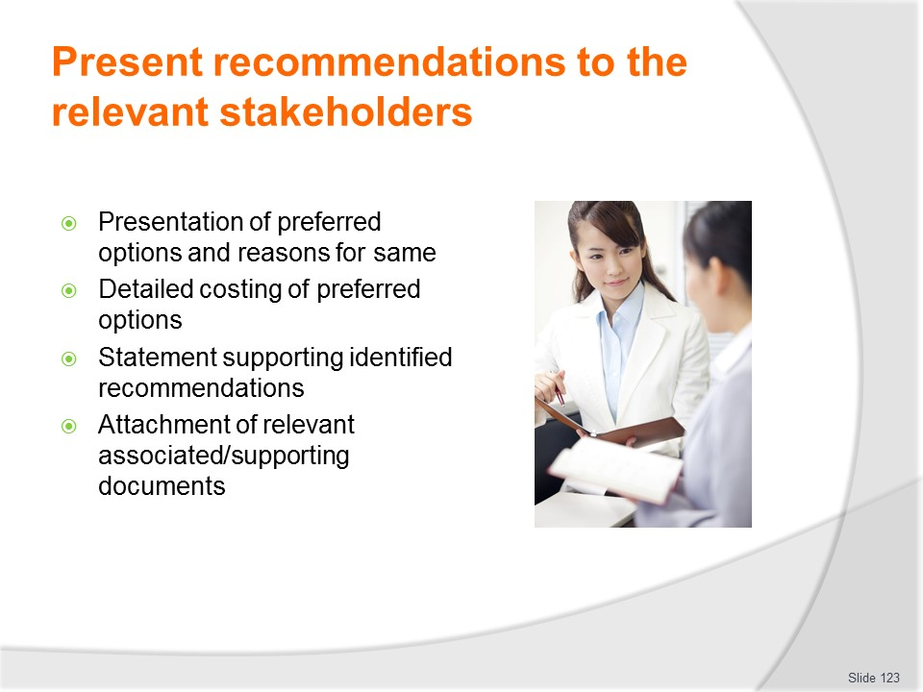
Slide No | Trainer Notes
Trainer continues identifying content of recommendations:
- Presentation of preferred options – and why they were chosen over the others identified above
- Detailed costings for the preferred options – together with timelines for implementation, identification of problems with implementation, and plans to overcome the identified problems
- A final paragraph urging the suggested recommendations – giving personal endorsement and noting expectation of unanimous support from others
- Attachments of relevant documentation the processes uncovered – such as:
- Quotes
- Written recommendations from others
- Relevant extracts from pieces of legislation
- Reports
- Articles
- Suppliers’ data – terms of trade, purchasing guides.

Slide
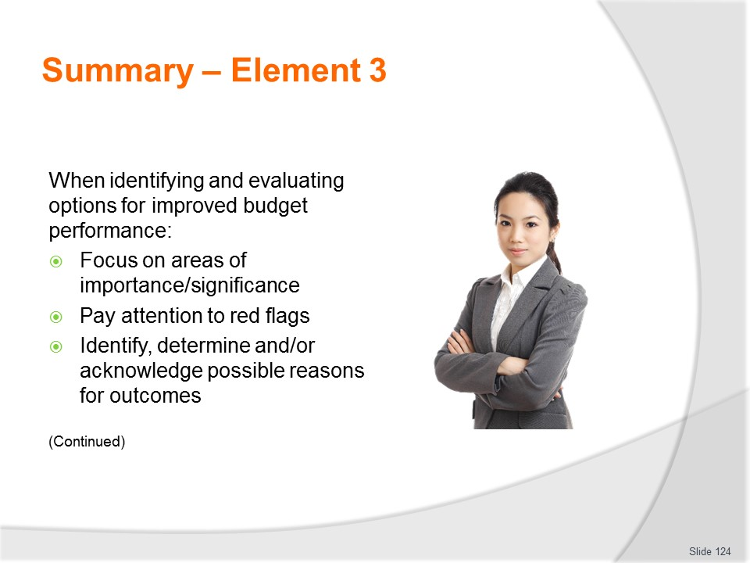
Slide No | Trainer Notes
 | Trainer provides a recap of the Element asking questions to check trainee understanding and responding to questions from trainees, as required.

Slide
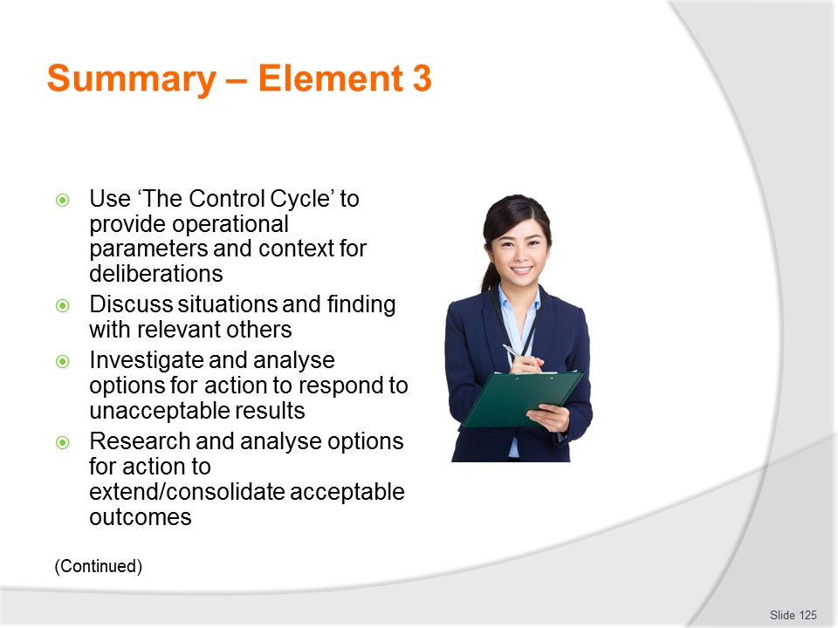
Slide No | Trainer Notes
 | Trainer provides a recap of the Element asking questions to check trainee understanding and responding to questions from trainees, as required.

Slide
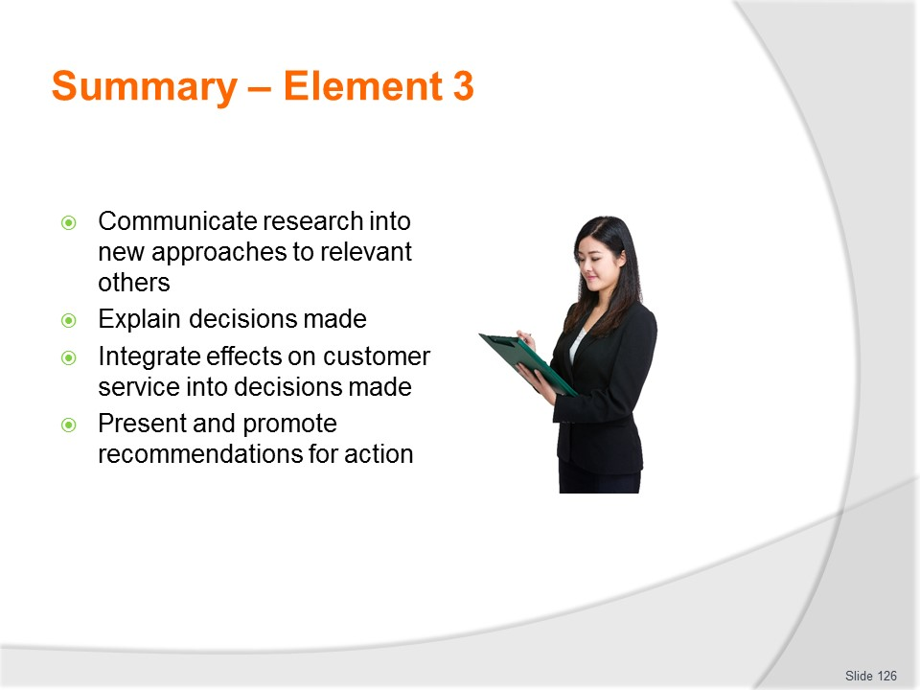
Slide No | Trainer Notes
 | Trainer provides a recap of the Element asking questions to check trainee understanding and responding to questions from trainees, as required.

Slide
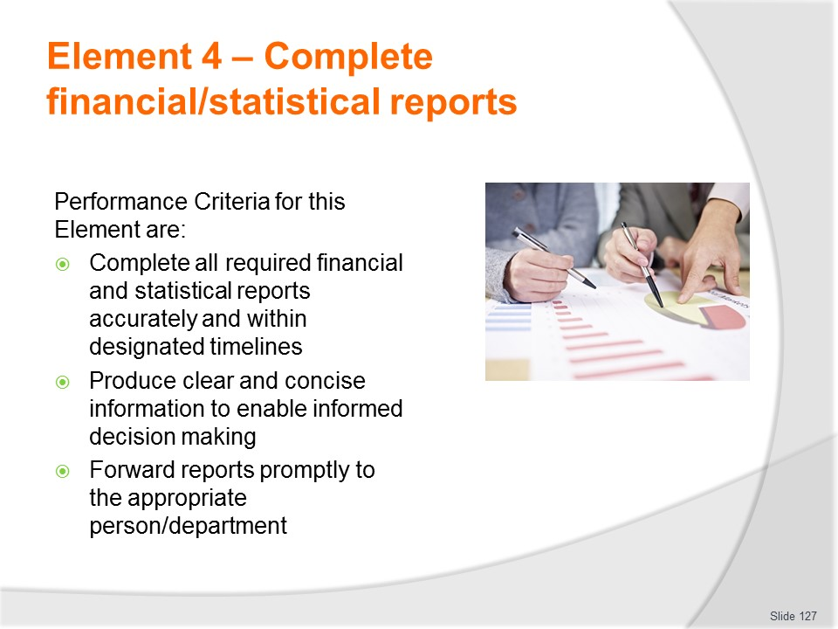
Slide No | Trainer Notes
Trainer identifies for trainees the Performance Criteria for this Element, as listed on the slide.
Class Activity – General Discussion
Trainer leads a general class discussion by asking questions such as:
- What reports need to be completed?
- What timelines apply preparing these reports?
- Who might be responsible for their preparation?
- Why do they need to be prepared?
- What decisions might flow as a result of information contained in these reports?
- How might these reports be forwarded?
- Who might they be forwarded to?

Slide
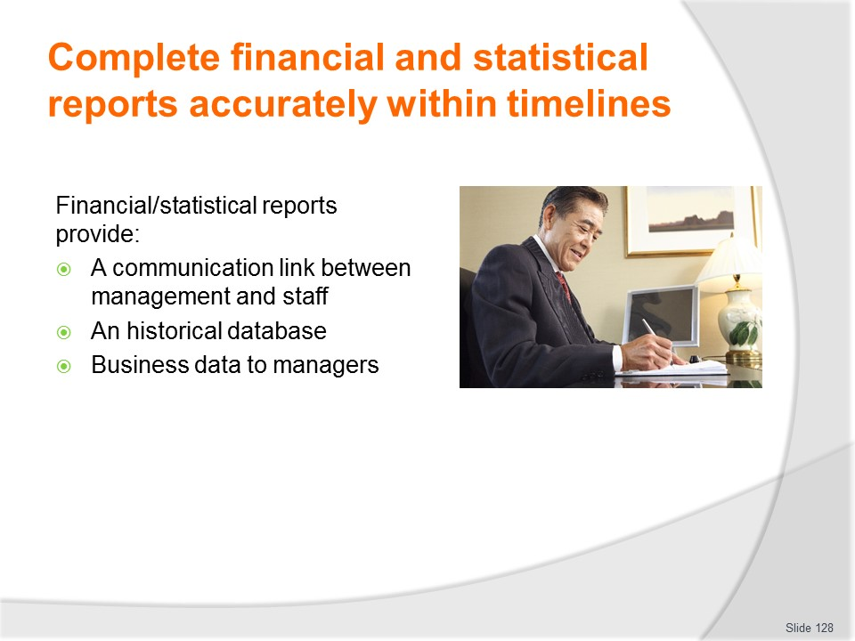
Slide No | Trainer Notes
Trainer advises operational reports can be seen as providing:
- A communication link between management and staff – in an organisation where, say, the business operates 24 hours per day, seven days each week no-one can be there all the time so these reports provide one way of making sure everyone receives vital information they need in order to do their job
- An historical database – which builds into a useful management tool available to be used to assist with future deliberations and predictions
- Business data to managers – which can inform and assess operational performance against budgets.

Slide
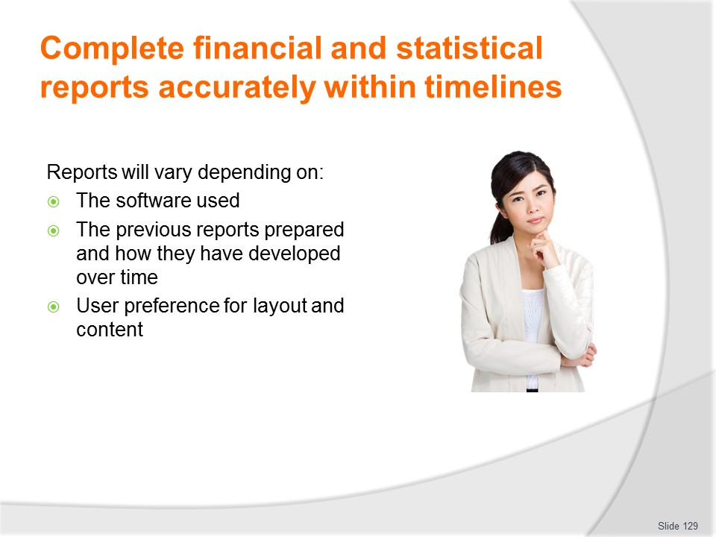
Slide No | Trainer Notes
Trainer states a ‘typical’ report probably does not exist as their format and content varies widely depending on:
- The software in use – to produce the reports
- Historical use of paper-based documents – and how they have changed/emerged over time to best suit the needs of the business
- User preference – for layout and content.

Slide
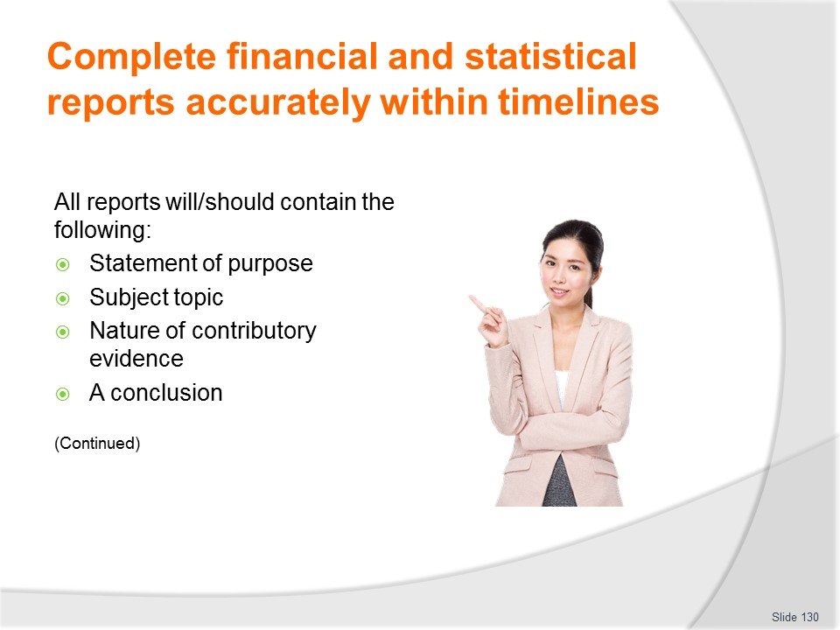
Slide No | Trainer Notes
Trainer explains all reports will/should contain certain basic elements:
- A statement of purpose – identifying the type of report and its intention – so readers are clear about what each report is all about
- Subject topic – a note explaining the exact focus of the document
- The nature of the contributory evidence – explanation or verification of sources, information and the period used as the basis for the report
- A conclusion – a plan of action flowing from the evidence contained and logical in nature, formulated from the proof/facts provided in the report.

Slide
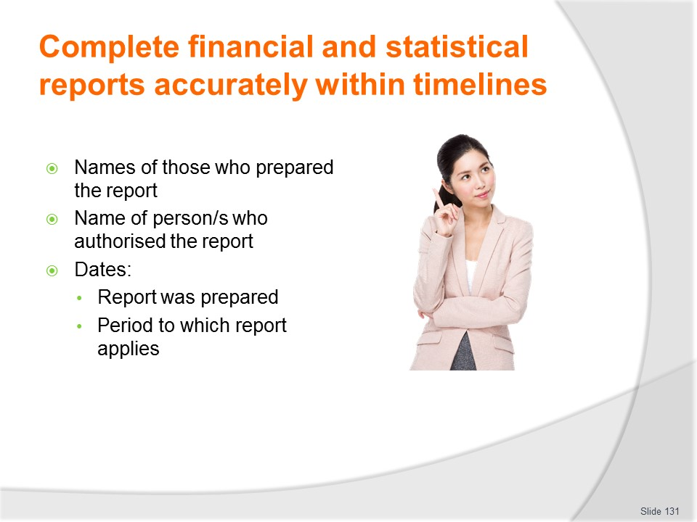
Slide No | Trainer Notes
Trainer continues explaining contents of reports:
- Identification as to who generated the report – together with its intended target audience (by individual names or positions/titles)
- Authorisation – an indication as to who has authorised the report.
- Date of the report – in terms of:
- Date report was prepared
- Period to which report relates.

Slide
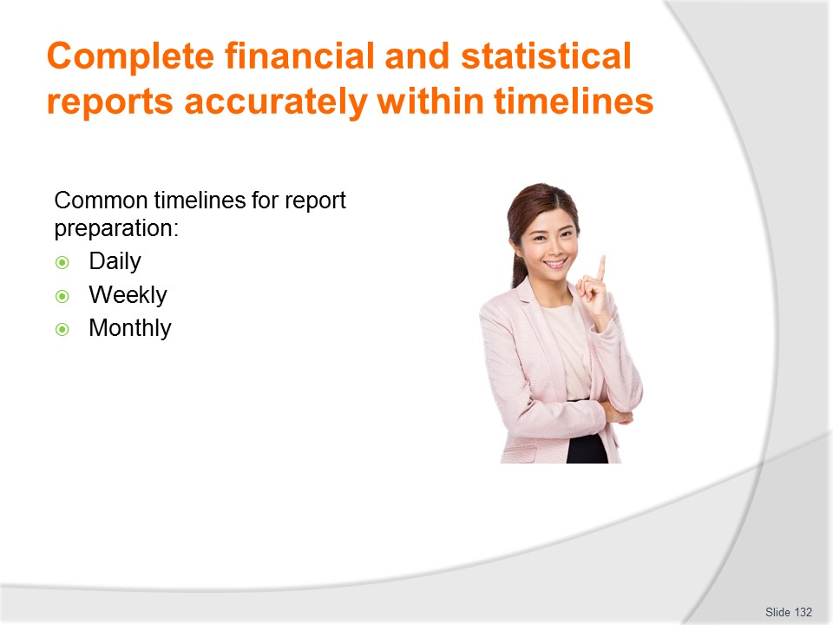
Slide No | Trainer Notes
Trainer highlights each business will determine what it regards as ‘designated timelines’ for budget reports noting these timelines commonly include:
- Daily
- Weekly
- Monthly.
It is not common for budget-related reports to be prepared on a daily basis even though other operational reports (for example, ‘exception reports’) are often generated on this basis.

Slide
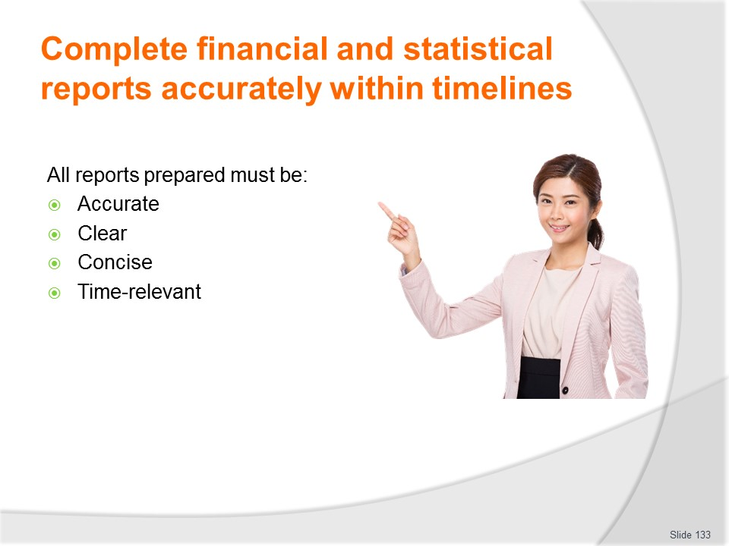
Slide No | Trainer Notes
- Trainer emphasises it is essential all reports prepared are:
- Accurate – they must:
- Be honest in what they contain
- Contain all relevant data for the period in question
- Never intentionally include misleading information
- Never intentionally exclude important negative data
- Reflect actual performance, results and outcomes
- Clear – they must:
- Easily understood
- Be prepared in accordance with the accepted format/layout for the individual business
- Use simple language and standard accounting-based terminology (see below)
- Concise – they should:
- Avoid unnecessary information
- Provide the basics – the reader is then obliged to follow-up issues/figures doing their own research and investigation
- Include additional/supplementary and/or explanatory information as Appendices to the report
- Time-relevant – they must:
- Be prepared in a timely manner – by the times required by the organisation or as imposed by external requirements
- Be clearly annotated to show the period to which they relate
- Contain comparative data to allow evaluations with other time periods.

Slide
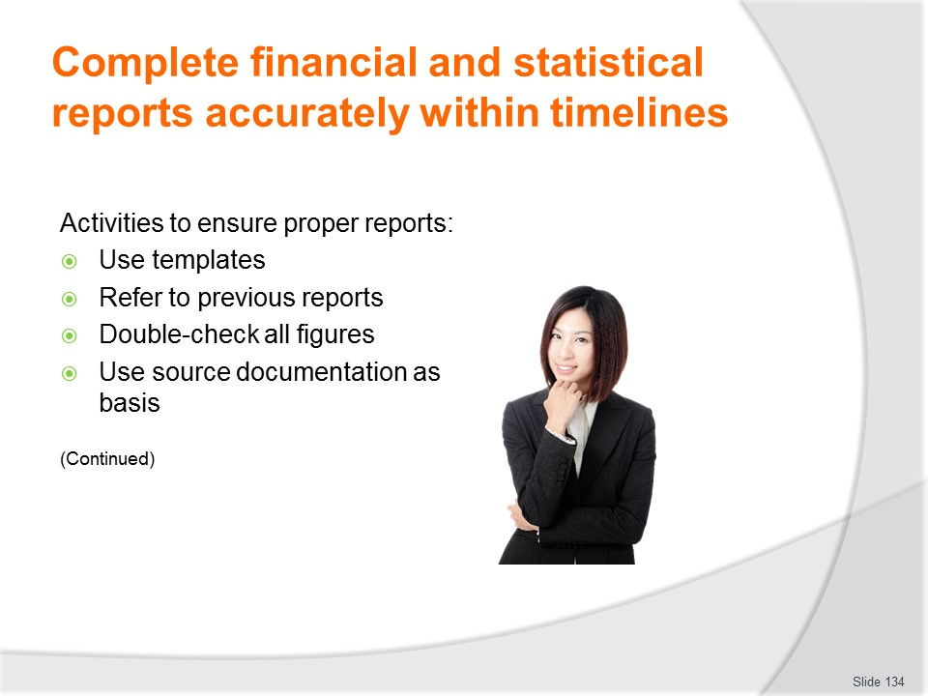
Slide No | Trainer Notes
Trainer notifies to help achieve what is required for reports the following should apply:
- Use pro forma templates – as the basis for preparing reports
- Refer to previous sample reports for the purposes of modelling production of reports – in terms of topics such as layout, information contained, detail
- Double-check all figures used – looking for transposition errors
- Use source documentation – as the basis for statistics included.

Slide
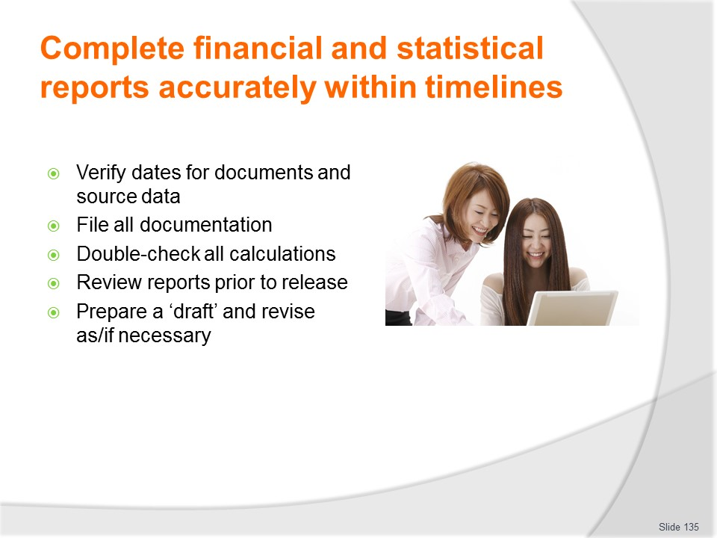
Slide No | Trainer Notes
Trainer continues identifying and describing activities to ensure proper reports:
- Verify the period to which source data relates – to ensure only statistics for the period in question are being used
- Ensure all source materials are filed – and available for further reference if required
- Double-check all calculations – to verify totals, extensions and percentages correct
- Review reports prior to release/distribution – to check for errors and omissions
- Provide a ‘draft’ version of the report to a trusted colleague (or designated internal person) for their perusal and approval – prior to finalising the report and releasing it for general consumption.

Slide
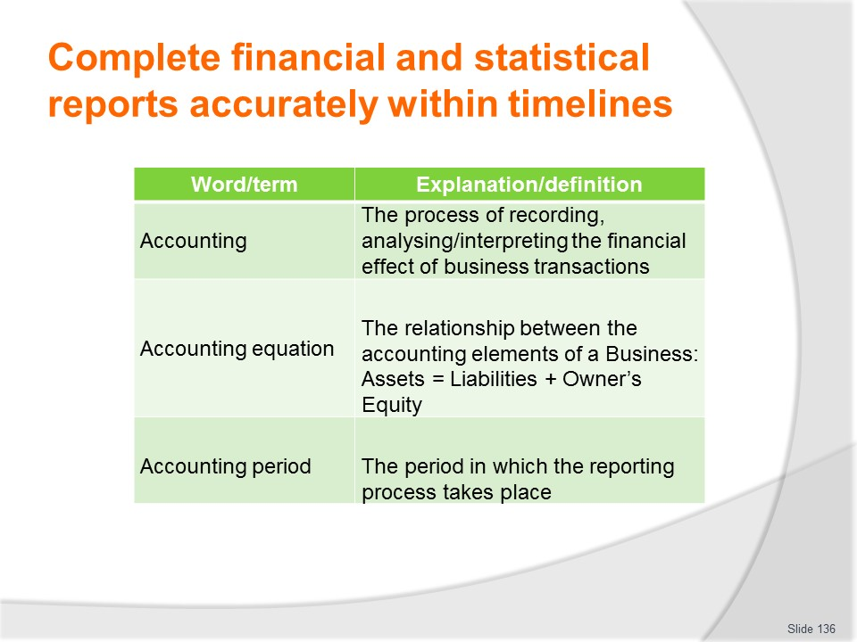
Slide No | Trainer Notes
Trainer presents a range of terms relevant to accounting and report preparation.
Class Activity
Trainer asks students to describe the terms presented and either confirms their answers or provides the correct explanation/definition.
Trainer should cover the ‘Explanation/definition’ column and reveal one-by-one as required.

Slide
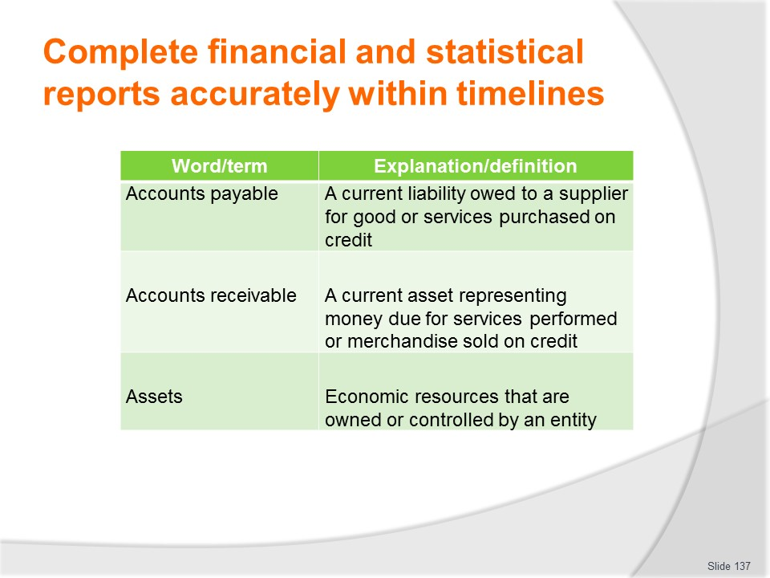
Slide No | Trainer Notes
Trainer presents a range of terms relevant to accounting and report preparation.
Class Activity
Trainer asks students to describe the terms presented and either confirms their answers or provides the correct explanation/definition.
Trainer should cover the ‘Explanation/definition’ column and reveal one-by-one as required.

Slide
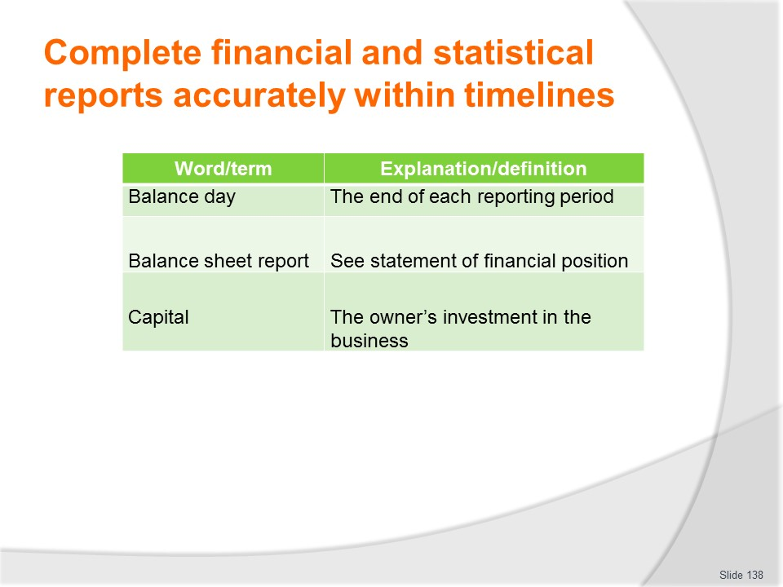
Slide No | Trainer Notes
Trainer presents a range of terms relevant to accounting and report preparation.
Class Activity
Trainer asks students to describe the terms presented and either confirms their answers or provides the correct explanation/definition.
Trainer should cover the ‘Explanation/definition’ column and reveal one-by-one as required.

Slide
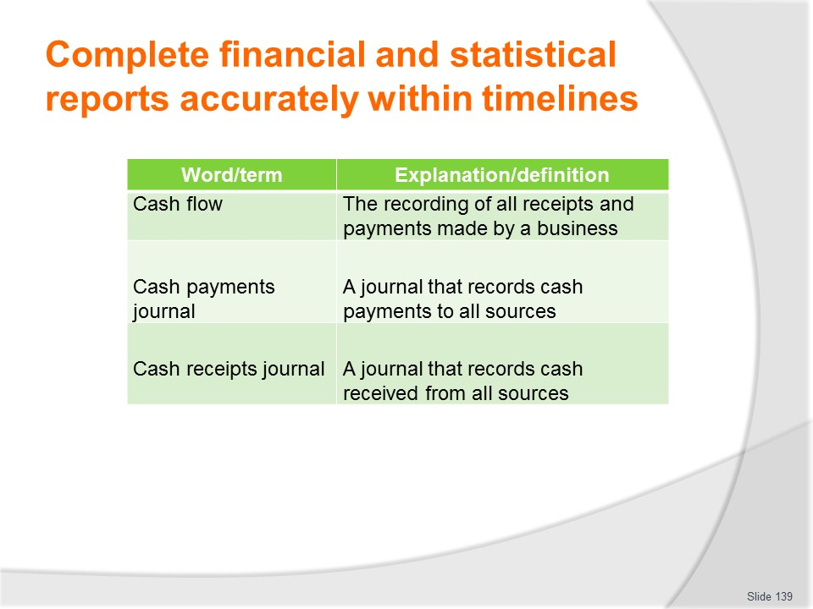
Slide No | Trainer Notes
Trainer presents a range of terms relevant to accounting and report preparation.
Class Activity
Trainer asks students to describe the terms presented and either confirms their answers or provides the correct explanation/definition.
Trainer should cover the ‘Explanation/definition’ column and reveal one-by-one as required.

Slide
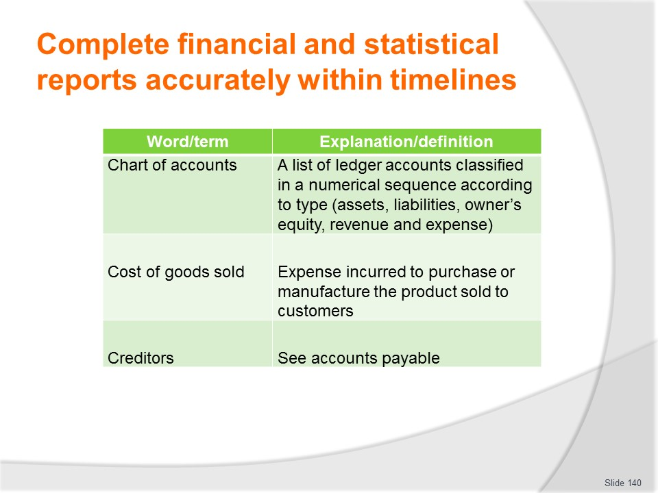
Slide No | Trainer Notes
Trainer presents a range of terms relevant to accounting and report preparation.
Class Activity
Trainer asks students to describe the terms presented and either confirms their answers or provides the correct explanation/definition.
Trainer should cover the ‘Explanation/definition’ column and reveal one-by-one as required.

Slide
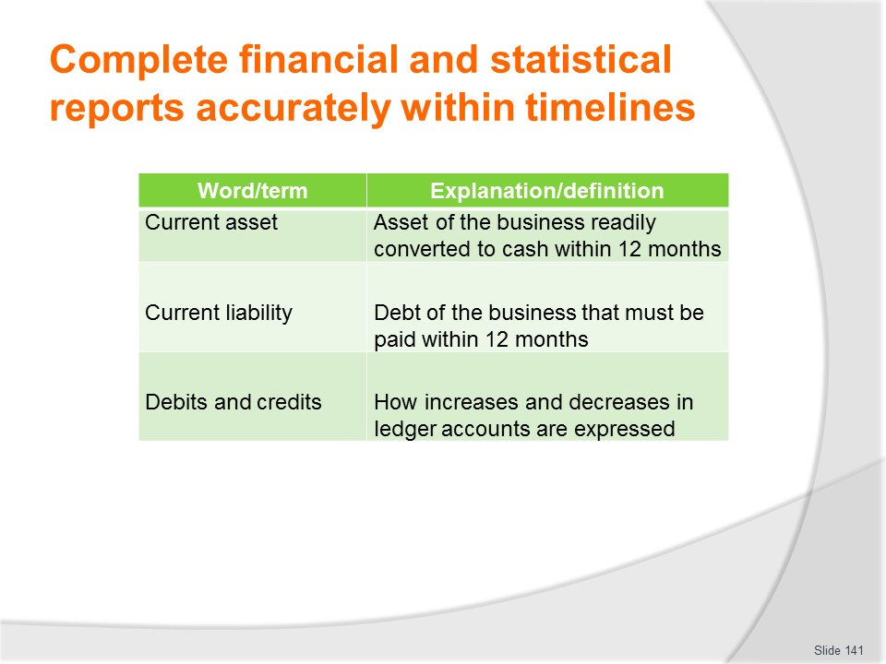
Slide No | Trainer Notes
Trainer presents a range of terms relevant to accounting and report preparation.
Class Activity
Trainer asks students to describe the terms presented and either confirms their answers or provides the correct explanation/definition.
Trainer should cover the ‘Explanation/definition’ column and reveal one-by-one as required.

Slide
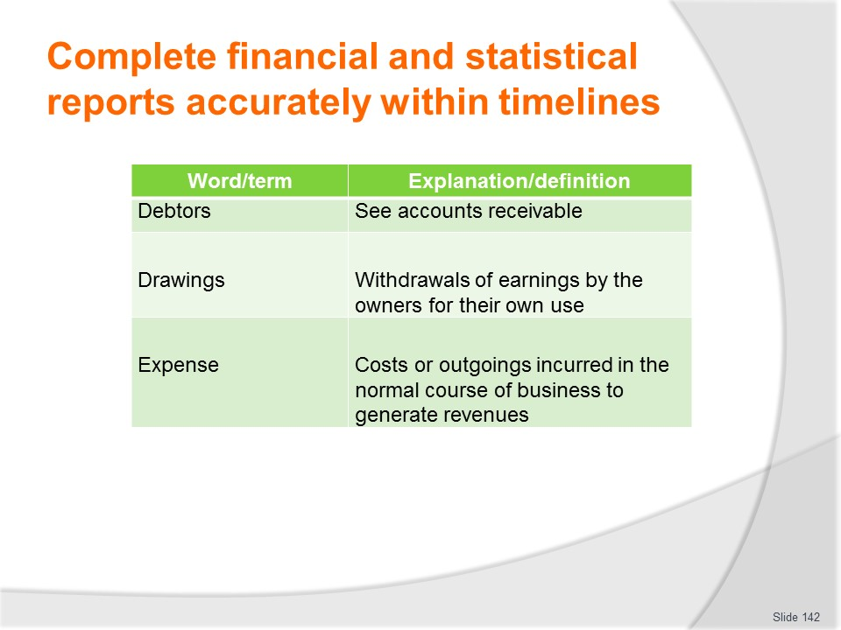
Slide No | Trainer Notes
Trainer presents a range of terms relevant to accounting and report preparation.
Class Activity
Trainer asks students to describe the terms presented and either confirms their answers or provides the correct explanation/definition.
Trainer should cover the ‘Explanation/definition’ column and reveal one-by-one as required.

Slide
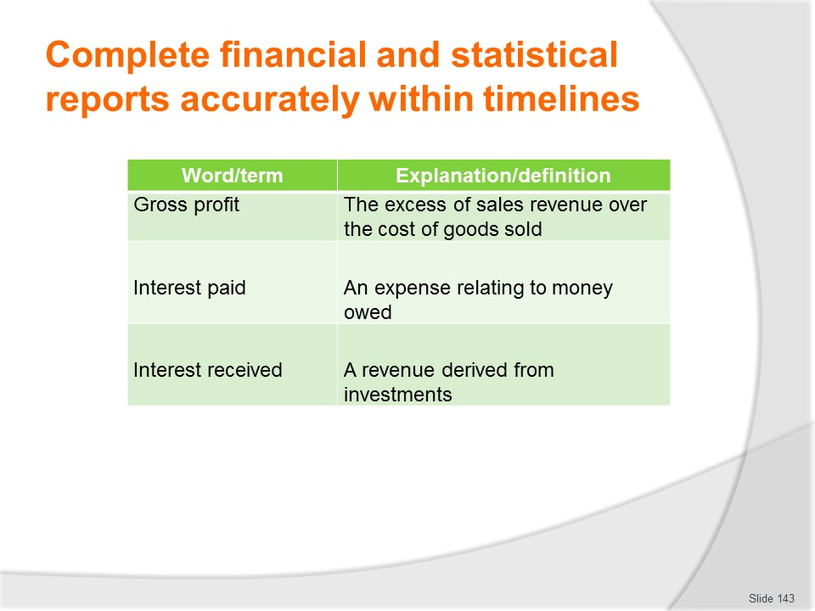
Slide No | Trainer Notes
Trainer presents a range of terms relevant to accounting and report preparation.
Class Activity
Trainer asks students to describe the terms presented and either confirms their answers or provides the correct explanation/definition.
Trainer should cover the ‘Explanation/definition’ column and reveal one-by-one as required.

Slide
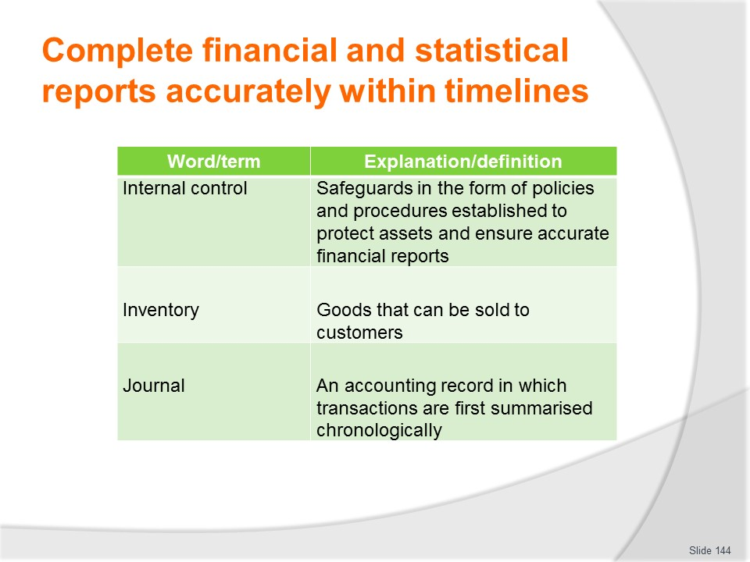
Slide No | Trainer Notes
Trainer presents a range of terms relevant to accounting and report preparation.
Class Activity
Trainer asks students to describe the terms presented and either confirms their answers or provides the correct explanation/definition.
Trainer should cover the ‘Explanation/definition’ column and reveal one-by-one as required.

Slide
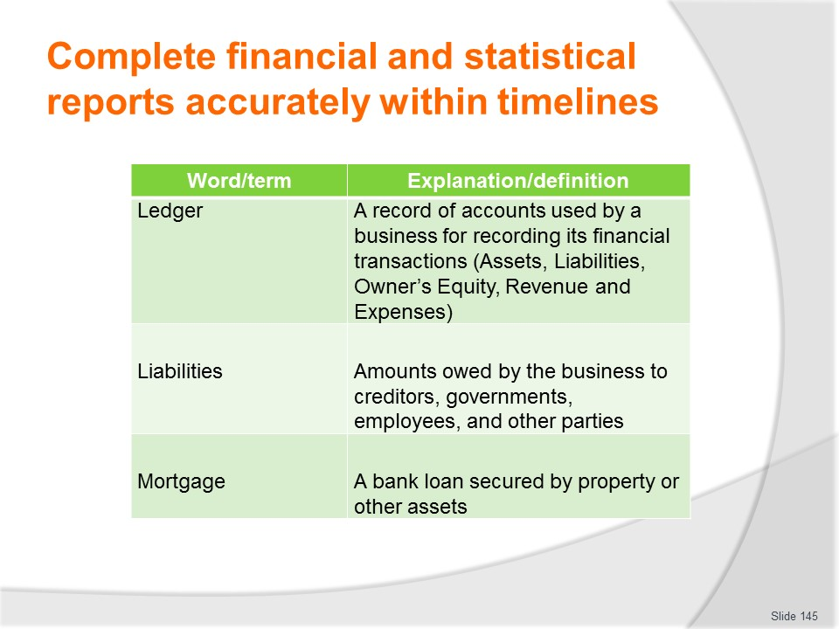
Slide No | Trainer Notes
Trainer presents a range of terms relevant to accounting and report preparation.
Class Activity
Trainer asks students to describe the terms presented and either confirms their answers or provides the correct explanation/definition.
Trainer should cover the ‘Explanation/definition’ column and reveal one-by-one as required.

Slide
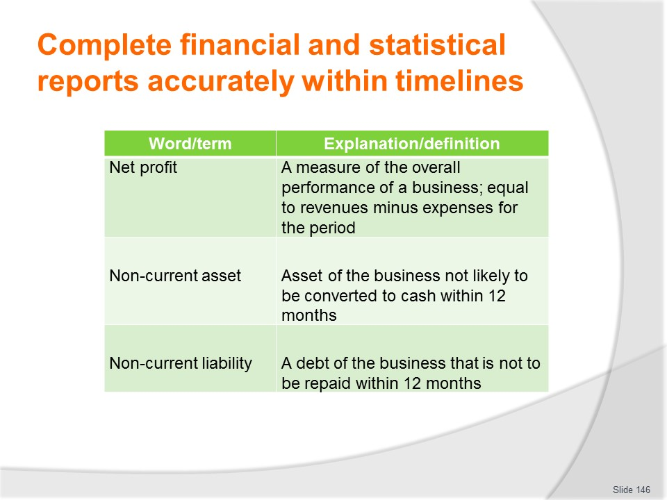
Slide No | Trainer Notes
Trainer presents a range of terms relevant to accounting and report preparation.
Class Activity
Trainer asks students to describe the terms presented and either confirms their answers or provides the correct explanation/definition.
Trainer should cover the ‘Explanation/definition’ column and reveal one-by-one as required.

Slide
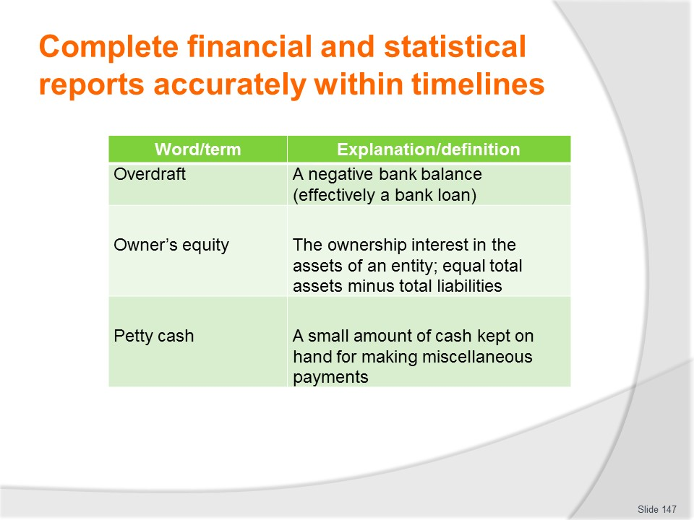
Slide No | Trainer Notes
Trainer presents a range of terms relevant to accounting and report preparation.
Class Activity
Trainer asks students to describe the terms presented and either confirms their answers or provides the correct explanation/definition.
Trainer should cover the ‘Explanation/definition’ column and reveal one-by-one as required.

Slide
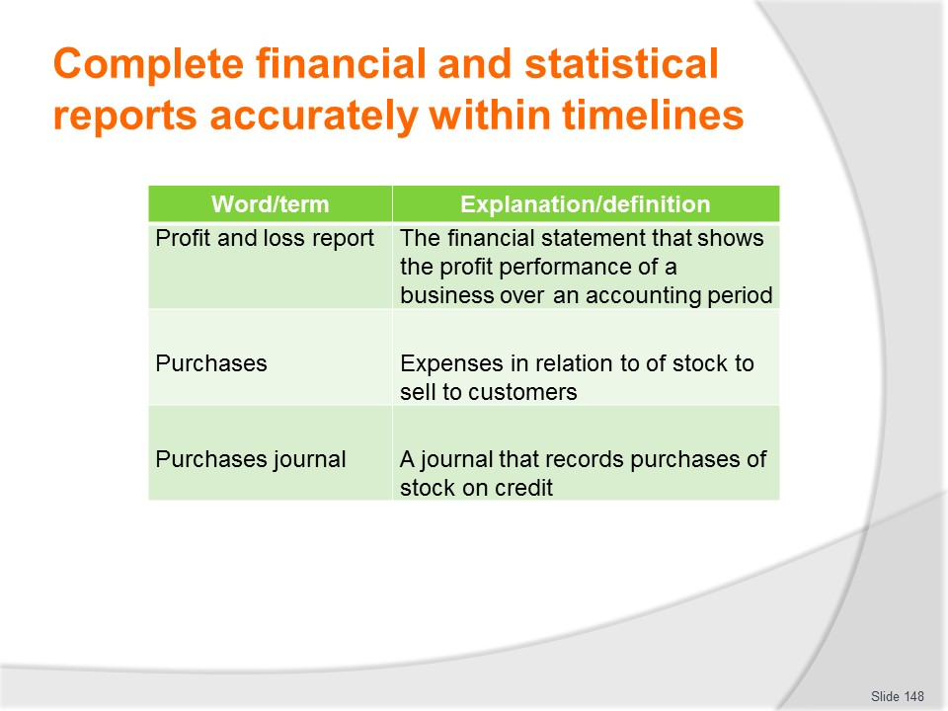
Slide No | Trainer Notes
Trainer presents a range of terms relevant to accounting and report preparation.
Class Activity
Trainer asks students to describe the terms presented and either confirms their answers or provides the correct explanation/definition.
Trainer should cover the ‘Explanation/definition’ column and reveal one-by-one as required.

Slide
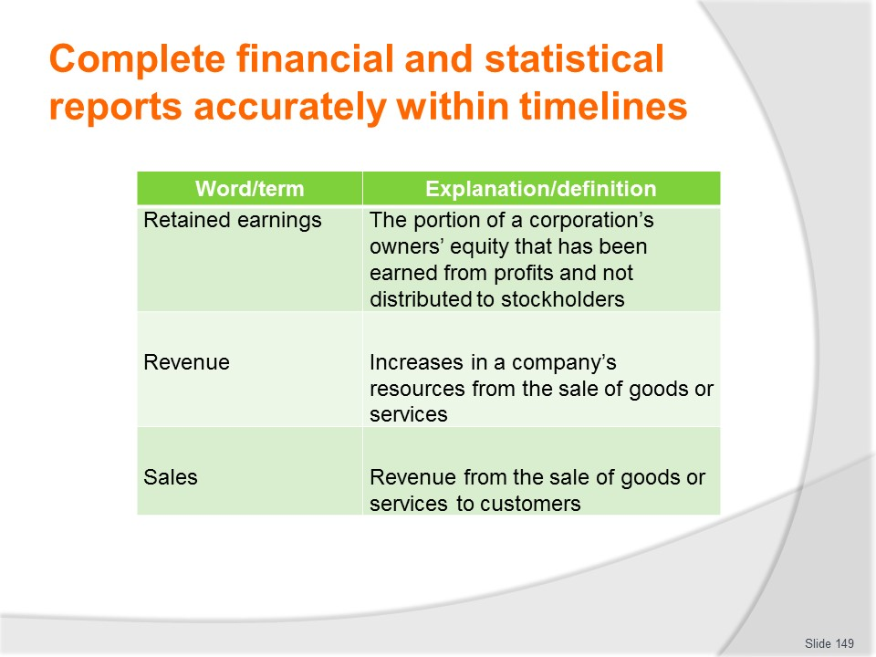
Slide No | Trainer Notes
Trainer presents a range of terms relevant to accounting and report preparation.
Class Activity
Trainer asks students to describe the terms presented and either confirms their answers or provides the correct explanation/definition.
Trainer should cover the ‘Explanation/definition’ column and reveal one-by-one as required.

Slide
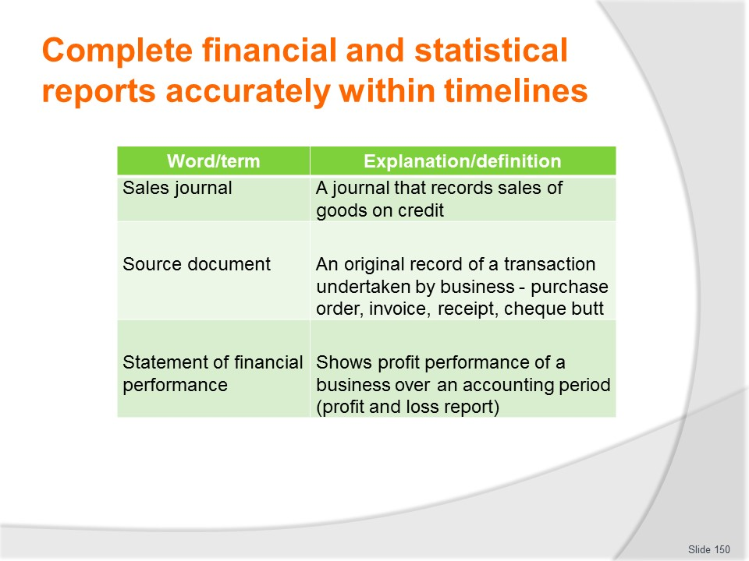
Slide No | Trainer Notes
Trainer presents a range of terms relevant to accounting and report preparation.
Class Activity
Trainer asks students to describe the terms presented and either confirms their answers or provides the correct explanation/definition.
Trainer should cover the ‘Explanation/definition’ column and reveal one-by-one as required.

Slide
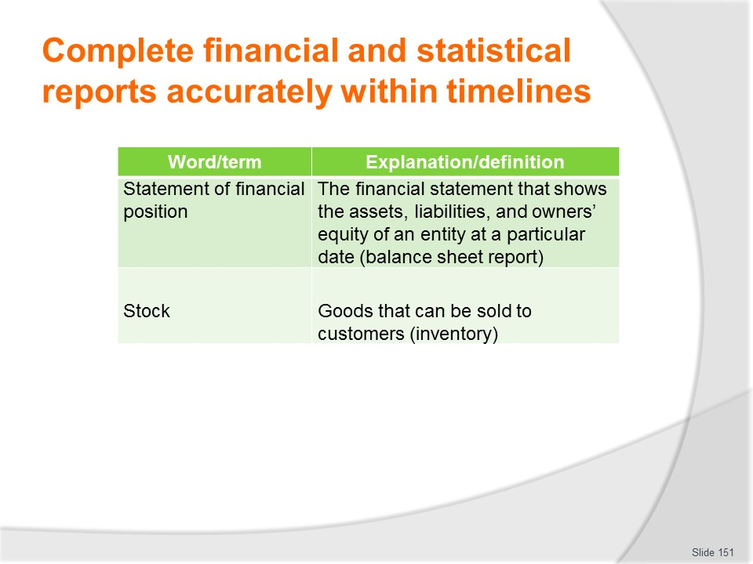
Slide No | Trainer Notes
Trainer presents a range of terms relevant to accounting and report preparation.
Class Activity
Trainer asks students to describe the terms presented and either confirms their answers or provides the correct explanation/definition.
Trainer should cover the ‘Explanation/definition’ column and reveal one-by-one as required.

Slide
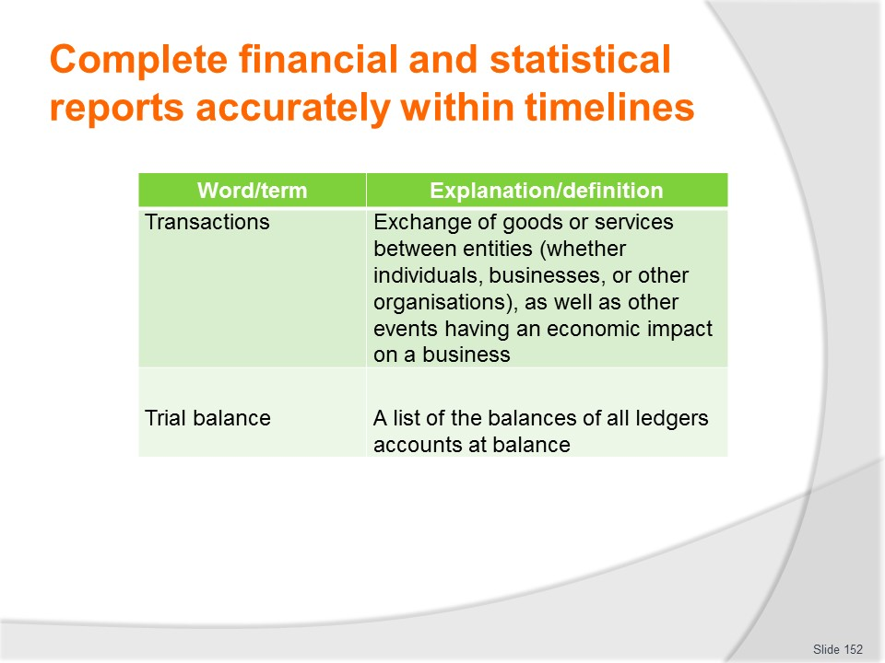
Slide No | Trainer Notes
Trainer presents a range of terms relevant to accounting and report preparation.
Class Activity
Trainer asks students to describe the terms presented and either confirms their answers or provides the correct explanation/definition.
Trainer should cover the ‘Explanation/definition’ column and reveal one-by-one as required.

Slide
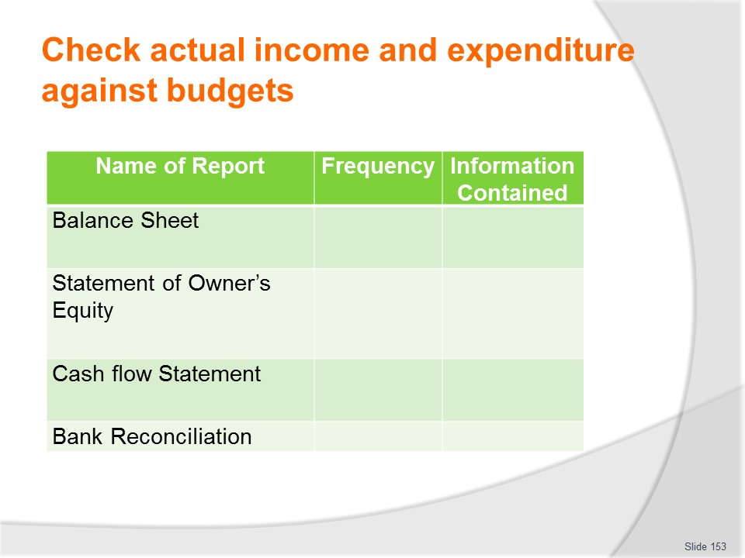
Slide No | Trainer Notes
Trainer lists examples of financial/statistical reports which may need to be completed.
Class Activity (1) – Question and Answer session
Trainer distributes and discusses example of reports as identified on the slide such as:
- With what frequency should/might they be prepared?
- What information do they contain?
Class Activity (2) – Handout
Trainer distributes and discusses examples of reports identified on slide.
Class Activity (3) – Major Exercise
Trainer provides relevant raw/base data and asks students to prepare reports identified on slide from such information.

Slide
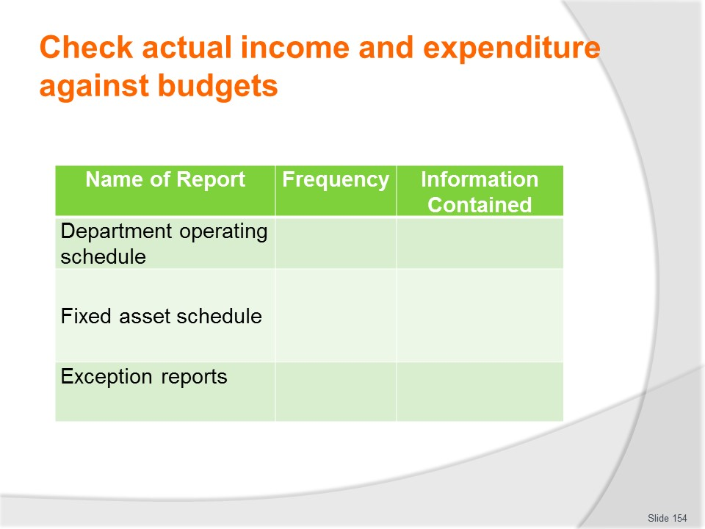
Slide No | Trainer Notes
Trainer lists examples of financial/statistical reports which may need to be completed.
Class Activity (1) – Question and Answer session
Trainer distributes and discusses example of reports as identified on the slide such as:
- With what frequency should/might they be prepared?
- What information do they contain?
Class Activity (2) – Handout
Trainer distributes and discusses examples of reports identified on slide.
Class Activity (3) – Major Exercise
Trainer provides relevant raw/base data and asks students to prepare reports identified on slide from such information.

Slide
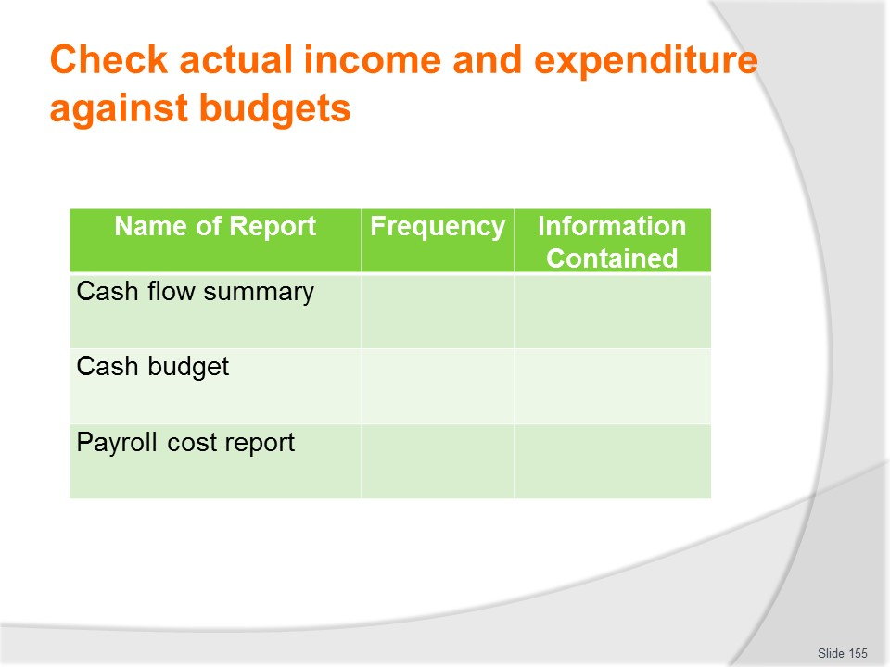
Slide No | Trainer Notes
Trainer lists examples of financial/statistical reports which may need to be completed.
Class Activity (1) – Question and Answer session
Trainer distributes and discusses example of reports as identified on the slide such as:
- With what frequency should/might they be prepared?
- What information do they contain?
Class Activity (2) – Handout
Trainer distributes and discusses examples of reports identified on slide.
Class Activity (3) – Major Exercise
Trainer provides relevant raw/base data and asks students to prepare reports identified on slide from such information.

Slide
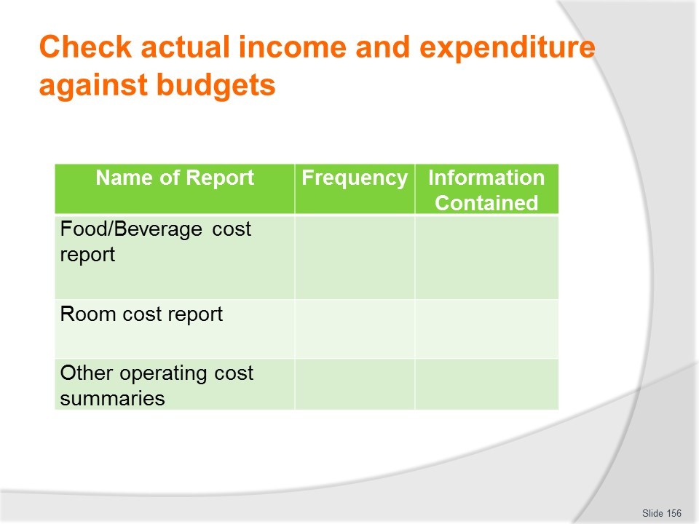
Slide No | Trainer Notes
Trainer lists examples of financial/statistical reports which may need to be completed.
Class Activity (1) – Question and Answer session
Trainer distributes and discusses example of reports as identified on the slide such as:
- With what frequency should/might they be prepared?
- What information do they contain?
Class Activity (2) – Handout
Trainer distributes and discusses examples of reports identified on slide.
Class Activity (3) – Major Exercise
Trainer provides relevant raw/base data and asks students to prepare reports identified on slide from such information.

Slide
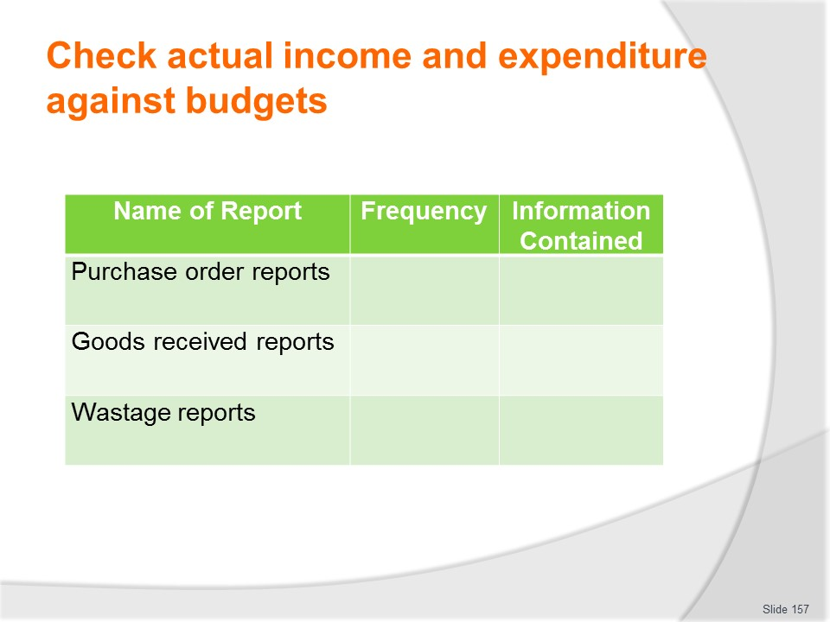
Slide No | Trainer Notes
Trainer lists examples of financial/statistical reports which may need to be completed.
Class Activity (1) – Question and Answer session
Trainer distributes and discusses example of reports as identified on the slide such as:
- With what frequency should/might they be prepared?
- What information do they contain?
Class Activity (2) – Handout
Trainer distributes and discusses examples of reports identified on slide.
Class Activity (3) – Major Exercise
Trainer provides relevant raw/base data and asks students to prepare reports identified on slide from such information.

Slide
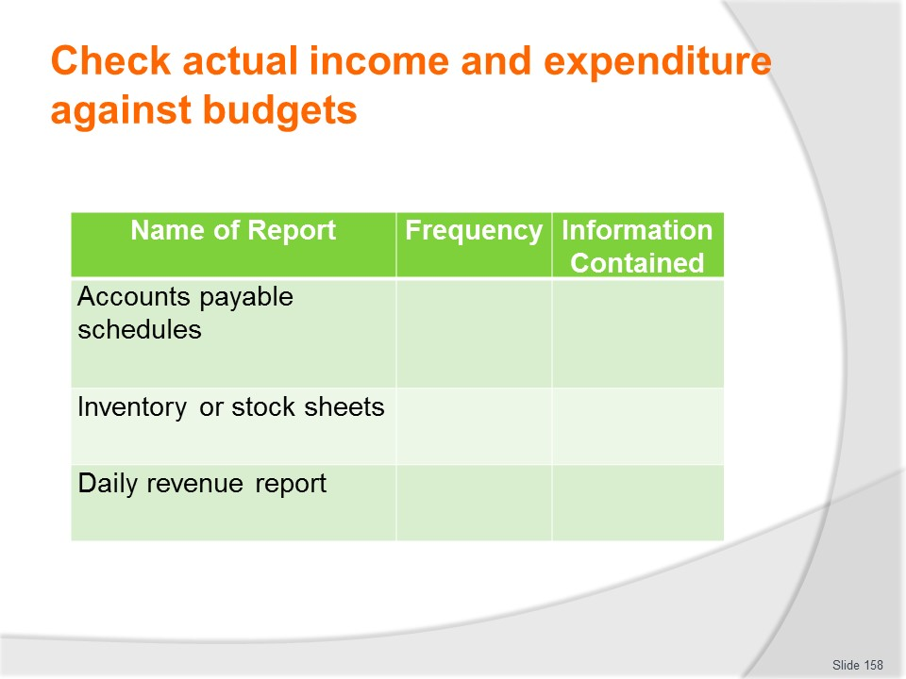
Slide No | Trainer Notes
Trainer lists examples of financial/statistical reports which may need to be completed.
Class Activity (1) – Question and Answer session
Trainer distributes and discusses example of reports as identified on the slide such as:
- With what frequency should/might they be prepared?
- What information do they contain?
Class Activity (2) – Handout
Trainer distributes and discusses examples of reports identified on slide.
Class Activity (3) – Major Exercise
Trainer provides relevant raw/base data and asks students to prepare reports identified on slide from such information.

Slide
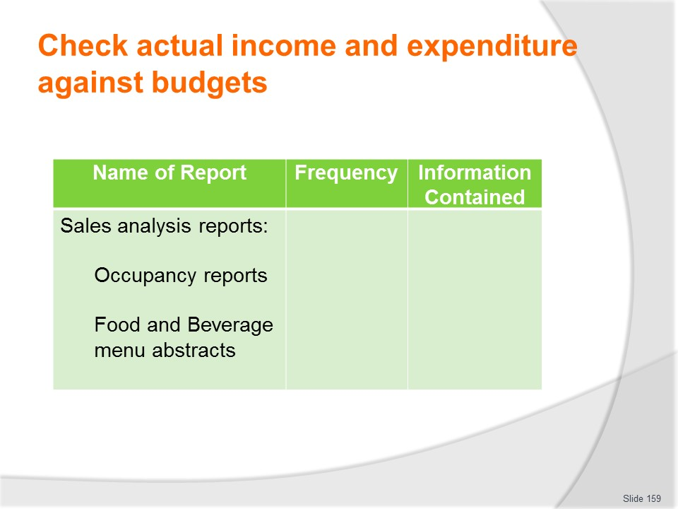
Slide No | Trainer Notes
Trainer lists examples of financial/statistical reports which may need to be completed.
Class Activity (1) – Question and Answer session
Trainer distributes and discusses example of reports as identified on the slide such as:
- With what frequency should/might they be prepared?
- What information do they contain?
Class Activity (2) – Handout
Trainer distributes and discusses examples of reports identified on slide.
Class Activity (3) – Major Exercise
Trainer provides relevant raw/base data and asks students to prepare reports identified on slide from such information.

Slide
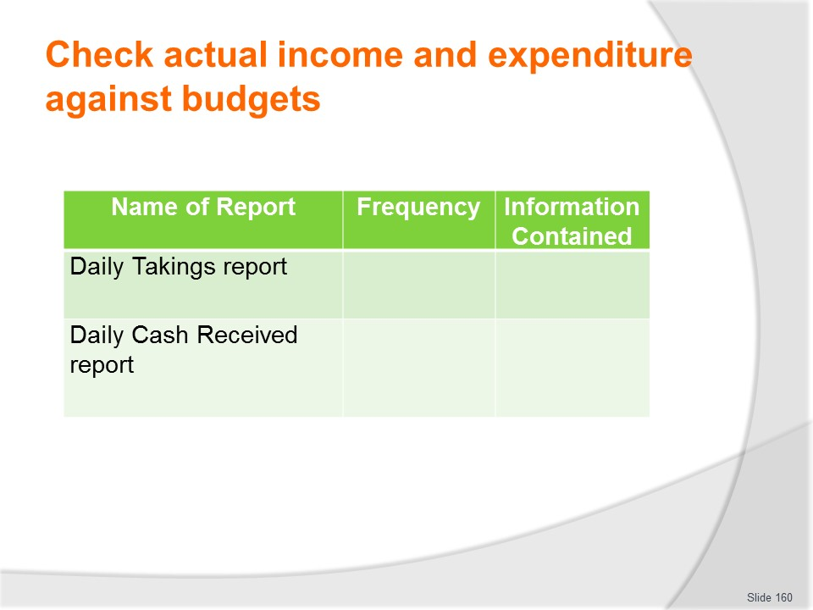
Slide No | Trainer Notes
Trainer lists examples of financial/statistical reports which may need to be completed.
Class Activity (1) – Question and Answer session
Trainer distributes and discusses example of reports as identified on the slide such as:
- With what frequency should/might they be prepared?
- What information do they contain?
Class Activity (2) – Handout
Trainer distributes and discusses examples of reports identified on slide.
Class Activity (3) – Major Exercise
Trainer provides relevant raw/base data and asks students to prepare reports identified on slide from such information.

Slide
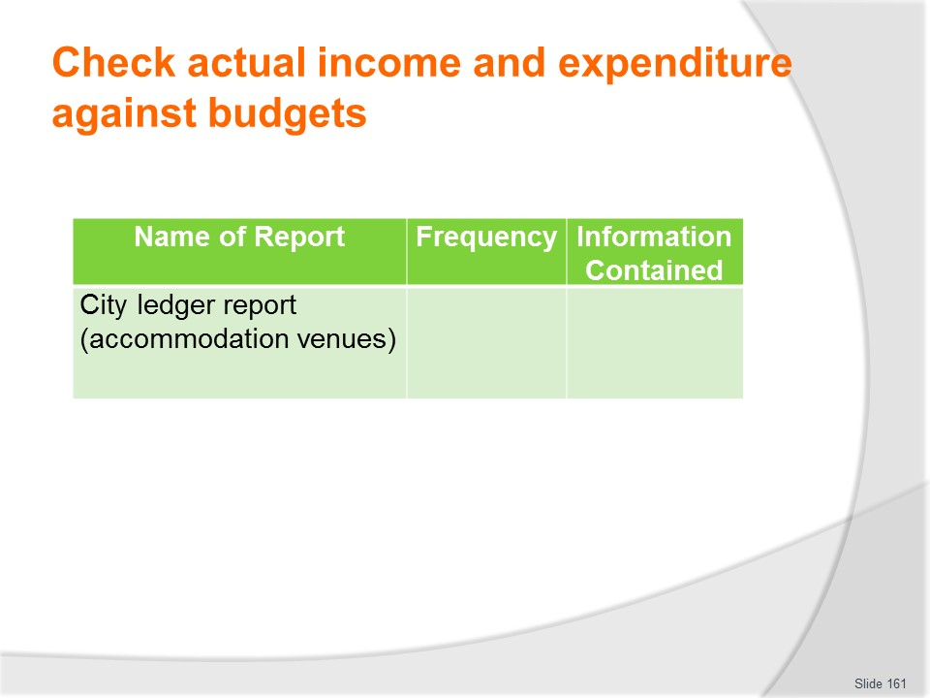
Slide No | Trainer Notes
Trainer lists examples of financial/statistical reports which may need to be completed.
Class Activity (1) – Question and Answer session
Trainer distributes and discusses example of report as identified on the slide such as:
- With what frequency should/might they be prepared?
- What information do they contain?
Class Activity (2) – Handout
Trainer distributes and discusses examples of report identified on slide.
Class Activity (3) – Major Exercise
Trainer provides relevant raw/base data and asks students to prepare report identified on slide from such information.

Slide
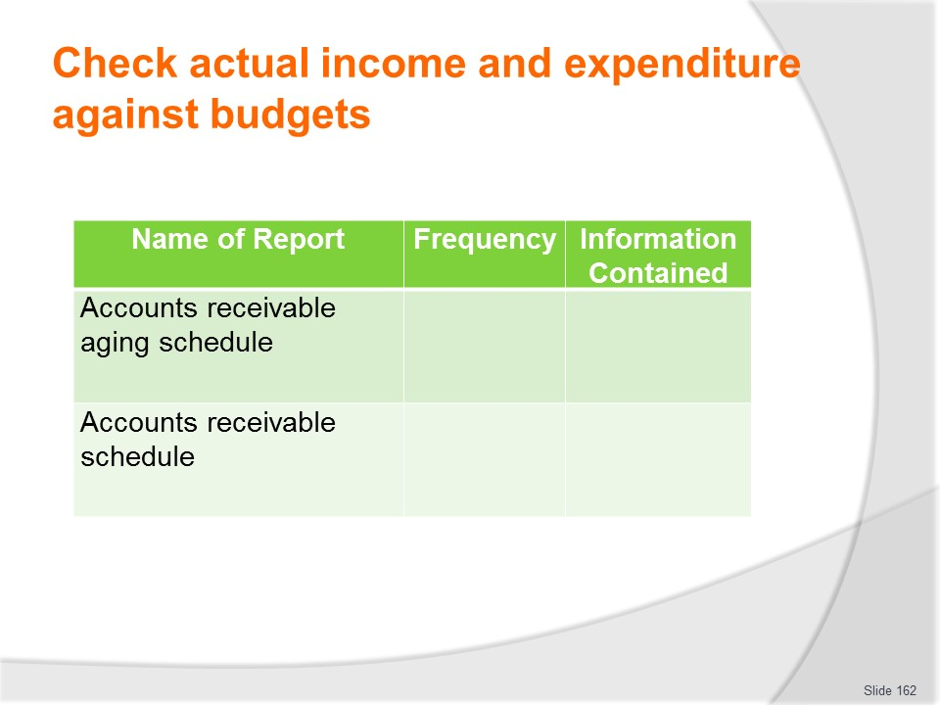
Slide No | Trainer Notes
Trainer lists examples of financial/statistical reports which may need to be completed.
Class Activity (1) – Question and Answer session
Trainer distributes and discusses example of reports as identified on the slide such as:
- With what frequency should/might they be prepared?
- What information do they contain?
Class Activity (2) – Handout
Trainer distributes and discusses examples of reports identified on slide.
Class Activity (3) – Major Exercise
Trainer provides relevant raw/base data and asks students to prepare reports identified on slide from such information.

Slide
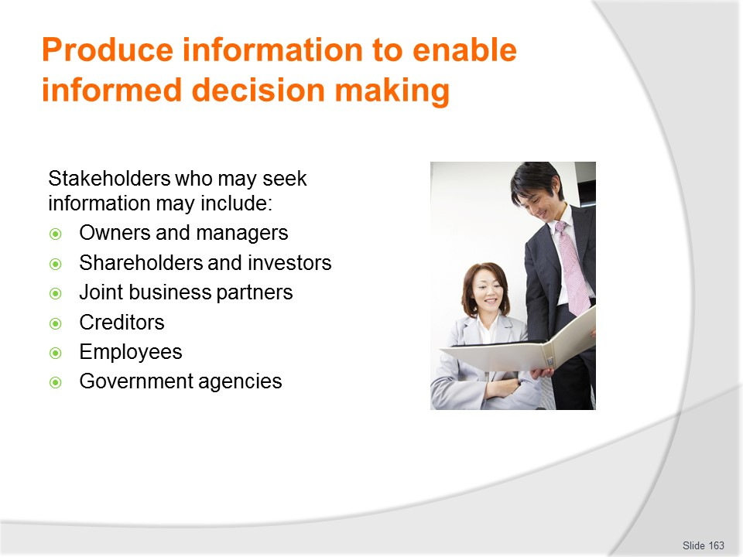
Slide No | Trainer Notes
Trainer identifies stakeholders who may seek to obtain financial/statistical reports of the business can include:
- Owners of the business
- Managers
- Shareholders and investors
- Joint business partners
- Creditors
- Employees
- Government agencies/authorities.

Slide
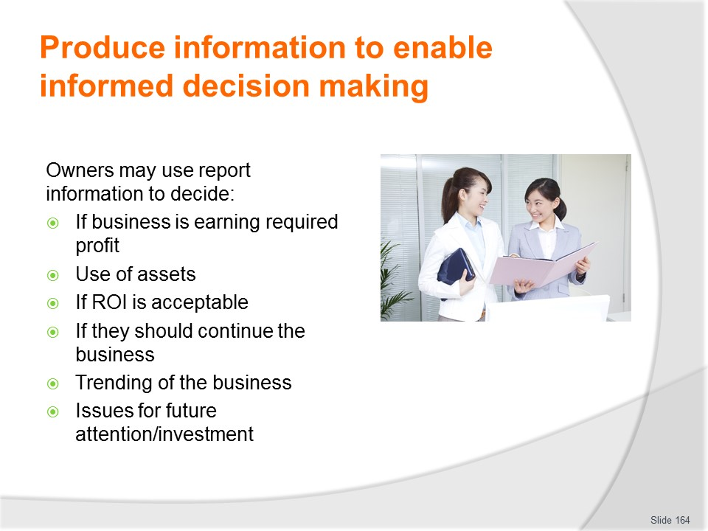
Slide No | Trainer Notes
Trainer states owners may use this information to decide:
- If the business is earning a satisfactory profit
- Whether the operation is using its short-term and long-term assets efficiently
- If the ROI is acceptable
- Whether or not continue operating the business – or to sell it, or move into another business
- About trade/results for ‘this period’ with historic data
- On issues regarding further investment in the business, expansions, refurbishment, upgrades – or contraction and/or deferment of plans for improvements/maintenance.

Slide
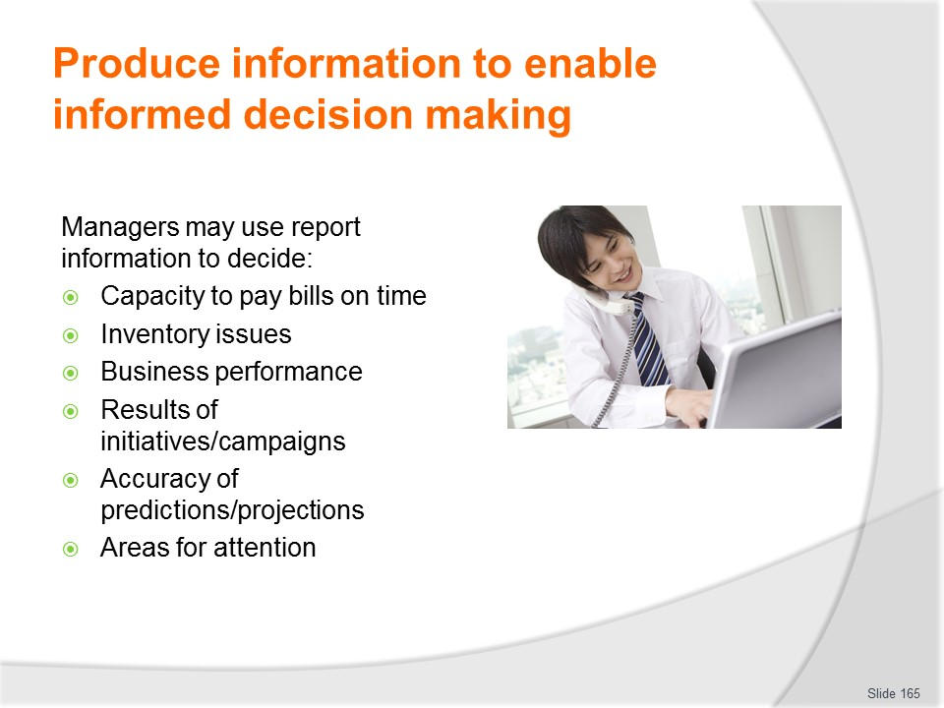
Slide No | Trainer Notes
Trainer states managers may use this information to decide:
- If the organisation will be able to pay its debts on time
- Size and value of inventory
- Business performance outcomes
- Effectiveness/success of business initiatives
- Accuracy of predictions/projections – against actual results
- Areas which require/demand remedial attention – and areas indicating where positive results may be able to translated to other sections of the business.

Slide
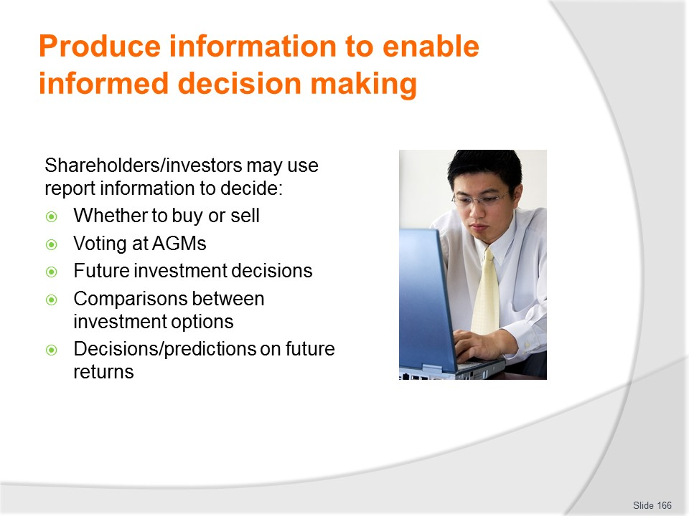
Slide No | Trainer Notes
Trainer states shareholders and investors may use this information to decide:
- If they should buy or sell their stake/interest in the business
- Their voting at AGMs – and other meetings
- Orientation to further/future investment in the business
- Comparisons between individual companies in the same industry/sector
- What they believe will be the future returns, earnings or dividends.

Slide
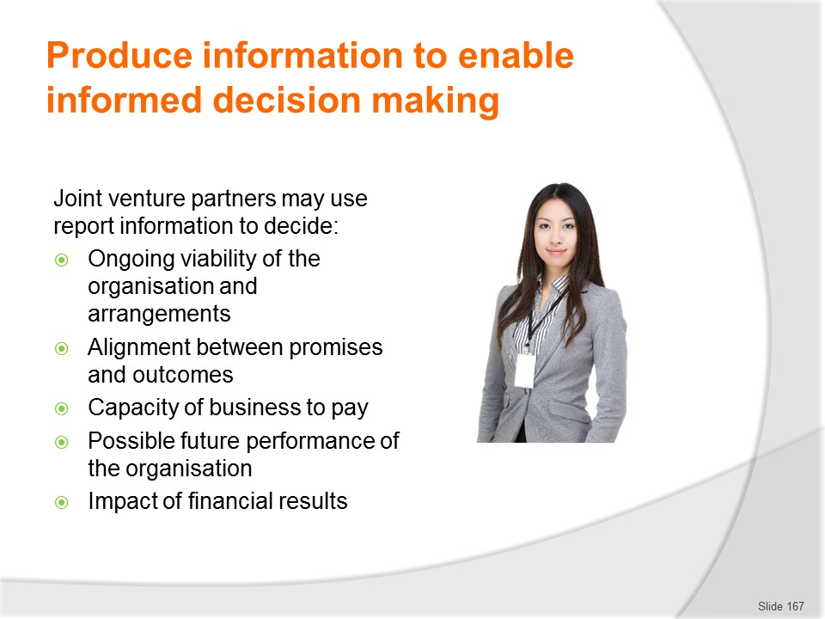
Slide No | Trainer Notes
Trainer states joint venture partners may use this information to decide:
- Ongoing viability of the organisation and the current arrangements
- Degree of alignment with promises made about performance and actual outcomes
- Comparisons between this company and other options for partnerships
- Capacity of the business to pay levies, charges, fees, dues, commissions, returns
- Possible future performance on the basis of past performance
- How the financial results reflects on the brand/image of the partner.

Slide
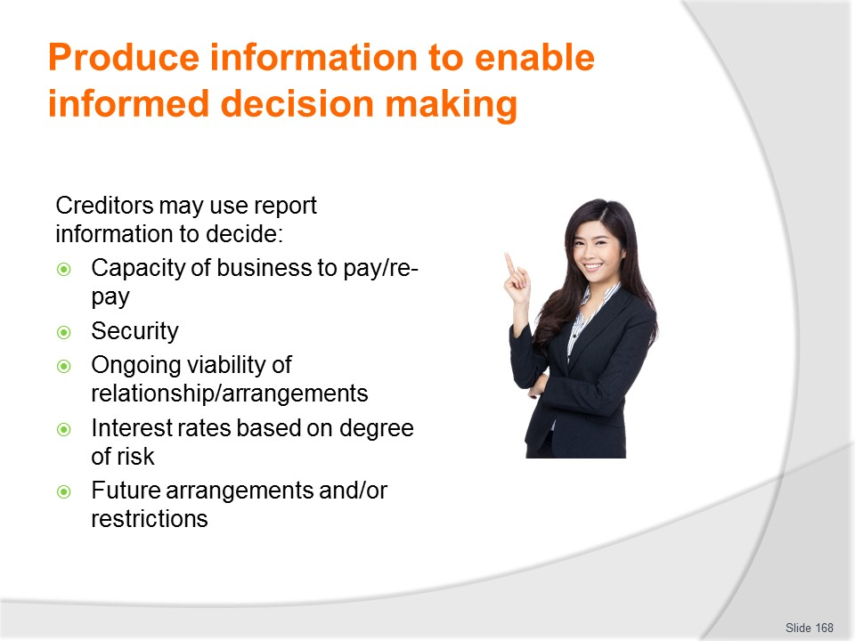
Slide No | Trainer Notes
Trainer states creditors may use this information to decide:
- Capacity of business to pay/re-pay principle, interest, money owed
- Security
- Whether or not to continue a business relationship with the organisation
- Interest rates based on degree of risk
- Restrictions/limitations on further borrowings.

Slide
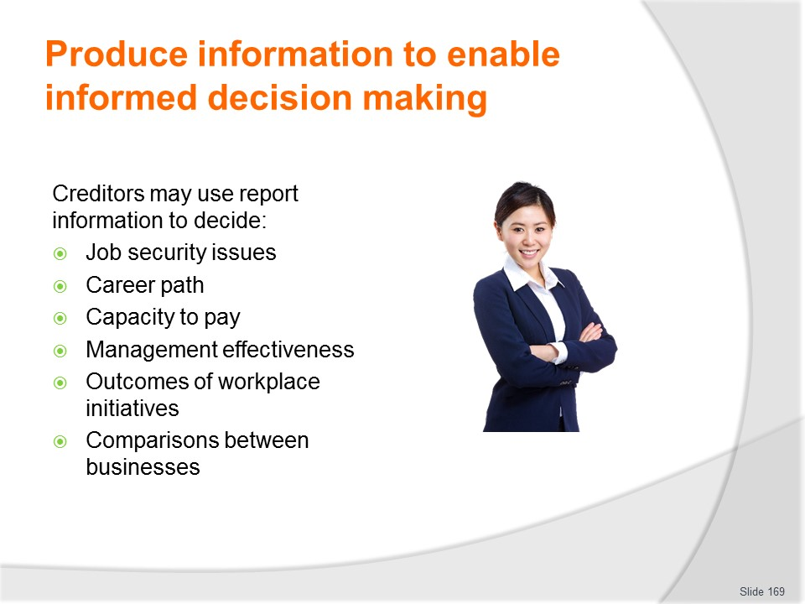
Slide No | Trainer Notes
Trainer states employees may use this information to decide:
- Job security issues
- Potential of the business for career development and promotion/job prospects
- Capacity of the organisation to pay wages and meet employment-related obligations
- Effectiveness of business management
- Outcomes of workplace initiatives they have been associated with
- Evaluations between different organisations in the same industry/sector.

Slide
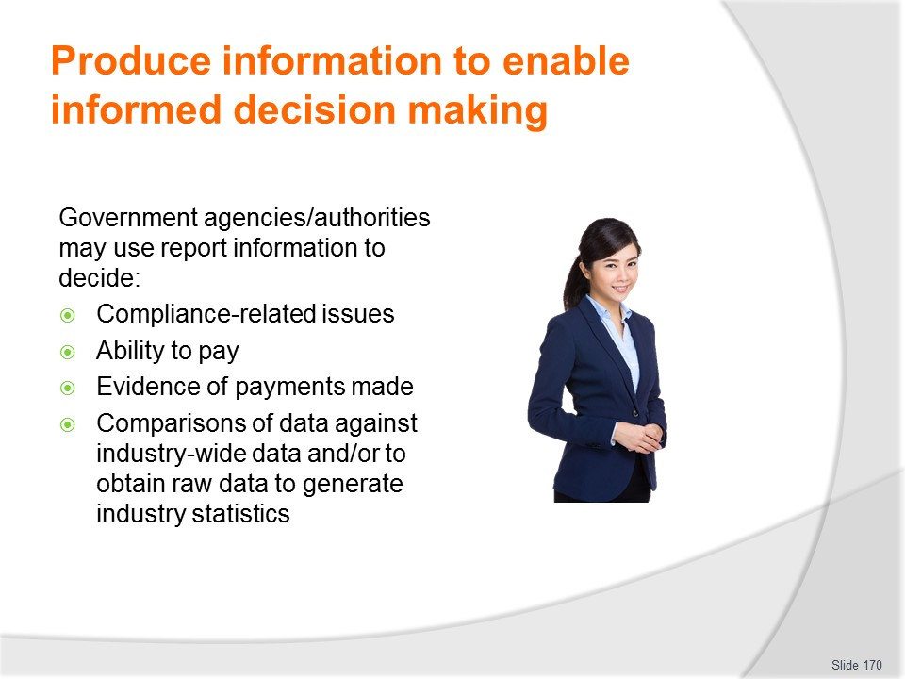
Slide No | Trainer Notes
Trainer states Government agencies/authorities may use this information to decide:
- Determine compliance-related issues
- Decide ability to pay government-imposed charges, taxes and similar
- Source evidence in relation to payments made – by government to the business, and by the business to government
- Capture required/specified industry-specific data.

Slide
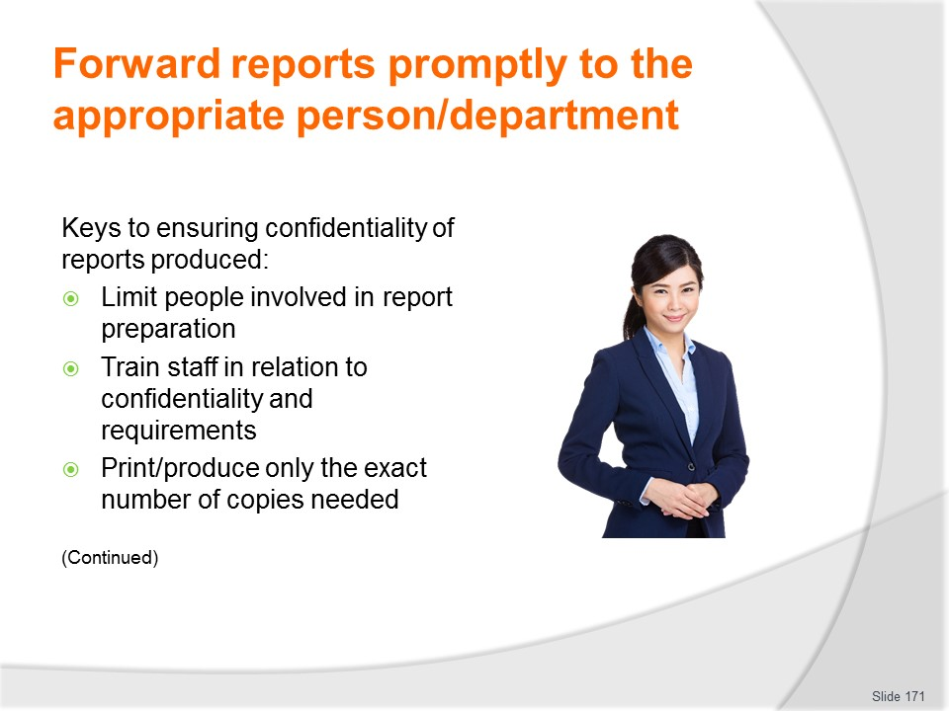
Slide No | Trainer Notes
Trainer states all financial reports contain information regarded as confidential/commercial-in confidence and it is therefore potentially dangerous to the viability of a business if it falls into the wrong hands so it needs to be protected to ensure it is not accessed by unauthorised persons or the competition. Keys to ensuring this are:
- Limiting the people involved in preparing the reports – to the minimum required to do the job properly
- Training staff regarding the need to keep report information confidential – through specific on-the-job training highlighting why confidentiality of this information is critical
- Printing/producing only the required number of copies of reports – and no extras/spare copies.

Slide
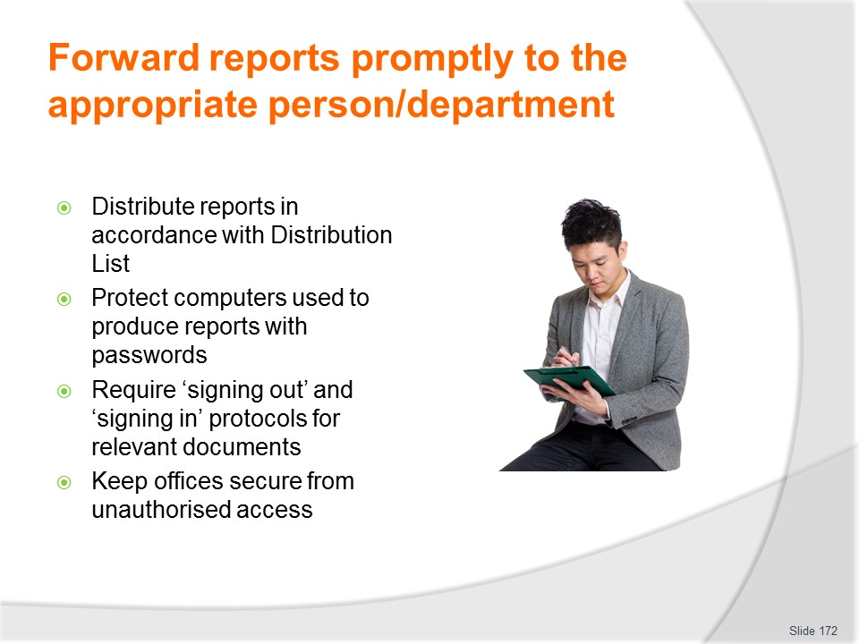
Slide No | Trainer Notes
Trainer continues identifying protocols to optimise confidentiality of reports produced:
- Distributing reports strictly in accordance with the approved Distribution List – for the report type (see following slides)
- Protecting computers with passwords – and not disclosing same to others
- Requiring signing out and signing back in of confidential information – to deter unauthorised access and enable identification of breaches
- Maintaining security of the office environment – through closed and locked doors, use of lockable filing cabinets and restricted access to administration areas.

Slide
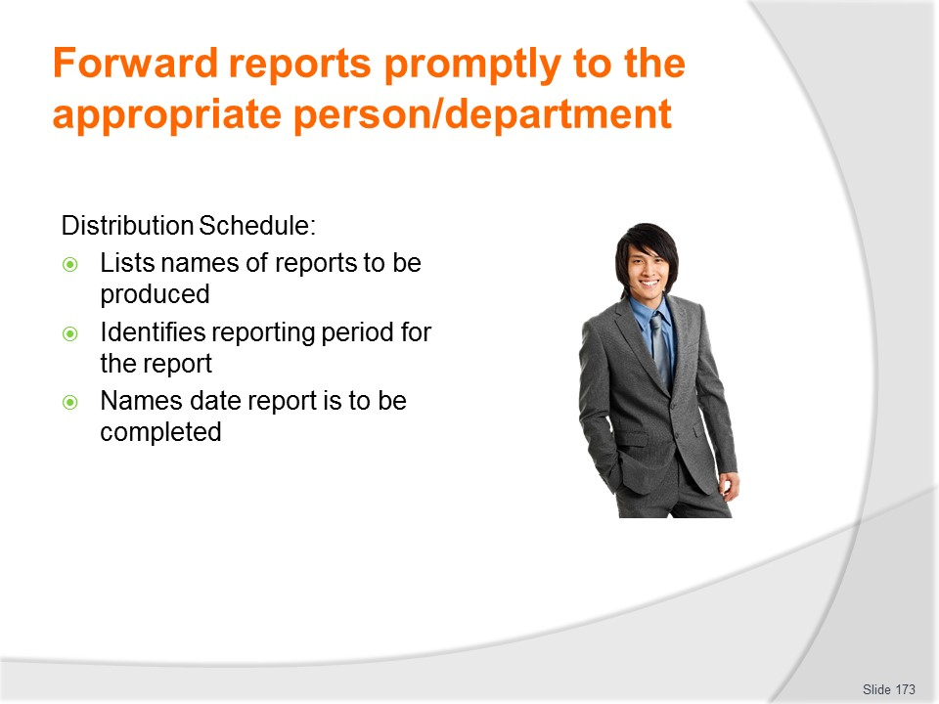
Slide No | Trainer Notes
Trainer identifies two critical elements of the distribution process for reports are:
- The Distribution Schedule
- The Distribution List.
- Trainer provides information about Distribution schedules identifying they contain:
- Name of report to be prepared
- Reporting period covered by the report
- Date report is to be completed.
Class Activity – Handout
Trainer distributes and discusses example of Distribution Schedule.

Slide
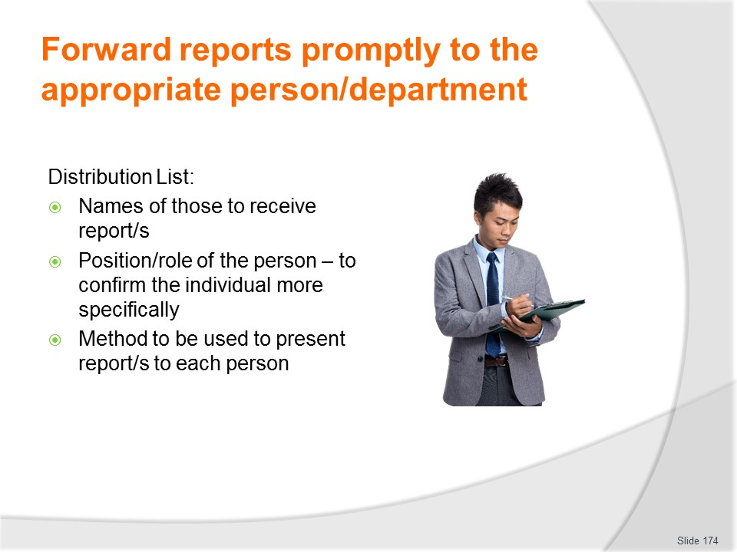
Slide No | Trainer Notes
Trainer discusses Distribution List identifying they contain:
- Personnel to receive report – by position and name
- Distribution method to be used for each person – such as electronic or hard copy.
Class Activity – Handout
Trainer distributes and discusses example of Distribution List.

Slide
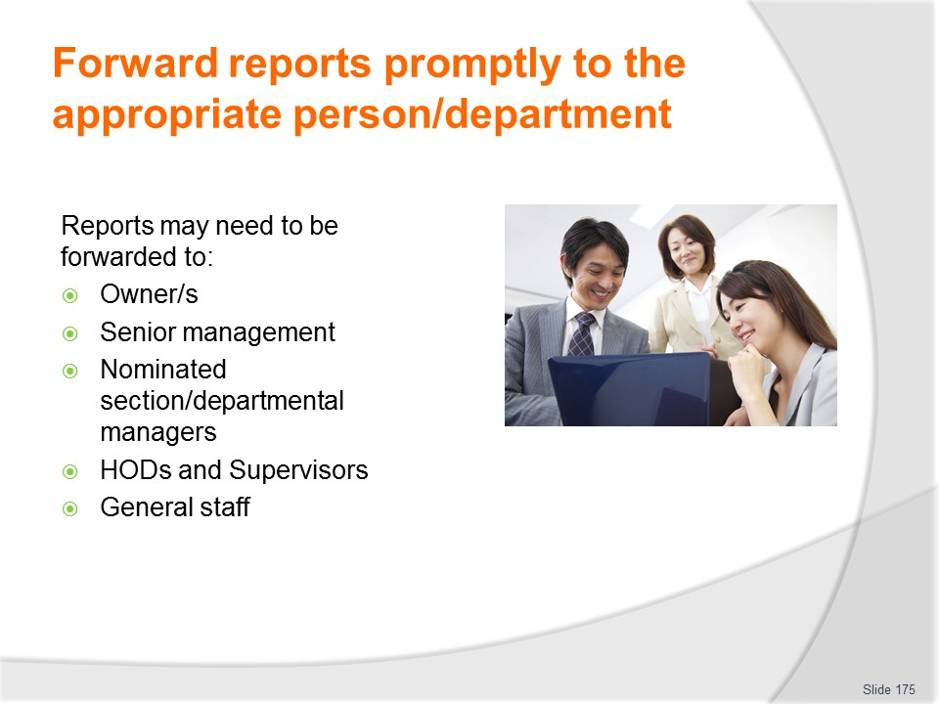
Slide No | Trainer Notes
Trainer identifies the following are an indication of who may be named on a Distribution List:
- Senior management
- Owners
- Personnel manager
- Sales manager
- Finance manager
- Heads of departments/sections
- Supervisors
- General staff.
Class Activity – Guest Speaker
Trainer arranges manager/owner from a relevant business to attend and discuss completion and distribution of financial and statistical reports.

Slide
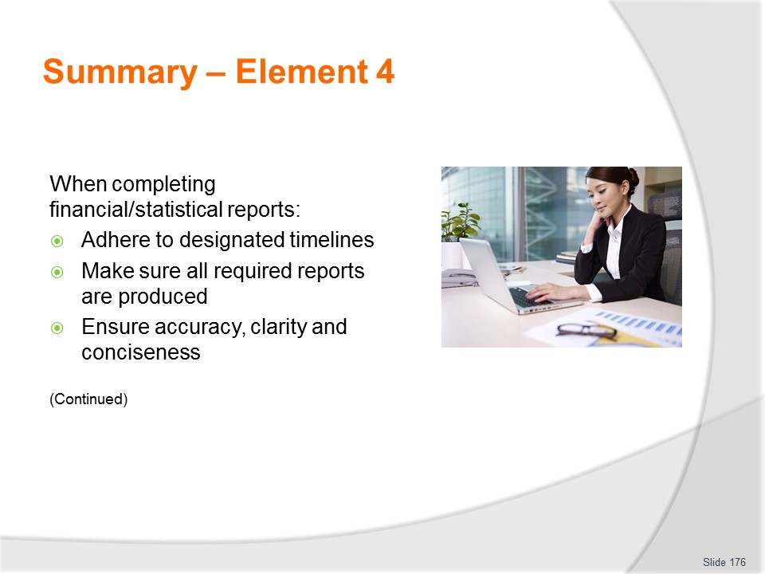
Slide No | Trainer Notes
 | Trainer provides a recap of the Element asking questions to check trainee understanding and responding to questions from trainees, as required.

Slide
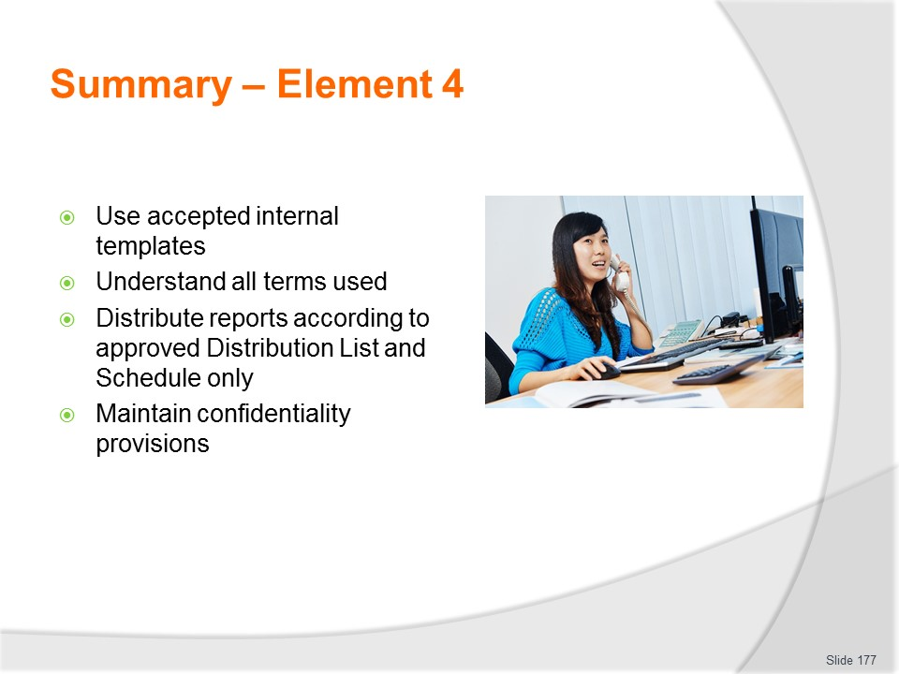
Slide No | Trainer Notes
Trainer provides a recap of the Element asking questions to check trainee understanding and responding to questions from trainees, as required.
Trainer thanks trainees for their attention and encourages them to apply course content as required in their workplace activities.

Recommended training equipment
Examples of the following types of budgets:
- Cash budgets
- Departmental budgets
- Wages budgets
- Project budget
- Purchasing/purchases (or ‘Materials’) budget
- Sales budgets
- Cash flow budgets
- Inventory budget
- Overhead budgets
- Capital Expenditure budgets
- Whole of business/organisation budgets
Sample budget notes
Sample Schedule of Accounts with budget lines and codes
Sample support and source documentation such as requisitions, inter-departmental transfer sheets, cash register audit rolls/tapes, takings sheets, debtors ledger, banking documentation/pay-in books, banking receipts, purchase orders, invoices and delivery dockets, statements, creditors ledger, assets register, receipts
Legislation as relevant to issues such as taxation and business structure
Sample budget and other relevant financial reports (see section 2.1 of Trainee Manual).
Purchase order guides/buying guides from suppliers
Samples of software packages used to produce financial/statistical reports.

Instructions for Trainers for using
PowerPoint – Presenter View
Connect your laptop or computer to your projector equipment as per manufacturers’ instructions.
In PowerPoint, on the Slide Show menu, click Setup Show.
Under Multiple monitors, select the Show Presenter View check box.
In the Display slide show on list, click the monitor you want the slide show presentation to appear on.
Source: http://office.microsoft.com
Note:
In Presenter View:
You see your notes and have full control of the presentation
Your trainees only see the slide projected on to the screen
More Information
You can obtain more information on how to use PowerPoint from the Microsoft Online Help Centre, available at: http://office.microsoft.com/training/training.aspx?AssetID=RC011298761033
Note Regarding Currency of URLs
Please note that where references have been made to URLs in these training resources trainers will need to verify that the resource or document referred to is still current on the internet. Trainers should endeavour, where possible, to source similar alternative examples of material where it is found that either the website or the document in question is no longer available online.

Appendix – ASEAN acronyms
AADCP | ASEAN – Australia Development Cooperation Program
ACCSTP | ASEAN Common Competency Standards for Tourism Professionals
AEC | ASEAN Economic Community
AMS | ASEAN Member States
ASEAN | Association of Southeast Asian Nations
ASEC | ASEAN Secretariat
ATM | ASEAN Tourism Ministers
ATPMC | ASEAN Tourism Professionals Monitoring Committee
ATPRS | ASEAN Tourism Professional Registration System
ATFTMD | ASEAN Task Force on Tourism Manpower Development
CATC | Common ASEAN Tourism Curriculum
MRA | Mutual Recognition Arrangement
MTCO | Mekong Tourism Coordinating office
NTO | National Tourism Organisation
NTPB | National Tourism Professional Board
RQFSRS | Regional Qualifications Framework and Skills Recognition System
TPCB | Tourism Professional Certification Board





